754X
IEP
Manual
(2023 – 2024)

*** Teachers and Related Service Providers must adhere to the policies outlined in this manual when developing Annual Review IEPs ***

Disclaimer: The information in this manual is specific to P754X and is not intended for use at other schools.

Annual Review IEPs at 754X

TABLE OF CONTENTS

Important Notices  Part I: The First Days of the School Year (or After Student Enrollment)  Part II: Preparing for the Annual Review  Part III: Developing an Annual Review IEP  Part IV: The Annual Review Meeting  Part V: Post-Meeting Paperwork & Faxing  Part VI: Implementing the IEP  Part VII: Reporting Progress to Parents  Part VIII: Triennials and Reevaluations  Addendum: Compensatory Services  Contact Information  Responsibilities Charts: Annuals, (Re)Evaluations & “Collapsed Triennials” | pp. 3 – 4  pp. 5 – 15  pp. 16 - 32  pp. 33 - 100  pp. 101 - 105  pp. 106 - 114  p. 115  pp. 116 - 119  pp. 120 - 123  pp. 124  pp. 125  p. 126 - 128

Helpful Tip!
If you have any difficulty reading any of these pages (particularly the figures and charts)…
you can always utilize the e-version and zoom in!

Symbols Used in This
Individualized Education Program (IEP) Manual
When you see the No Cookie Cutter icon next to an item in this manual it is to serve as a reminder that the “I” in “IEP” stands for “INDIVIDUALIZED” and NOT “Identical.”* We should be developing unique IEPs based on each student’s unique interests, skills and needs. NEVER cut from one student’s IEP and paste into another’s!
When you see the Red Flag icon next to an item in this manual it indicates that we have had compliance issues with this aspect of the IEPs we developed last school year. Please take extra care when developing this section of the IEP!
TWO FLAGS indicates that it has been problematic for 2 or more years!!!

When you see the Two Thumbs Up icon next to an item in this manual it indicates that, as an organization, we did a relatively good job in that area last school year.

DO NOT COPY AND PASTE BETWEEN IEPs !!!
- NEVER copy from a student’s previous IEP and paste into the current IEP unless a) a comparison with past performance is being made or b) you are developing a 595/LTA IEP. In both cases, you must have the permission of your AP and you must place quotation marks around everything from the previous IEP (with a notation about where it came from.

- NEVER EVER copy from one student’s IEP or (Sentence Starters!) and paste into another student’s IEP!

Annual Review IEPs at 754X

Part I: First Days of the School Year (or After Student Enrollment)

1) Chapter 408 : see page 115 for more details.

- The Chapter 408 process must be repeated each time the student gets a new IEP, has an IEP amended or reconvened, or is transferred into your class.

- CLARIFICATION 1: If there is a tag noting “New IEP Required Upon Return to School” you must email the IEP Coordinator immediately. When a former LTA/595 student returns, the IEP must be immediately Revised to restore Related Services. Once the Revision is finalized, a new IEP must be developed and meeting within 3-4 weeks of the students return to school, regardless of the Compliance Date in SESIS.

- CLARIFICATION 2: If an LTA/595 Mandated Triennial is developed for a Long Term Absent/595 student, a new Triennial must be developed and completed within 60 days of that student’s return to school.

- CLARIFICATION 3: If there is a tag on the IEP noting that "IEP To Be Revised to Add Periodic Assessment" (SANDI or MAP Growth) you must contact Dr. Fitz as soon as the student has taken the assessment. If new Annual Goals are added, the IEP will be Reconvened. If no Annual Goals added, the IEP will be amended.

- The only classes that are should appear on the Recommended Programs @ 754 are: ELA, Math, Science, Social Studies and Career Dev. If, during your 408 Review, you see any other classes listed, please notify me ASAP.

Note: Regardless of the quality of an IEP when you “inherit”, in the eyes of State Ed, once that student is on your roster your team is responsible for its contents and your team is responsible for implementing it! Therefore, it really is in your best interest, not to mention the best interest of your student, that either the IEP meeting be reconvened and the IEP document corrected or a new Annual Review IEP be developed!]

2) IEP Due Dates:

2a) Legally, IEPs with Sept. and Oct. Compliance Dates must be completed prior to that
Compliance Date. If your IEP Team anticipates difficulty meeting that deadline, you MUST
email your Asst. Principal and cc the IEP Coord. Your AP may or may not advise you to contact
the student’s parents/guardians to ask if they would give us a little more time to develop a quality IEP.

If for some reason, the IEP Draft will not be completed two weeks prior to the meeting and/or the meeting will not be held by the 754 Due Date (2 weeks prior
to the Compliance Date), you must discuss this with your AP!

2) IEP Due Dates (cont.):
2c) In general, the IEP Team’s Case Manager is to be whoever the student’s Official Class Teacher
is two months prior to the Compliance Date. This general rule may not be in effect for IEPs with
September and October Compliance Dates. In case of discrepancies, regardless of this general
rule, APs will make the final determination as to which team must write the IEP based
on which staff they feel best knows the student.

2d) Starting with IEPs with November Compliance Dates:
- IEP Meetings are to be held no later than 2 weeks prior to the Compliance Date.
- A completed Draft IEP (not including some parental input) is due two weeks prior to the
Meeting Date (i.e. one month prior to the Compliance Date.) You must notify the IEP
Coordinator by email and cc your AP once this is done. It is hoped that this will give the
IEP Coordinator an opportunity to provide feedback (esp. on missing sections and
misalignments) prior to the meeting. This way corrections can be made in advance, thus
avoiding follow-up IEP meetings. E.g.: For an IEP with a 12/4 Compl Date, completed Draft
IEP would be due on 11/6 and the Meeting would have to be held on or before 11/20.

2d.1) The Official Class Teacher and Team must develop, to the best of their ability, an IEP for every
student on their roster, even if they have not met the student. (see next page for notation on LTA IEPs)

2e) The IEP Coordinator will be responsible for opening the draft of the Notice of IEP two months
prior to the Compliance Date.

2e.1) Once notified that the Notice has been opened, the Teacher must complete,
finalize, print and send home the Notice of IEP. Select a date no later than 2
weeks prior to the Compliance Date convenient for ALL IEP Team Members.
When asked: “Record sending letter and event?” ALWAYS click “Okay.”
2e.2) The Teacher must then notify the IEP Coordinator who will then open the
Draft IEP. Though not recommended, it is permissible for a teacher or
counselor to open the Draft but only after following step 2e.1. That person
MUST notify the IEP Coordinator. Failure to notify the IEP Coordinator
will likely result in required components not being entered in the Draft.

Long Term Absence (LTA) IEPs
- To be eligible for an LTA IEP, the student must have less that Rate of Attendance of 20% or less, or be
enrolled in Class 595. Other students may be eligible for a LTA IEP at the discretion of that student’s AP.
- If an LTA student is on a class roster two calendar months prior to the Compliance Date, the Official Class Teacher and the Counselor are responsible for developing the IEP and holding the meeting by the 754X Due Date (i.e. 2 weeks prior to the Compliance Date).
- Be sure to add the Attendance Teacher to the Notice of IEP and invite her to the meeting. Attendance Teacher should participate in the meeting whether the parent and student attend or not.
- The Student and Parent Level 1 Vocational Assessments should be mailed home.
- The Official Class Teacher should generate a Level 1 Vocational Assessment and complete it to the best of her/his ability. If he/she does not know the student, the Level 1 should be completed by staff members who knew the student in previous years (unless the student is a recent admit.) Information from the Level 1s should be woven into the Present Levels.
- If verbatim passages are copied from the student’s current IEP and pasted into the new IEP,
each section must be prefaced with the following:

To date ___________ has a _____% rate of attendance for the school year. _________’s
last three dates of attendance were: _______, ______ and _______. A new Annual Review
meeting MUST be held upon ___________’s return to school. The following is the most
current information we have on _________ and it comes from the IEP dated _______:

- Any and all of the verbatim passages carried forward to the new IEP, must be put in quotation marks.
- Annual Goals from the current IEP carried forward to the new IEP need not be in quotation marks but
should be prefaced with the phrase “Goal From Previous IEP Unmet Due to Lack of Attendance”.
- The IEP Coordinator will add the following label to the IEP: LTA IEP; NEW Annual Review Required
Upon Return to School.
- IEPs for students officially in Class 595 will be developed by the IEP Compliance Team.
- Be sure to add an Attendance Goal for student to achieve 90% Attendance within 1 year.
CLARIFICATION

If an LTA/595 Mandated Triennial is developed for a Long Term Absent/595 student, a new Triennial must be developed and completed within 60 days of that student’s return to school.

2) IEP Due Dates (cont.):
2f) The IEP Coordinator will continue to publish monthly updates of upcoming IEP dates
using the best information available in SESIS. But, as this system often has errors and
conflicting information, it is the responsibility of ALL members of the IEP Team
(Teachers and Related Service Providers) to know when an IEP is due based on the
students SESIS Profile and current IEP! Email the IEP Coordinator as soon as you
become aware of any conflicts or errors, but a student’s name being left off the list of
upcoming IEPs is NOT an excuse for not completing an IEP on time.

2g) Determining an IEP Compliance Date in Student’s Profile
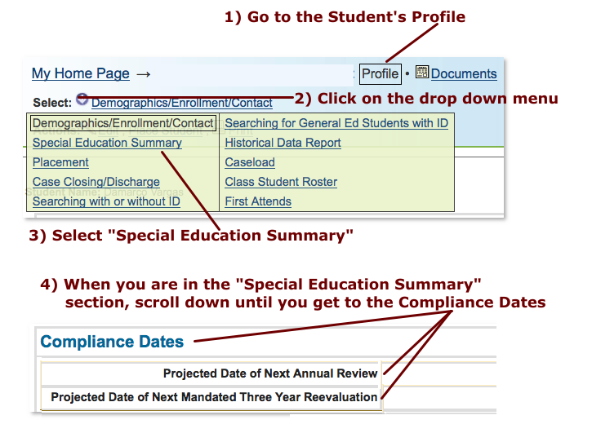

2h) Compare the Compliance Date with the “Projected Date of Annual Review” found on the Cover

Page of the student’s current / most recent IEP.
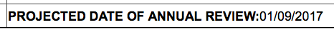
- If there is a discrepancy between the two dates consult with the IEP Coordinator.
- If a Mandatory Triennial is due prior to, or within 4 months after the Compliance Date, consult the Student
Assessment Team and the IEP Coordinator via email.
NOTE: As per page 87 of the SOPM: “(I)f the student’s three-year reevaluation is due in the same year, conduct
the three-year reevaluation by the student’s annual review date.”
In some cases, Administration may decide that an Annual Review will still have to be held.

- IEP Due Dates (cont.):

2i)
Note: The parents, IEP Team, school administration or district may request that a new Annual
Review be opened or re-opened as an Amendment/Reconvene at any time, regardless of the
Compliance Date(s). For example, If a given class has a large number of students with IEPs due in
the Spring semester, the AP may direct that team to conduct some of those IEPs the previous Fall.

The IEPs Coming Due lists that the IEP Coordinator emails to the 754X Organization each month are a backup way of knowing when students’ IEPs are due. The primary way of knowing when IEPs are due is for Teachers and Related Service Providers to make notations of the Compliance Date when they conduct the 408 Reviews (as well as the IEP Due Dates List that Official Class Teachers send to their APs in Sept.) The term “Due Date” refers to the 754X Due Date (i.e. two weeks prior to the Compliance Date.)

SEE THE FOLLOWING PAGE FOR MORE INFORMATION.

Special Note: Teachers and Related Service Providers must adhere to the instructions outlined in the last column of the IEPs Due in (Given Month) list.

IEPs Coming Due Lists…
At the beginning of each month the IEP Coordinator emails the IEP Teams a list of Annual Review IEPs that are due the subsequent month (e.g. the January 2023 list is sent out the first week of December 2022.) These lists are merely reminders that these IEPs are coming due. All IEP Team Members are responsible for knowing their students’ IEP Due Dates and Compliance Dates based on the 408 Reviews they conducted and the Due Date Forms filled out in September (see page 8) and updated each time a new student is put on the class roster.
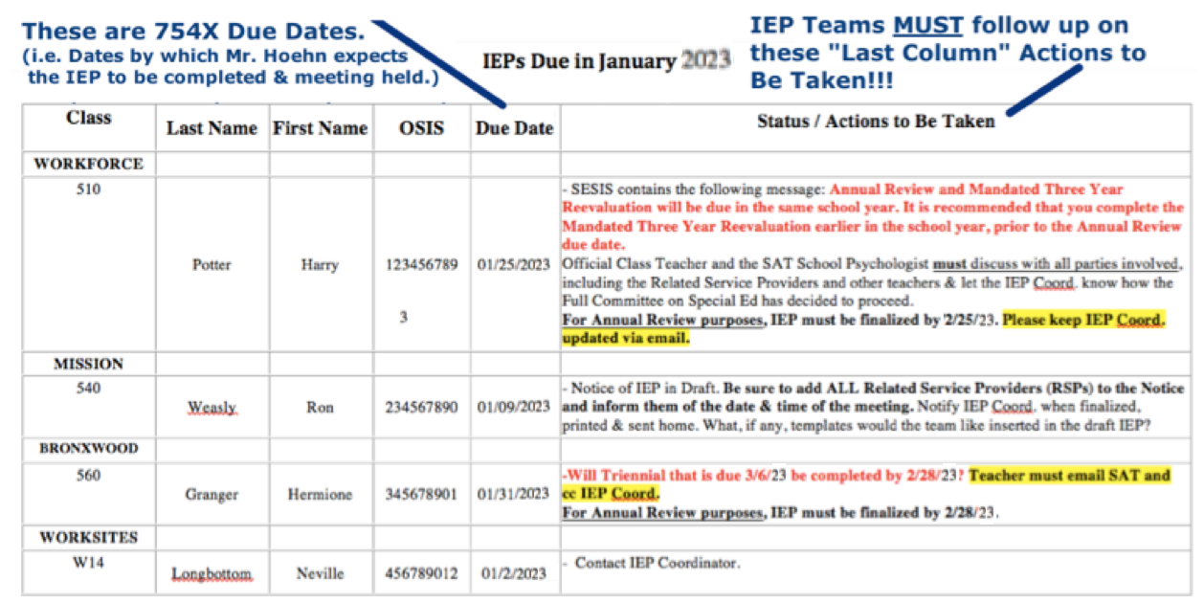

The IEP meetings for all students graduating or aging out must be held, and IEPs finalized no later than April 30th, even if the Compliance Dates fall between the beginning of May and the end of June.

A Note on Mandated Three Year Reevaluations (a.k.a Mandated Triennials or Tri(s)):
“When a mandated three-year reevaluation is due, the school/CSE, upon review of existing data and the student’s needs, may determine that a reevaluation would be unnecessary. In that case, the school may seek the parent’s agreement to waive the mandated three-year reevaluation. A school/CSE should not routinely seek to waive mandated three-year reevaluations. Any waiver must be based on the individual student’s needs. If the school/CSE determines that the mandated three-year reevaluation would be unnecessary, the PWN: Request for Waiver of a Mandated Three Year Reevaluation Form must be completed and sent to the parent. This form must explain the specific reasons for the determination, and that the parent has the right to disagree with the school/CSE. If the parent does not sign and return the form, the reevaluation must be conducted.
Standard Operating Procedures Manual (SOPM):
The Referral, Evaluation, & Placement of School-Age Students with Disabilities (retrieved Aug. 2, 2018): pg 88
- The School Assessment Team (SAT) should contact the IEP Team well in advance of a Mandated Tri. If your student is due or overdue for a Mandated Tri and you have not heard from the SAT two months prior to the Annual Review Compliance Date, the Teacher should email the SAT School Psychologist and cc the IEP Coordinator.
- Our students have a right to a Tri. A list of reasons to justify holding a Tri is never a requirement. However, if the School Psychologist (SAT), the Teacher, and the Related Service Providers happen to develop a list of “specific reasons for the determination” that the Tri is not necessary, the School Psychologist (SAT) should present the list to the Asst. Principal who supervises that student’s class.
- As the Summary Page now requires Reading and Math Grade Levels, 754X policy us that a Tri with Testing is always required when a student is due for a Mandated Three Year Review.

NOTE: As per page 87 of the SOPM: “(I)f the student’s three-year reevaluation is due in the same year, conduct
the three-year reevaluation by the student’s annual review date.”

At the Heart of a Transition-Focused IEP you will find:
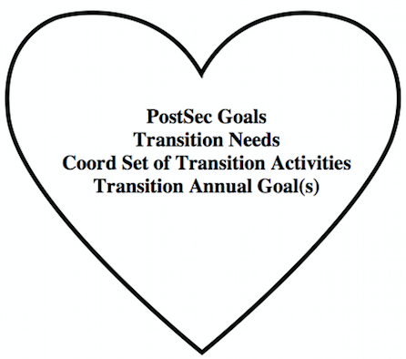

And the information yielded by the Level 1 Vocational
Assessments is the oxygen this heart depends on!!!

3) Student Level 1 Vocational Assessments – During the first or second Counseling session for a student
(in September or when the student enrolls at 754X) the Counselor* will work with that student on completing a
preliminary Student Level 1. This is the Student Level 1 that should be referenced for all Sept –
Dec Annual Reviews. For Annual Reviews taking place Jan – June, the Counselor will offer the student the
opportunity to update the Level 1 within one week of the opening of the Notice and IEP Draft by the IEP
Coordinator. The Counselor must upload (via fax or scanner>pdf) the Student Level 1 within one week of
the IEP Draft being opened! *Note* The Level One Voc Assessment Committee intends to develop a new
version during this school year.
* If the student does not have a Counseling mandate, the Teacher works with the student on the Level 1.

Reminders
3a) All Level 1 forms must be dated* as that date is referenced when the IEP
Coordinator completes a Prior Written Notice (PWN).

3b) Level 1s, Invitations, FBA/BIPs, etc. should all be single sided!

*In fact, every document uploaded into SESIS must be dated. Last year, State Ed directed us to
Reconvene an IEP for the sole reason that a document was not dated!!!

INCREASING
INTRASTAFF COMMUNICATION

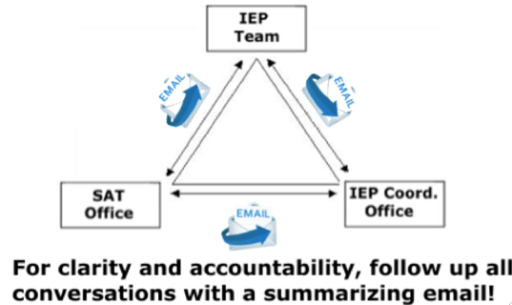 | When communicating about students and their IEPs please adhere to the following guidelines:  - Compose a separate email for each student.  - Include the student’s first and last names in the email heading along with the OSIS number (no dashes and no spaces!)

To Reiterate: If you have an oral conversation the IEP Coordinator and/or the SAT School Psychologist regarding division of IEP responsibilities for an Annual, Triennial or Collapsed Annual / Triennial, be sure to follow it up with an email summarizing for clarity what was agreed upon!

Annual Review IEPs at 754X

Part II: Preparing for an Annual Review

If a postponement is needed for any reason, you must log an Event AND issue a new Notice of IEP!

4) Notice of IEP (Part 1)
- Using SESIS, the IEP Compliance Team will Create a Notice of IEP Meeting. (Do not hesitate to remind the IEP Coordinator if you see this hasn’t been done!)
- 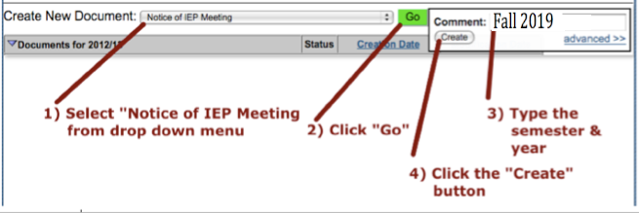

4a) Select Annual Review:
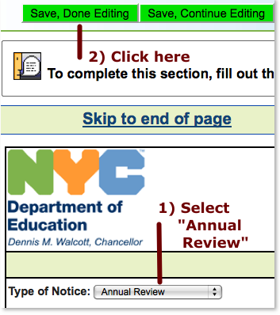
4b) Click on this link:

4) Notice of IEP (Part 1 cont.)
4c) IEP Compliance Team opens Notice of IEP & notifies the Teacher & Counselor via email (for exceptions see 2e.2 on pg. 6)
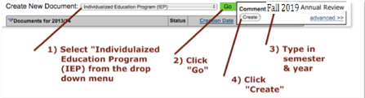

5) Notice of IEP (Part 2)
Setting the Official Date and Time of the Annual Review Meeting:
5a) After the IEP Coordinator has opened a Notice of IEP, the Teacher and ALL RSPs should settle on at least two possible dates and times to hold the Annual Review meeting that are at least 2 weeks prior to the Compliance Date. The Teacher should contact the student’s parent /guardian to set up an IEP meeting for either of those two dates and times. If neither date/time is convenient for the parent/guardian, the IEP Team should select a third date/time convenient for all members of the team, including the parent/guardian and student.
5b) The Teacher will ask the parents if they prefer to receive the following forms via the mail or in their young adult’s bookbag: the Notice of IEP Meeting, the Level 1 Vocational Assessment and the Consent to Invite an Outside Agency.

5c) The Teacher re-opens draft of the Notice of IEP that the IEP Coordinator created.
5c.1) 5c.2) 5c.3)

Continuing Policy Regarding District Representatives

The Principal has designated Official Class Teachers as the individuals who will serve as the Case Managers and District Representatives for Annual Review IEP Meetings held at our school.

According to the Standard Operating Procedure Manual (SOPM – retrieved 8/2/19 - p. 42-45), the District Representative has the following responsibilities:

- Serving as the chairperson of the meeting;
- Facilitating open discussion among all participants regarding issues related to eligibility for services and development of IEP recommendations;
- Ensuring that the parent is a meaningful participant in the IEP process and encouraging the parent to discuss
observations, opinions, and/or concerns about the student’s education;
- Providing information regarding the continuum of services including supports and services, including those
currently and potentially available in the student’s current school and those available in other schools in the district;
- Explaining that the law requires students with disabilities to be educated with nondisabled students to the maximum extent appropriate and that the team must consider whether the student can make satisfactory
progress in the general education setting with supplementary aids and services before recommending other programs;
- Ensuring that all potentially appropriate program and service options are considered, regardless of the programs and services currently provided in a school;
- Ensuring that the student’s IEP includes the supports, services, and accommodations s/he needs to meet his/her IEP goals and provides the student the opportunity to progress in the grade level curriculum and on
New York State and district assessments to the extent appropriate;
- Working to build consensus among the IEP team members on all issues;
- In the event that consensus cannot be reached regarding the IEP recommendations for a student who is already receiving special education services, determining the IEP recommendations and ensuring that the parent is fully informed of his/her due process rights and that the IEP reflects the disagreement in the “Other Options Considered” section (Summary Page) and in the relevant “Student Needs That Are of Concern to the Parent” section(s) of the Present Levels of Performance.

District Representatives are expected to be familiar with
the Continuum of Services available in New York Public Schools.
For more information see the Q & A at:
https://www.p12.nysed.gov/specialed/publications/policy/schoolagecontinuum-revNov13.htm

- Notice of IEP (Part 3) The Teacher edits the Notice of IEP to enter the meeting date, time, and IEP Team membership.
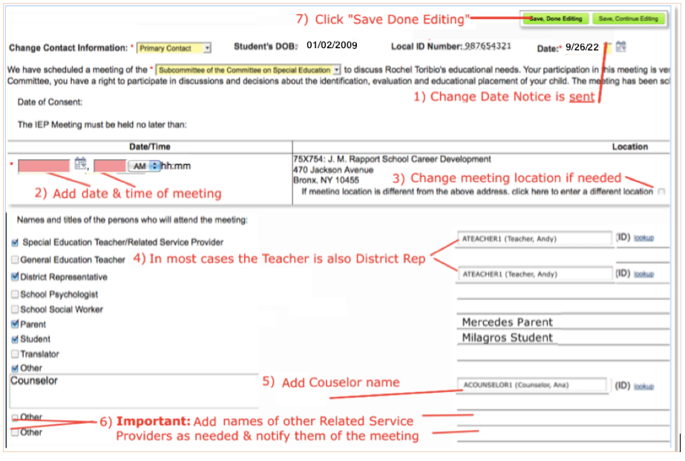

*Reminder to Teachers* It is very important to remember to invite ALL the students RSPs to the meeting! You’ll know who those RSPs are by double-checking the Recommended Services on the previous IEP. *NEW* If a Less Restrictive Environment (LRE) is being considered, invite the SAT School Psychologist & she will let you know if she plans to attend.

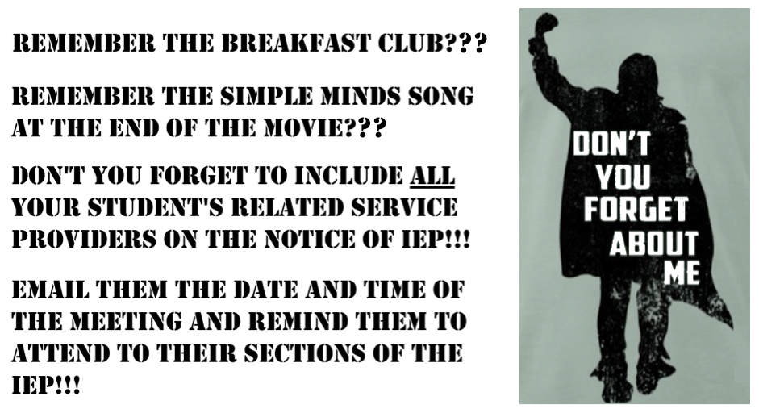

7) Notice of IEP (Part 4)
7a) The Teacher prints the Notice of IEP.
* REMINDER* When asked: “Record sending letter and event?” ALWAYS click “Okay.”

7b)
Confirm that the Notice has been “Finalized”:

7) Notice of IEP (Part 4 cont.)

7c) Exiting Notice of IEP Meeting

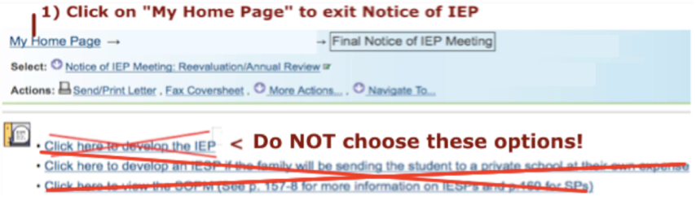

7d) The Teacher should send home the following by mail or student book bag (whichever
the parent / guardian prefers) : Notice of IEP Meeting, Level 1 Vocational Assessment - Parent
Version and Consent to Invite Outside Agency and, when appropriate, information on having the IEP
translated to the family’s home language. (See following page for more information on IEP
translations.)

*Reminder*

Be sure to let the Payroll Secretary know about the meeting one day in advance to ensure that you do not get coverage for the period when the meeting is to be held.

District 75 has been invited to participate in a program where parents who are speakers of Arabic, Bengali, Chinese, French, Haitian Creole, Korean, Russian, Spanish or Urdu can request that their children’s IEPs be translated into their native language.

To facilitate this process we will follow these steps:
- Before sending home the Notice of IEP, check the Demographics page of the student’s SESIS Profile.
- If the Home Language is one of the nine DOE covered languages listed above, print the Letter to Parent in that language. *
- Enclose the Letter to Parent in the same envelope as the Notice of IEP that you send home.
- When the parent attends the meeting ask if she or he has gone online and requested a translation of the IEP.
- If not, offer the parent another opportunity to do so and guide him or her though the process on your computer.
- When the family indicates that they would like the IEP translated, check the appropriate box on the Request to Review / Finalize IEP Form.

* Student Qualification for IEP Translation is also noted on the
“IEPs Coming Due” lists that the IEP Compliance Team send out each month.

7.1) Requesting Opening of Draft IEP
***Please follow the school’s established process for opening IEPs! Failure to follow this process was the source of many problems the past five years.***
In most cases the IEP Coordinator opens the Notice of IEP and the Official Class Teacher completes it, prints it, sends it home (or emails it IF we have signed/e-signed permission) and notifies the IEP Coord. The IEP Coordinator then opens the draft IEP. If anyone else opens the Notice of IEP and/or the draft IEP they MUST email the IEP Coord.! Failure to notify the IEP Coordinator will likely result in required components not being entered in the Draft.
After carefully reviewing the student’s current IEP, the Official Class Teacher should email the IEP Coordinator a request to open a draft IEP. That emailed request must include the following information:

2023-2024 Form

Request to OPEN Draft IEP
1) Student Name & OSIS: Official Class:
2) Student Gender: ___________
3) Do you wish student specific sentence starters to be emailed to your team? ___ Yes ___ No
4) Which Periodic Assessments (REQUIED 2x per year) will be listed in the Evaluation Results?
___ MAP Growth Reading (req. for all Mission Students) ___ SANDI Reading (req. for all Alt. Students)
___ MAP Growth Math (req. for all Mission Students) ___ SANDI Math (req. for all Alt. Students)
5) How does the student get to school? ___ Metro/Walk ___ Yellow Bus
(If Yellow Bus, is Travel Training / Independent Travel being considered? ___ Yes ___ No ____ N/A)
6) Is family entitled to translation of IEP (see Column 7 in IEPs Coming Due List) ___ Yes ___ No
If yes, in which language should the IEP be translated into? ______________
7) Consult the List of IEPs Coming Due (Column 8) and the student’s current IEP & indicate which of the following Related Services (incl. Counseling) are mandated for the student?
Related Service:___________________ Related Service Provider’s Name ___________________
8) Does the last finalized IEP (i.e. current IEP) indicate need for a Behavior Intervention Plan (BIP)?
___ Yes, and the recommendation is to continue the BIP.
___ Yes, but the recommendation will be to discontinue the BIP.
___ No, but the recommendation will be to conduct a Functional Behavior Assessment (FBA)
___ No, the student does not need a BIP.
9) Does the student have a 1:1 para according to the last finalized IEP (i.e. current IEP)? ___ Yes ___ No
If yes, indicate all that apply: ____ Behavior Support ___ Health ___ Alternate Placement (Language Translation) ___ Transportation

10) Who is the student’s PE Teacher? _____________
11) Does the student take Yoga as a class here at school? ___ yes ___ no
12) Does the student have an Independent Schedule/Program? ___ yes ___ no
13) Other concerns the IEP Compliance Team should be aware of? ____________________________

RECAP: The Process for Opening an Annual Review

IEP teams are STRONGLY ADVISED to adhere to the following protocol for opening IEPs:

- IEP Coordinator opens Notice of IEP and notifies team via email
⬇ ⬇ ⬇
- Official Class Teacher, in consultation with the Student, Family, other Teachers and ALL Related Service Providers who work with the student, sets the date and time for the meeting at least 2 weeks prior to the Compliance Date
⬇ ⬇ ⬇
- Class Teacher completes, finalizes, prints and sends home the Notice of IEP (even if parent was notified about the meeting by phone!)
⬇ ⬇ ⬇
- Class Teacher emails Request to Open Draft IEP to the IEP Coordinator
⬇ ⬇ ⬇
- IEP Compliance Team opens a PE Report (& Dance Report if applicable), opens Draft IEP, enters his sections, notifies the teams via email that the Draft IEP is open and attaches a document containing student specific sentence starters (if requested). IEP Compliance Team coordinates sending home Procedural Safeguards (email, mail, student book bag or provided at meeting)
⬇ ⬇ ⬇
- IEP Team begins developing the Annual Review IEP

NOTE: IF you decide to work outside this protocol and open documents on your own you still MUST notify the IEP Coordinator once the Notice has been finalized. NEVER open a draft IEP unless the Notice has been finalized.
- Invitations
8a) The Teacher must formally invite the student to the Annual Review meeting and must enter the DATE on which the Invitation is given to the student. The student must SIGN and DATE the Student Invitation indicating whether or not they plan to attend.
If the Invitation is missing: the date of meeting, date invitation given to student, date signed or student’s signature/mark, the IEP will not pass State Performance Plan - Indicator 13 (SPP-13) and State Ed considers the IEP to be out of compliance.
If the student declines the invitation, periodically re-extend the invitation up until the date and time of the meeting.

The Student Invitation does not get sent home. This invitation must be scanned and uploaded into SESIS with the Label/Comment “Student Invitation.” The other option is to use the Label / Comment “Invitations” but only if also uploading the Student Invitation, Consent to Invite Outside Agency AND Agency Direct Invitation together.

Students have a right to attend their IEP meetings. Therefore, Annual Review and Triennial/Reeval meetings should not be scheduled for or held at the end of the school day when students are on their way home.

- Invitations (cont.)

Don’t Forget to Set an Extra Plate: Inviting an Outside Agency to the IEP Meeting

8b) Outside agencies can provide invaluable services to our transitioning students and their families. Their participation in the IEP process should be actively sought. When a “Consent to Invite Outside Agency” is returned (even if the parents do not wish to invite an agency), the Teacher should keep it on file as this will eventually have to be faxed in to SESIS. If the parents/guardians checked the “yes” box giving consent, the Teacher should then fill out an “Outside Agency Direct Invitation” and make a copy (also to be faxed in at a later date), and mail the original to the agency. The Teacher should also call a representative of the agency to let them know to expect the invitation.

* NOTE * If no agency is represented at the Annual Review meeting, the New York State
Department of Education’s expectation is that the subject will be brought up during the
meeting. The Counselor should take the lead in providing the family with the names and
contact information of at least three outside agencies that could assist the student in the
transition process. A notation about this discussion that lists the three agencies should be
made in the Academic Achievement section of the Present Levels.

9) ***Reviewing the Student’s Previous IEP***: Remember that when you list the student’s previous IEP in the
Evaluation Results you are affirming that you completed this step. Also note that when the IEP Coordinator
completes a Prior Written Notice (PWN) he lists the student’s previous IEP as a “record or report used in the
decision to propose or refuse (an) action.”

Prior to developing a new Annual Review IEP, the members of the IEP Team must review the student’s previous IEP (i.e. the student’s current functioning IEP). The Teacher, Counselor and other Related Service Providers should ask the following questions:
- In what ways is the student still the same as described in the Present Levels?
- In what ways has the student grown since those Present Levels descriptions were written?
- Have any of the Student Needs Relating to Special Factors (e.g. English proficiency level,
need for a BIP, need for communication device, etc.) changed?
- Has the student mastered her or his Annual Goals?
- Have the student’s PostSecondary Goals changed? How can they be refined or expanded?
In what ways have his or her Transition Needs changed?
- Are the Recommended Special Education Programs/Service still appropriate?
- Are the student’s Testing Accommodations appropriate?
- What is the student’s Participation in State and District-Wide Assessment? Standardized?
Alternate? Don’t assume that you know the answer!
- What is the student’s English Language Learner status? Does it match the student’s SESIS
profile?
- How can the students Participation with Students without Disabilities be increased?
- If the Special Transportation page indicates that the student is on yellow bus, can Travel
Training be recommended for the student at this time?
- Has the Instructional/Functional Level for Reading and Math increased since last reported on
the Summary Page? Should any of the Placement Options that were considered
and rejected last year be reconsidered for this Annual Review?

10) Level 1 Vocational Assessments and Learning Style Assessment:
Level 1 Vocational Assessments are mandatory. In addition to the Parent version, there are Teacher and
Student versions of the Level 1 that must be completed and faxed into SESIS. There is also an optional
version for Paraprofessionals. These assessments yield important information for use in completing the Present
Levels, the PostSec Goals, the Coordinated Set and Annual Goals. Make sure that the student’s name and date of assessment are filled in! Counselors are responsible for conducting the Level 1s with their students by the second counseling session in September (or by second counseling session after student’s enrollment at 754X). For Annual
Reviews held from January (i.e. IEPs with February Compliance Dates) through June, the Counselor is to
review and update the Level 1 with the student within one week of the opening of the IEP. The Teachers will work with those students for whom it has been determined that a counseling mandate is not required. The Counselor must give (or immediately fax) a copy of the Student Level 1 to the Teacher in exchange for a completed Teacher Level 1 and Parent Level 1 (if returned). Teacher Level 1’s are also due within one week of the IEP draft being opened. Teachers also need to conduct a Learning Style Assessment such as The VARK (www.vark-learn.com) or
Student Learning Style Survey. This is needed because Teachers need supporting evidence when they report on the student’s learning style in the Present Levels.

Level One Vocational Assessments Are Mandatory!!!  Level I Voc Assessments give us multiple perspective insight into our students’ interests, strengths and hopes for the future, not only in terms of employment, but also home living and recreation. The chart to the right shows how a Level 1 is essential to the development on an IEP. The Student and Teacher Level 1 Voc Assessments must be completed PRIOR to developing any section of the IEP. If there is no other option other than to have the parent / guardian complete the Level 1 at the actual Annual Review meeting, be sure to go back and incorporate their input into the Present Levels of Performance and other parts of the IEP that need parental input. | 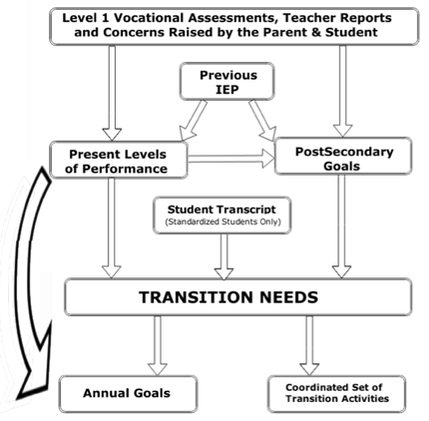

Remember: A Quality Transition-Focused IEP Is Dependent Upon
Information-Rich Level 1 Vocational Assessments!!!

The Assistant Principal’s Role in the IEP Process
- As was mentioned earlier, an AP may request that a new Annual Review be opened or current Annual Review re-opened as Amendment / Reconvene at any time, regardless of the Compliance Date.

- If the IEP Coordinator recommends that changes be made to the IEP document, but one or more team members disagree with the recommendations, they should discuss the matter with their AP. The AP will review the section(s) in question and decide if the changes have to be made or not.

- APs are also to be cc’d on all emails regarding IEPs that are coming due and are overdue.

- 754X Administrators will continue to conduct random quality assurance checks on both draft and finalized IEPs. Be sure to email you AP once the Draft IEP is complete (two weeks before the meeting & one month before the Compliance Date)
—& cc the IEP Coord.

- D75 policy is that the Periodic Assessment for Alternate students is SANDI. If you wish to supplement it with MAP, speak to your AP.

11) Physical Education Teacher’s / Yoga Teacher’s Progress Report* (Present Levels)

The Physical Education Teachers and Yoga Teacher will complete this form within SESIS itself.
*This report does not generate automatically!!! The IEP Coord. opens it manually. He does not know to open it if you have not followed the protocols outlined on page 25 or emailed him asking him to open it.

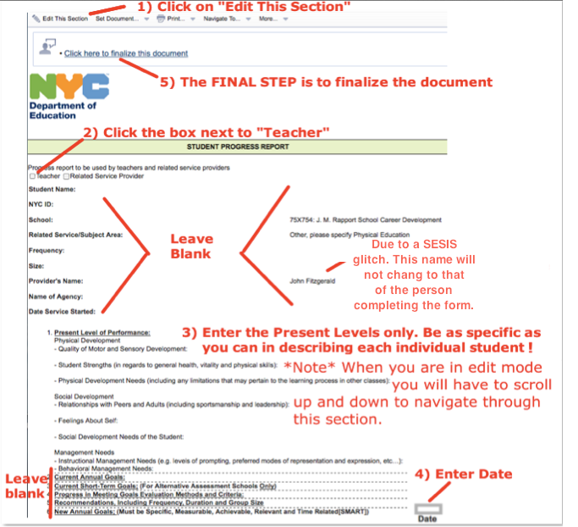
The Physical Education Teacher’s / Yoga Teacher’s Report provides the IEP Team with much valuable information not only about the students’ Levels of Physical Development, but the students’ Levels of Social / Emotional as well. Be sure to reference these reports in the Present Levels

12) Cluster Teacher’s Progress Report (Present Levels)

In most cases, Cluster Teacher Present Levels Reports are recommended but not required for Annual Review IEPs. A notable exception is when a student is being recommended for a change to a Less Restrictive Environment (LRE) or a More Restrictive Environment (MRE). When the School Assessment Team (SAT) is conducting a Mandatory Triennial, they may ask the Cluster Teachers for a Progress Report (Present Levels). Contact the IEP Coordinator for more information on how to complete this document in SESIS.

13) Related Service Provider’s Progress Report:

Any time a mandated Related Service is going to be terminated, that Related Service Provider must first complete a Progress Report in SESIS and consult with the AP and the other members of the IEP Team.

Also, when the School Assessment Team (SAT) is conducting a Mandatory Triennial, they may ask the Related Service Providers for a Progress Report. Contact the IEP Coordinator for more information on how to complete this document in SESIS.

Annual Review IEPs at 754X

Part III: Developing the Draft Annual Review

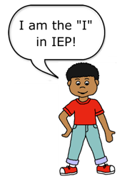

While there are few regulations regarding the order in which the sections of the IEP must be completed, the order* in which they are presented in this manual is the order most recommended.
- Cover Page (1st section of IEP) - Coordinated Set of Transition Activities (10th section)
- Present Levels of Performance (2nd section) - Reporting Progress to Parents (6th Section)
- Measureable Annual Goals (5th Section) - Particip in State & District Assment (11th section)
- Testing Accommodations (9th section) - Special Transportation/Placement (13th Section
- Compensatory Services - Twelve Month Service (8th Section)
- Participation w/ Stdnts w/o Disabilites (12th Section) - Summary Page (14th Section)
- Student Needs Related to Special Factors (3rd section) - Conference Attendance Page (15th Section)
- Recommended Special Ed. Programs/Services (7th section)
- Measurable PostSecondary Goals (4th section)

* The two exceptions to this rule of thumb are that a) Counselors must enter the student’s PostSec
Goals as soon as they have guided the student through the Level 1 Voc. and b) Teachers and all
RSPs must complete the Present Levels (and Transition Needs (Teachers)) and Annual Goals (NEW!!!)
prior to developing the rest of the IEP. This is because all programs, services, goals and activities must
be DRIVEN BY THE STUDENT’S NEEDS!

Flowchart Showing How Certain Parts of an IEP Inform Other Parts

IEP Coordinator’s Responsibilities in
Developing the Draft IEP

The IEP Coordinator is the party primarily responsible for completing the:

- Cover Page (except the date, which is entered by the Teacher/Case Manager on the day of the meeting,
just prior to printing the Conference Attendance Page).
DO NOT FILL IN DATE OF MEETING IN ADVANCE OF THE MEETING
- Student Needs Related to Special Factors page (except for a) the BIP justification which, if
needed, is completed by the Counselor and b) the sections related to devices for Speech and Hearing. )
- Reporting Progress to Parents page (by entering “November, March, June, (August if applicable)
& before new IEP is developed”)
d) 12 Month Services/Program page
e) Participation in State & District Wide-Assessment page
f) Participation w/ Students w/o Disabilities (requires Teacher / RSP elaboration)
g) Special Trans/ Placement Recommendation (Teacher must confirm the Transportation & Placement info)
h) Promotional Criteria section of the Summary Page (Teacher enters everything else)

The IEP Coordinator is responsible for notifying the Teacher, Counselor, & Asst. Principal via email that IEP Draft is open.

*NOTE* The IEP Team must review and ensure the accuracy of ALL of the above prior to the meeting, paying particular attention to: b, e, f and g.

“COMPLETE OR DELETE!”

You are not required to use the “sentence starters” that the IEP Coordinator emails you.
But if you do employ them, you must remove anything that you don’t utilize!

15) Cover Page (1st section of IEP):

The IEP Coordinator completes the Cover Page, with the exception of the Date of IEP.
After the Annual Review is held the Teacher enters the EXACT DATE that the meeting is held
NOT the date you were planning to hold it.* The date you enter here populates the date on the Summary and Conference Attendance Pages.
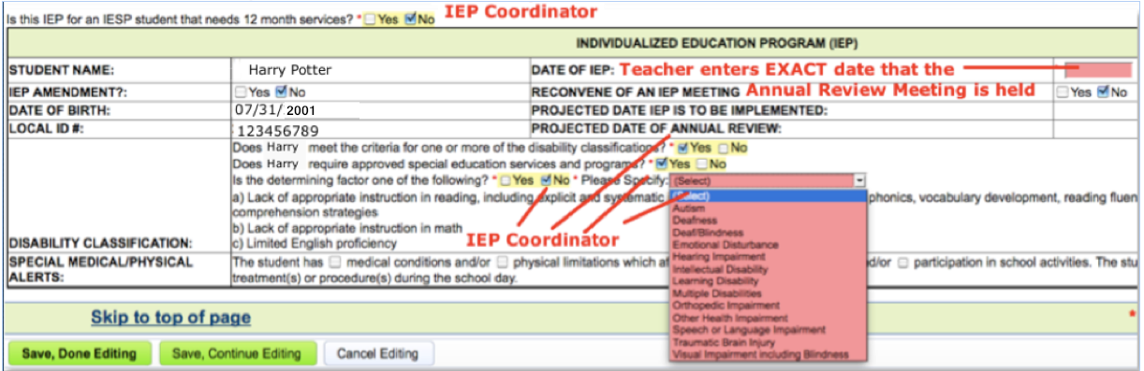

* With SESIS, or the Internet itself, being “down” always a distinct possibility, best practice dictates printing
the entire IEP (stamped DRAFT), including the Conference Attendance Page, a day or two before the meeting.
But if the date of the meeting changes be sure to update the Cover Page!

Something to think about . . .  If the Present Levels of Performance are supposed to be written thoughtfully and with great care, why would we ever want to refer to them as “The PLOP???” If we need a shorthand way to refer to them, isn’t it just as easy to say “Present Levels” or write  “Pres. Levs.?” | 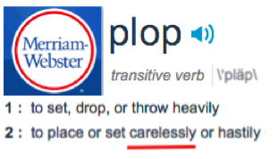

Teachers & RSPs must complete the Pres. Levels (and Transition Needs (Teachers)) prior to developing the rest of the IEP. This is because all programs, services, goals and activities must be NEEDS DRIVEN!

REMINDER: If you promise an Annual Goal or Transition Activity you must deliver on the promise in the Annual Goals or Coordinated Set!

16) Present Levels of Performance (2nd section of IEP):
The Student and Parent / Guardian the are the central members of the IEP team their voices must be prominent
in the Present Levels with statements such as: “Jaime says that…”, “ Angela’s mother reports that”, etc. Indirect
quotations are acceptable, but direct quotations are much stronger!

Responsibilities of IEP Team Members for Present Levels

Evaluation Results: information entered by the Official Class Teacher

Academic Achievement: information entered by the Official Class Teacher, with input from All Teachers on the student’s program and the Parent / Guardian and the Student.

Social Development: information entered by the Counselor, with input from All Teachers on the student’s program, other
Related Service Providers (as appropriate) and the Parent / Guardian and the Student.

Physical Development: information entered by the Teacher, with input from the P.E., Teacher, Dance Teacher, other Related Service Providers (as appropriate) and the Parent / Guardian and the Student.

Management Needs: Behavioral Management Needs are entered by Counselor and Academic Management Needs are entered by the Official Class Teacher. Additional input from All Teachers the student sees, other Related Service Providers (as appropriate) and the Parent / Guardian and the Student is encouraged.

Effect of Stud. Needs on Invlvmnt in Gen Ed Curric: suggested by IEP Coord w/ specific individualized input & examples from All Teachers who have that student in class. Be sure to document that a Gen Ed placement was considered first!

Please consider writing out all Present Levels Statements in bullet format!!!
PRESENT LEVELS OF PERFORMANCE AND INDIVIDUAL NEEDS CONSIDERATIONS

Present Level Statements should answer these questions:

- What are the student’s unique needs that result from his or her disability?

- What is it that the student can and cannot do at this time?

- What are the student’s strengths in this area?

- How do these needs affect the student’s participation and progress in the general curriculum and participation in
age-appropriate activities?

- What are the parents’ concerns for the education of their child?

- What instructional and/or behavioral supports or services have been effective or not effective in addressing the
need area in the past year?

- What accommodations and/or program modifications or supplementary aids and services have been effective or
not effective in addressing the need area in the past year?

- What instructional supports and services will likely be supported and used by the student?

Source: Guide to Quality Individualized Education Program Development and Implementation — http://www.p12.nysed.gov/specialed/publications/iepguidance.htm

PRESENT LEVELS OF PERFORMANCE AND INDIVIDUAL NEEDS STATEMENTS

QUALITY INDICATORS:

- Reflect individual-need determinations.

- Provide instructionally relevant information about the student.

- Identify how the student is progressing towards the State learning standards.

- Are descriptive and specific.

- Provide the basis for annual goals and direction for provision of appropriate educational programs and
services.

- Are written in such a way that parents, professionals and paraprofessionals can understand.

- Are based on the results of the individual evaluation.

- Reflect the priorities and concerns of the parents for the education of their child.

- Reflect transition service needs.

- Identify where the student is now functioning so it is clear what it is he/she has to learn next and what
supports and services he/she needs to get there.

- Identify what impact the student’s disability is having on his or her ability to participate and progress in
age appropriate activities or in the same curriculum as nondisabled peers.

District 75 Office of Transition Services/Adapted from the Guide to Quality Individualized Education Program (IEP) Development and Implementation http://www.p12.nysed.gov/specialed/publications/iepguidance/IEPguideDec2010.pdf

16) Present Levels of Performance (2nd Section of IEP):
16a) Evaluation Results - Official Class Teacher completes this section. Use most current information available.
For Alternate Assessment Students:
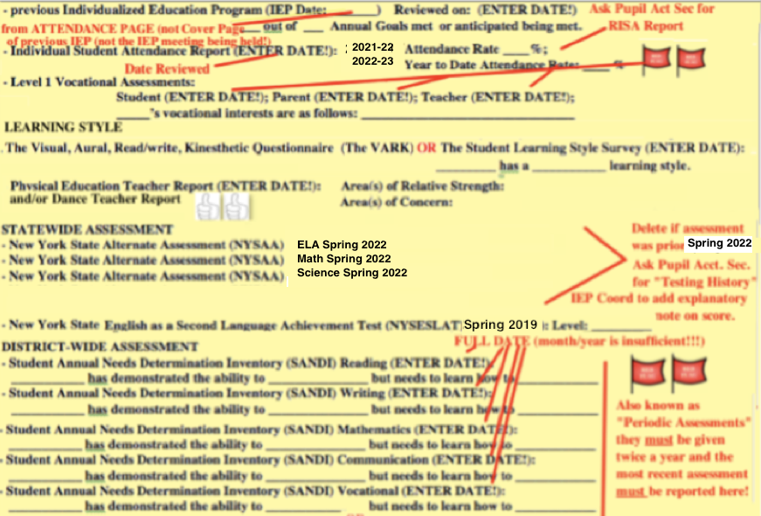

************************************************************************************************************

The last sentence of Eval Results should state something along the lines of:
Teachers on the IEP Team arrived at the grade levels reported on the Summary Page by gauging _________’s skill sets relative to the grade level benchmarks outlined in the NYS Next Generation Learning Standards.

On (DATE), an appraisal of the benchmarks __________ has met suggest a _______ grade level for Reading. On (DATE), an appraisal of the benchmarks __________ has met suggest a _______ grade level for Mathematics.
16) Present Levels of Performance (2nd Section of IEP):
16a) Evaluation Results - Official Class Teacher completes this section. Use most current information available.
Alternate Assessment Students (CONTINUED):Reporting NYSAA Scores for Alt. Assessment Students:
Alternate teachers should ask the Pupil Accounting Secretary (Ms. Vargas) for a Testing History. If Spring 2023 NYSAA scores are available they should be reported in the Eval Results along with the following explanations as appropriate:

Once the NYSAA Scores from Spring 2023 are available, the IEP Compliance Team will upload them in SESIS.
The IEP Compliance Team also will report student performance on NYSAA in the Evaluation Results.
If the student did not take NYSAA in Spring 2023, or scores are not yet available, be sure to DELETE the sentence starters that refer to it!
NYSAA Eligibility (from https://www.p12.nysed.gov/specialed/publications/documents/2019-nysaa-policy-brief.pdf)
How is a student determined eligible to participate in NYSAA?
The committee on special education (CSE) is responsible for determining whether a student is eligible to participate in NYSAA. At each annual review meeting, the CSE must determine on an individual basis whether the student will participate in:
the State’s general assessment with or without accommodations; the State’s alternate assessment with or without accommodations; or a combination of the State’s general assessment for some content areas and the State’s alternate assessment for other content areas. The CSE must ensure that decisions regarding participation in the State testing program are not based exclusively on category of disability, language differences, excessive or extended absences, cultural or environmental factors, previous low academic achievement, or previous need for accommodations to participate in State or district-wide assessments. Only students with severe cognitive disabilities are eligible for the NYSAA.
The CSE must determine annually whether a student with a severe cognitive disability is eligible to take the NYSAA based on the following criteria: the student has a severe cognitive disability and significant deficits in communication/language and significant deficits in adaptive behavior; AND the student requires a highly specialized educational program that facilitates the acquisition, application, and transfer of skills across natural environments (home, school, community, and/or workplace); AND the student requires educational support systems, such as assistive technology, personal care services, health/medical services, or behavioral intervention.
What do parents need to know about their child’s participation in NYSAA?
if the CSE determines that a student will participate in NYSAA, the student’s parents must be clearly informed that their child’s performance will be measured based on alternate achievement standards that are reduced in depth, breadth and complexity and do not meet the expectations necessary to earn a regular high school diploma (i.e., local or Regents diploma) in NYS. In addition, parents must be informed that in order to earn a diploma in NYS, students must earn required course credits and take required Regents examinations and that their child will not be able to earn a NYS high school diploma if they continue to participate in NYSAA in one or more subjects in high school. See Page 92.
16) Present Levels of Performance (2nd Section of IEP):
16a) Evaluation Results - Official Class Teacher completes this section. Use the most current information available.
For Standardized Assessment Students:
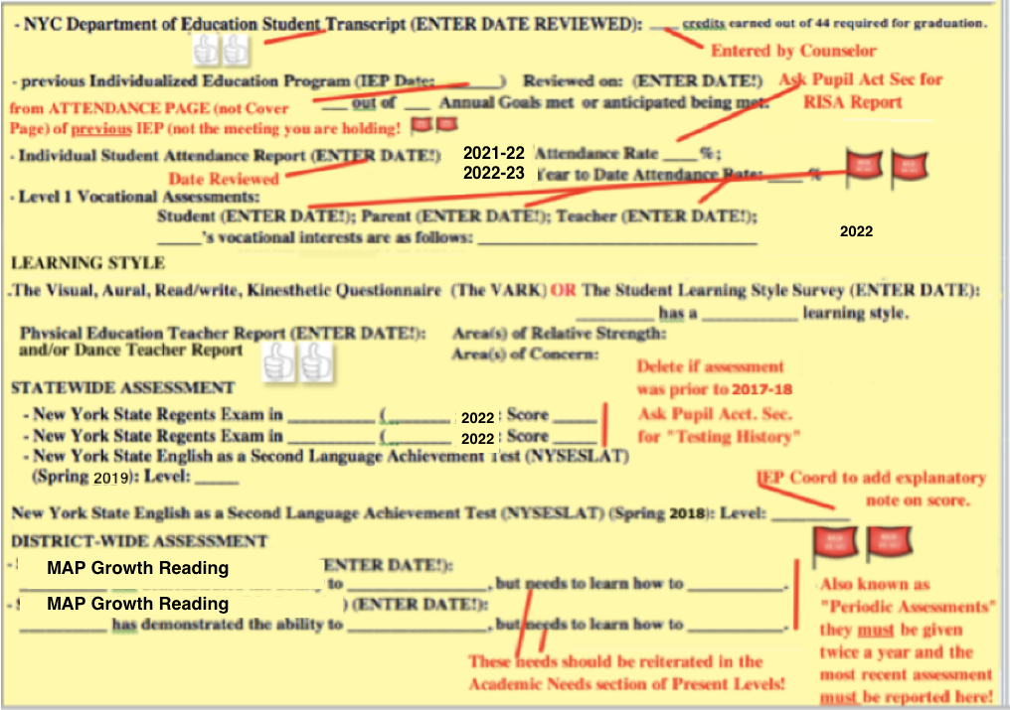
************************************************************************************************************
The last sentence of Eval Results should state something along the lines of:
Teachers on the IEP Team arrived at the grade levels reported on the Summary Page by extrapolating from the results of ________’s MAP Growth assessment. On (DATE), ________’s results on MAP Growth suggested a ___ grade level in Reading. On (DATE), ________’s results on MAP Growth suggested a __ grade level in Mathematics.
OR
Teachers on the IEP Team arrived at the grade levels reported on the Summary Page by gauging _________’s skills sets relative to the grade level benchmarks outlined in the NYS Next Generation Learning Standards.

On (DATE), an appraisal of the benchmarks __________ has met suggest a _______ grade level for Reading. On (DATE), an appraisal of the benchmarks __________ has met suggest a _______ grade level for Mathematics.
16) Present Levels of Performance (2nd Section of IEP) (cont.):
16b.1) Academic Achievement, Functional Performance and Learning Characteristics: Levels of Knowledge
and Development in Subject and Skill Areas – Official Class Teacher, with Other Teachers input as
requested, completes this section.
- To make the IEP document easier for the students (when possible), parents and your colleagues on the IEP Team to read we are
continuing to recommend use of a bullet format of presentation in the Present Levels.
- The IEP Coordinator will email sentence starters.
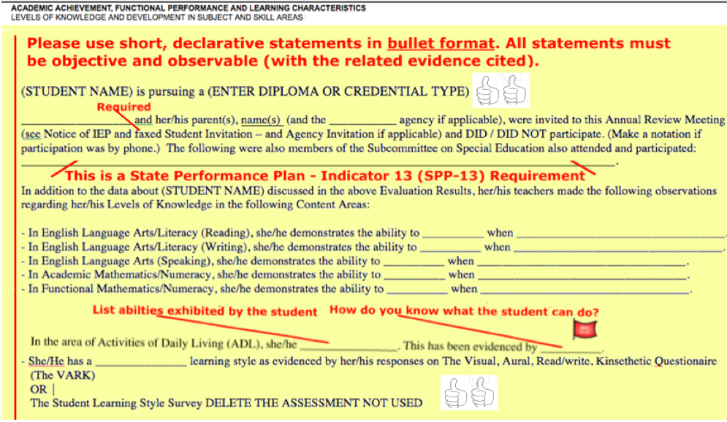
COMPLETE OR DELETE!
- - - - - - - - - - - - - - - - - - - - - - - - - - - - - - - - - - - - - - - - - - - - - - - - - - - - - - - - -
NEW After the list of the names and roles of the people who attended the IEP Meeting, there should be statement indicating that primary foci of the IEP are 1) progress and participation in the General Education Curriculum and 2) transition to postsecondary education/training, employment and independent living.

16) Present Levels of Performance (2nd Section of IEP) (cont.):

NEW
STUDENT SELF-DESCRIBED CRITERIA FOR SUCCESS
The first sentence in Eval Results should be a statement about how the student defines future success for herself or himself. For example: “In the future, I will feel successful when _____________________________.”

NEW
CRITERIA FOR MOVE TO LESS RESTRICTIVE ENVIRONMENT (LRE)
The Academic Achievement and Social Development sections of the Present Levels should contain list of
of individually developed criteria that a student must meet in order to move to a Less Restrictive Environment for the following categories of students:
- Students with an 8:1:1 ratio
- Students with a 1:1 Behavior Support Paraprofessional
- Standardized students 17 years of age or older
- Any student that staff feel could be ready for an LRE in the next school year.

NEW
WHEN A STUDENT’S HOME LANGUAGE IS A LANGUAGE OTHER THAN ENGLISH
When a student’s Home Language is a language other than English, the Present Levels must contain
specific statements about the student’s abilities to understand and use that Home Language! As per the NYCDOE IEP Survey:
- “the IEP requires information about both the student’s home language as well as English . . . The Present Levels must include specific and detailed information about a student’s reading (and writing, speaking?) skills in both their home language and English.”
- The Present Levels should include “statements regarding the student’s use of their home language(s) and current state of English language acquisition.”
- The Present Levels should include “input from bilingual/ENL teachers and/or clinicians.” Input can also be solicited from paraprofessionals that speak that language as well as from the student’s parent(s)/family.

16) Present Levels of Performance (2nd Section of IEP) (cont.):
16b.2) Student Strengths, Preferences and Interests – Official Class Teacher completes this section,
with relevant input from Other Teachers and the Related Service Providers as needed.
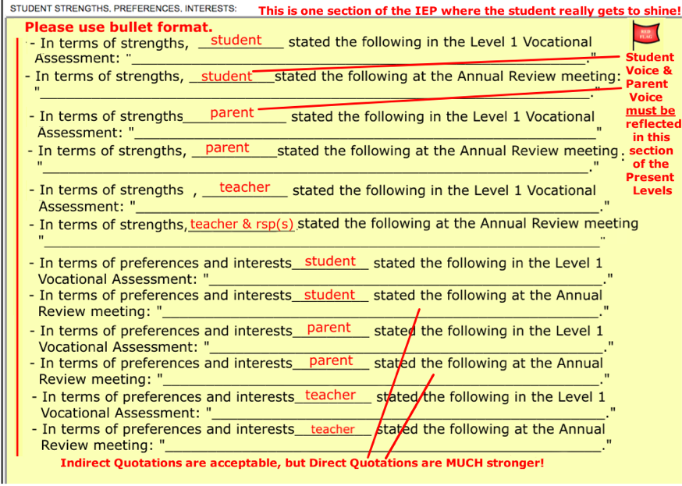
COMPLETE OR DELETE!

AND REMEMBER! All Teacher and Related Service Provider statements must be objective and must cite concrete examples!

16) Present Levels of Performance (2nd Section of IEP) (cont.):

16b.3) Academic, Developmental & Functional NEEDS of the Student –
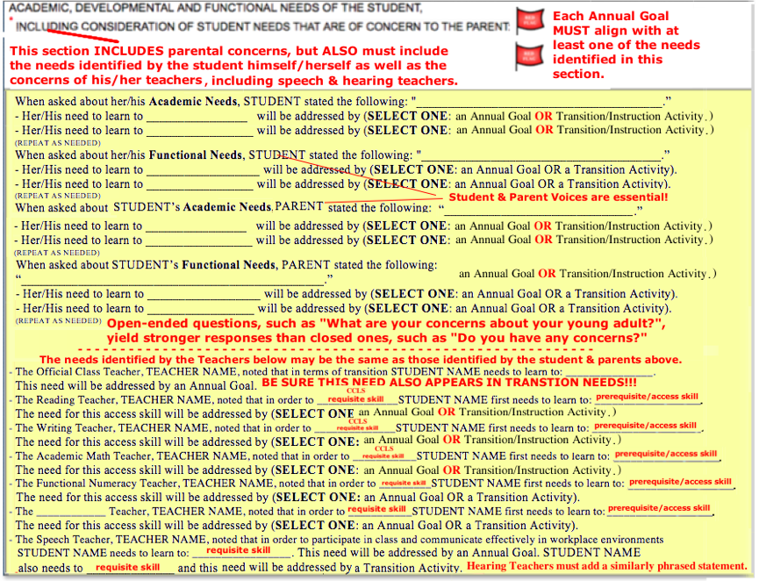

COMPLETE OR DELETE!

SEE NEXT PAGE FOR ENLARGEMENT

Enlargement of Detail from Previous Page
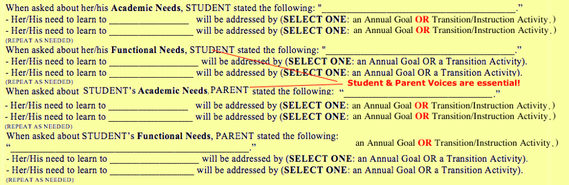
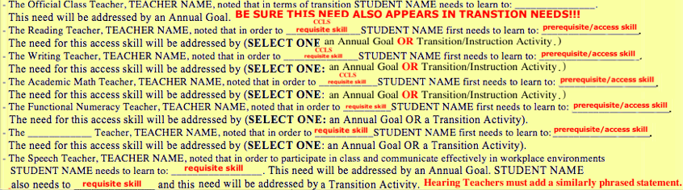

16) Present Levels of Performance: (cont.)

16d) Social Development:
The Counselor will take the lead on developing this section, with input from the Teachers, other
Related Service Providers and Parents.

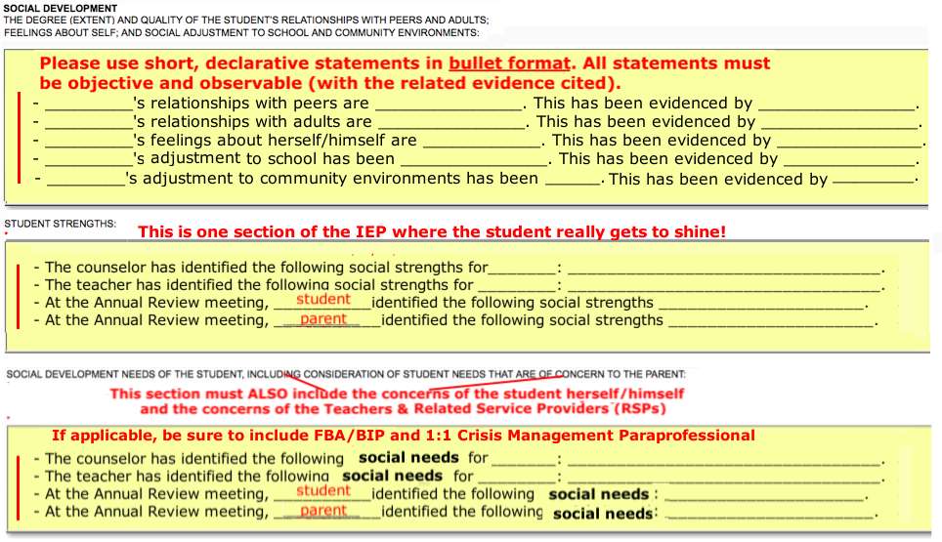

“COMPLETE OR DELETE!”

16) Present Levels of Performance: (cont.)
16e) Physical Development:
The Teacher should reference the “Physical Education and Dance Teacher Present Levels Report”
(see page 32) that has been entered into SESIS when completing this section. If the
student is seen by an Occupational Therapist or Physical Therapist, these Related Service Providers
will add to this section. If the student is seen by the School Nurse (e.g. for medication, blood pressure
check, etc.), the Teacher should consult with him or her.
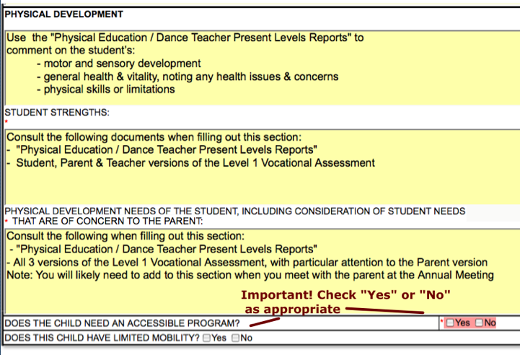

16) Present Levels of Performance: (cont.)
16f) Management Needs: These “Needs” are NOT the things that the student must learn/master (those are
covered earlier in the Academic, Developmental and Functional Needs of the Student and Social
Development Needs of the Student). For this section, it is useful to think of “Needs” as the “Supports”
that staff must provide for the student to be successful at this time.

The Counselor and Teacher should collaborate on this section. Do not write N/A or leave blank!
Be sure to address both Behavioral (Counselor) and Academic (Teacher) Management Needs.

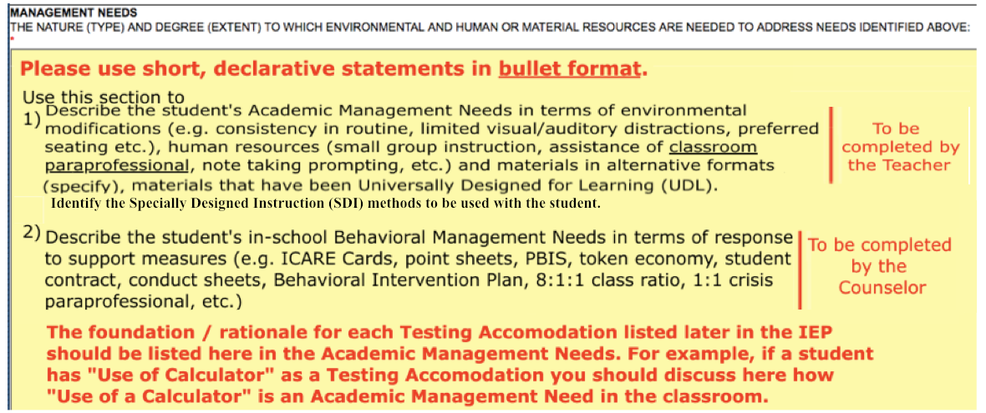
See page 93 for more information on alignment between Management Needs and Testing Accommodations!

*NEW* The Academic Management Needs section requires a statement indicating that Assistive Technology (AT) was considered for the student and a statement as to why AT is, or is not, being recommended for the student.

16) Present Levels of Performance: (cont.)
16g) Effect of Student Needs on Involvement and Progress in the General Education Curriculum.
*Notes* - General Education MUST be considered for EVERY student even though, in most cases
at our school, it will most likely be rejected. A reason for that rejection must be given.
- The Teacher is responsible for individualizing “The Effect Statement”
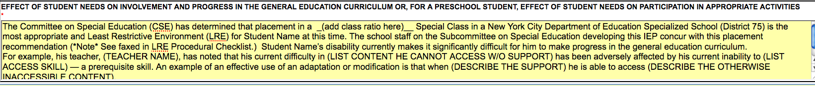
Additional Comment for Students with Related Services:
The Related Service of ___will support the student in accessing, progressing and participating in the Gen Ed curriculum by: ________
The Related Service of ___will support the student in accessing, progressing and participating in the Gen Ed curriculum by: ________
The Related Service of ___will support the student in accessing, progressing and participating in the Gen Ed curriculum by: ________

Additional Comment for Alternate Students:
Additional Comment for Standardized Students:
Do not use any of the above statements for SETSS students, instead use:

- Considering Gen Ed - “The Effect Statement” on the Present Levels page must note that General Education was considered and state why it was (presumably) rejected as a placement. In the Other Options Considered section of the Summary Page select at least three of the options offered including: General Education (required), at least one other placement less restrictive than the placement recommended in the IEP and at least one other placement more restrictive than the placement recommended in the IEP.
16) Present Levels of Performance: (cont.)
16h) Least Restrictive Environment: Procedural Checklist:
The Teacher/District Rep must complete and sign this document after the team has completed the Present
Levels but before* you complete the Recommended Special Education Programs and Services page. In
our school (with the exception of SETSS students) the answer to question 1 will always be “No”, thus
requiring that Section B be completed for all (non-SETSS) students. This form must be scanned and uploaded
into SESIS as a Document Related to IEP.

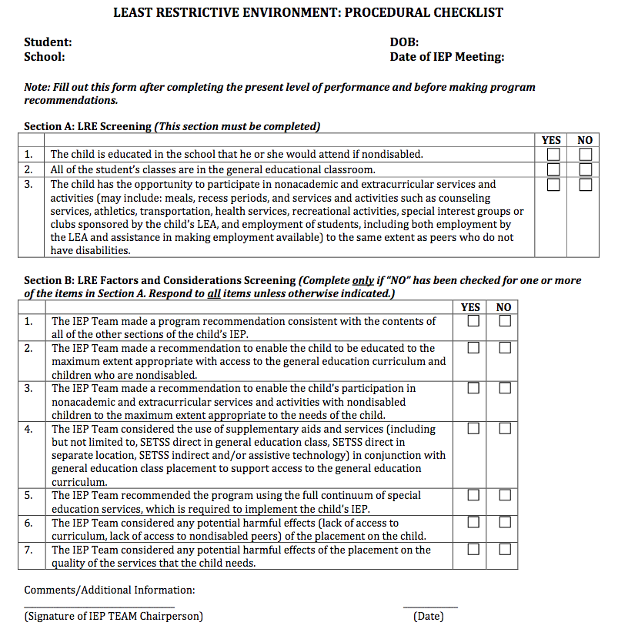
* As phrasing of statements in Section B seem to contradict this requirement, best practice is to review this form and make the proper adjustments before scanning and uploading into SESIS.

SAMPLE PRESENT LEVEL OF PERFORMANCE STATEMENTS

When you complete the student’s present level of performance and individual need section
of an IEP, you should be able to state: The student’s unique needs that require the student’s educational program to be individualized: We are individualizing this student’s education program because of his unique needs related to his disability in the areas of . . . . (e.g., reading, writing, organization, memory, vision, hearing, problem solving, attention, motor skills).

What the student can and cannot do in each area of identified need: In the area of ___________, we know this student can currently _____________, but cannot ______________. (e.g., in the area of memory, he can remember a two-step sequence, but does not complete activities that involve multiple steps such as "get ready for school.)

The strengths of the student are upon which you can build : He learns best through _____________________ (e.g., pairing auditory with written work; using music to trigger memory; redirection; modeling).

The areas of concern the parents have raised about their child's needs: (e.g., He becomes upset and cries at home when he has to do writing assignments; he is not showing at home any of the language skills teachers report he has achieved in school; he has tantrums in the community).

The environmental, human or material resources the student will need to enable him/her to
benefit from education: (e.g., He will need structure and routine throughout his instructional day; close supervision during transitions; assistance with note taking; adaptive furniture for motor support; instructional materials in large print formats; a positive reward system for appropriate behavior).

How the disability affects involvement and progress in the general curriculum, or for
preschool students, how the disability affects participation in age appropriate activities: The present levels of performance must include a description of how a student’s disability affects the student’s involvement in the general curriculum.

District 75 Office of Transition Services/Adapted from the Guide to Quality Individualized Education Program (IEP) Development and Implementation http://www.p12.nysed.gov/specialed/publications/iepguidance/IEPguideDec2010.pdf

17) Student Needs Relating to Special Factors (3rd Section of IEP):

17a) The IEP Coordinator will complete this section except for the parts related to FBAs & BIPs.
The IEP Coordinator will confirm the ESL status of ELL students and will log an Event in
SESIS if there is a discrepancy between the IEP and the student’s SESIS profile.

17b) The Counselor enters all information related to FBAs & BIPS.

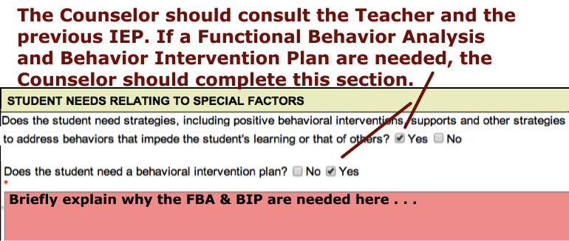

17c) The Speech Teacher and Hearing Teacher are responsible for checking the boxes for communication
devices and assistive technology devices for those students who need them.

A Word on FBAs, BIPs and 1:1 Behavior Support Paraprofessionals…

While all students with a 1:1 Behavior Support Paraprofessionals MUST have a Functional Behavior Analysis
(FBA) and Behavior Intervention Plan (BIP), the converse is not necessarily true. Students without 1:1 Crisis
Paras can, and in many cases should, have an FBA and BIP. In fact, the expectation is that an FBA be given
and BIP enacted well before considering something as restrictive as a 1:1 Para. When an FBA/BIP is being
considered for a student for the first time, it is important to first consult the IEP Coordinator and the SAT
School Psychologist as the FBA is an assessment and requires parental consent.

18) A) Measurable Annual Goals (5th Section of IEP):

Keep In Mind . . .

Relation of Annual Goals to the Standards: The IEP annual goals do not list everything a student is expected to learn in a year and are not a substitute for the general education curriculum. The IEP therefore, is not intended to identify content area goals. Instead, annual goals are linked to the learning standards established for all students by reflecting the foundation skills* and/or strategies the student requires to master the content of the curriculum and meet standards established for all students. They focus on offsetting or reducing the learning or behavioral problems resulting from the student’s disability so that the student can access and progress in the general education curriculum or alternate performance indicators**. The IEP Team must also write goals that address the student’s individual needs, including needs not necessarily related to the general education curriculum such as behavior and transition, where appropriate.
~The Standard Operating Procedures Manual (Feb. 2009)~
*(e.g. reading, writing, listening, computation, etc.)
** Subsequently replaced by the Next Generation Learning Standards

Don’t Forget . . .

All Annual Goals must be written as SMART goals:
Specific  Measurable  Achievable  Relevant  Time-bound* | Annual Goals should describe exactly what the students will do (e.g., “will decode”, “will write”, “will multiply”, etc. ) Avoid broad and vague expressions (e.g., "will improve", "will increase", "will decrease").  Annual Goals should describe the student’s action as observable and reportable (with tangible evidence).  Annual Goals should express the high expectations we have for our students, yet they must also be realistic considering the students’ Present Levels  Annual Goals should be contextualized, to the greatest extent possible, in relation to the Post-secondary Goals / Transition Needs, with particular attention paid to concerns expressed by the students and their parents.  Annual Goals address a student’s current needs and progress is measured on a regular basis.

* While we no longer write “Within one year,” a one year time frame is implied in the term Annual Goal. Also, there is a timeframe
embedded in the criteria and schedule aspects of the goal.
18) Measurable Annual Goals (cont.):
18a.1) For ALL students:
Each student must, at minimum, have:
1 Literacy-based goal (Aligned w/ Need(s) outlined in Present Levels; developed by ELA and/or* Social Studies
Teacher(s) in consultation with all other Teachers; progress measured and reported to Parents
formally by ELA and/or Social Studies Teachers, and informally by all others)

1 Numeracy-based goal (Aligned w/ Need(s) outlined in Present Levels; developed by Math and/or* Science Teachers
in consultation with all other Teachers; progress measured and reported to Parents formally
by Math and/or Science Teachers, and informally by all others)

* Clarification: Presumably, when the Official Class Teacher is also the ELA or Social Studies Teacher, s/he will take primary responsibility for
the Literacy-based goal. Likewise, when the Official Class Teacher is also the Math or Science Teacher, s/he will take primary responsibility
for the Numeracy-based goal. Primary responsibility for the other goal(s) should be decided at team meetings. If the team cannot reach an
agreement on this, the Official Class Teacher should consult with the AP via email, cc-ing the school team members and the IEP Coordinator.

1 Transition Skills goal (Aligned w/ Need(s) outlined in Present Levels and Transition Needs; developed by Official Class
Teacher in consultation with all other teachers; measured by Student Conferencing and
Transition teachers formally, and informally by all others)
A Transition Goal is required for both Alternate and Standardized Students

1 Related Service goal for each service received (Developed, measured and progress reported to parents by RSPs)

REMINDER 1 Replacement Behavior Goal if the student has a BIP. It must be separate from the Counseling
Goal and should be a restatement of the Replacement Behavior from
the BIP/FBA.

18a.2) Additional Annual Goals may be required depending on Academy / Cluster requirements or parent /
student request.
CLARIFICATION:
Annual Goals for Alternately Assessed students SHOULD be linked to needs identified by the SANDI Assessment. However, the SANDI Item # SHOULD NOT appear in the goal.

HAVE YOU INDENTIFIED YOUR STUDENT’S SPECIFIC NEEDS IN THE PRESENT LEVELS
BEFORE YOU START WRITING
THE ANNUAL GOALS???

18) Measurable Annual Goals (cont.): 18b) Adding Annual Goals
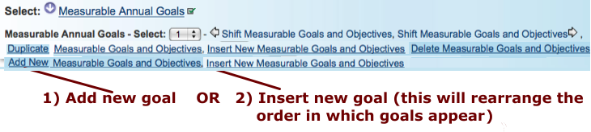

For Alternately Assessed Students: DO NOT LIST SANDI ITEM NUMBERS IN THE GOAL!

18c) Entering Annual Goal Details
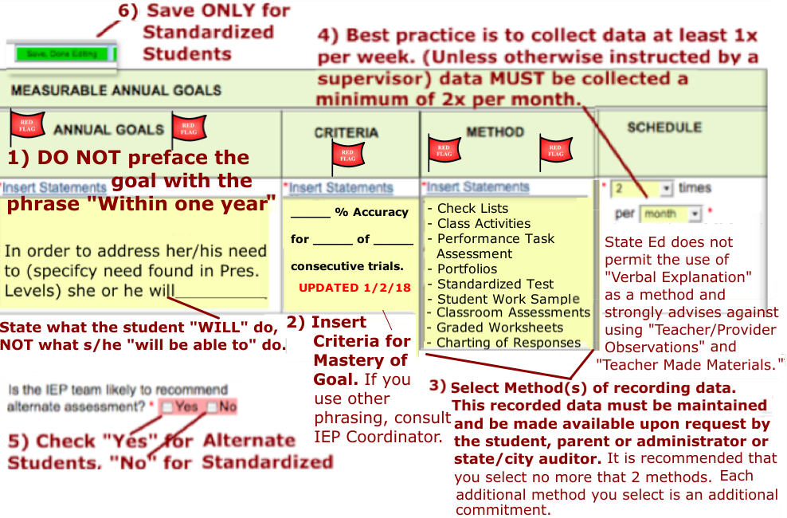

Reminder on “Method”: State Ed prohibits the use of “Verbal Explanation” and strongly discourages the use of “Teacher Provider Observations” and “Teacher Made Materials.” Use “Class Activities” with caution and only with the approval of your AP!

Criteria: The criteria for mastery of the Annual Goal must be expressed both in terms of “How well does the student need to perform?” (usually expressed as a percentage) AND “How often does the student have to perform that well?” / “How many times does the student have to perform that well?” Criterion like “80% accuracy for 4 of 5 consecutive trials” are seen frequently. But note that the “How well?” component need not “equal” the “How often?/How many times?” component. For example, criterion like “75% accuracy for 4 of 5 consecutive trials” or “90% accuracy for 3 of 5 consecutive trials” are completely legitimate! The criteria is set by the Teacher’s or Related Service Provider’s professional discretion.

Note: The criteria for goals related to safety, such as street crossing or turning on a stove, must be set
for 100% accuracy.

A Best Practice…
It is highly recommended that you make development of your data collection tools part of your goal writing process. It will help you determine if the goal your write is truly measurable!!!
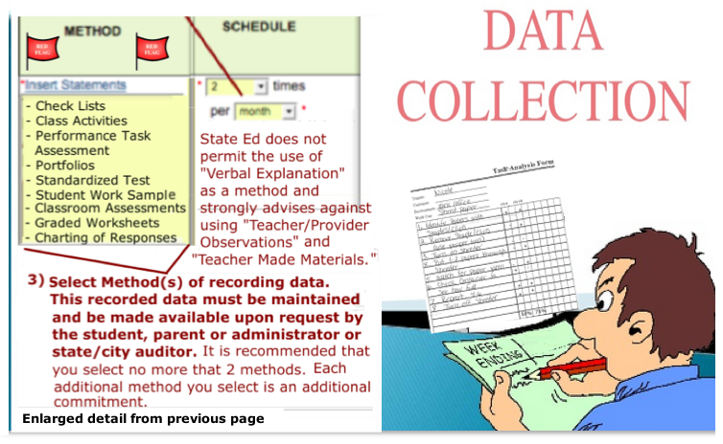

*** If your student transfers to another class, either during or at the end of the school year, ***
be sure to pass your data collection tools on to the next teacher!
Have your data readily available to share with administrators or monitors/auditors.

Notes on Data Collection Methods
Teacher Made Materials | What do these look like? Are we talking about worksheets? A rubric must be included for evaluation of the student’s performance.
Standardized Test | Problematic given how rarely they are given. Consult w/ AP before selecting this option.
Class Activities | Teacher must create a clear description of the class activity and  maintain clear documentation of the students repeated performance of the activity.
Portfolio | A collection of the student’s work with evaluative commentary on the student’s performance. The portfolio must be prefaced with a statement of the Annual Goal.
Teacher/Provider Observations | How will the Observations be documented? State Ed discourages selection of this method. Consult w/ AP before selecting this option
Performance Assessment Task | A tangible product must be repeatedly produced by the student and evaluation documented by the Teacher.
Check Lists | A breakdown of the goal into its component parts. Depending on the nature of the goal, this may be your best option for a data collection  tool.
Verbal Explanation | Not permitted by State Ed!

You must collect data via every method listed. Therefore, it is highly advised that you select
only one or data collection methods.

18) Measurable Annual Goals (cont.):

18d) Adding Short Term Objectives (STOs) (for Alternate Assessment students only)

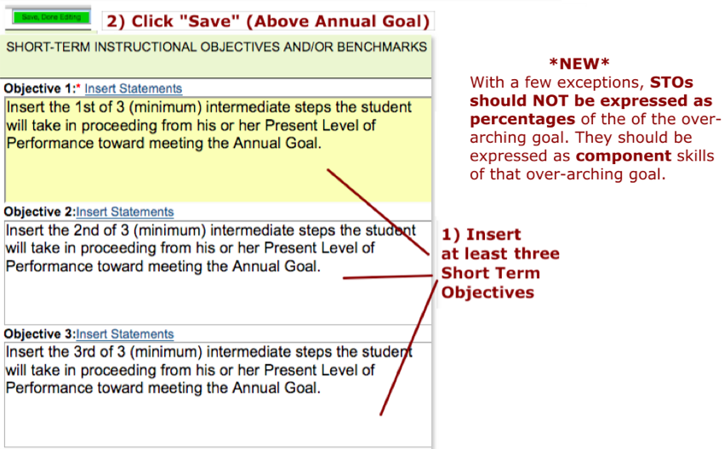

Note on STOs: STOs typically address sub-skills of the larger skill being addressed by the Annual Goal. STOs should be developed by breaking down the larger skill into its component parts. For the most part, this should not be done by creating STOs expressed as percentage of accuracy*.
- On the rare occasion when using percentages is the only option (e.g. an Attendance Goal), you must consult with your AP via email and cc the IEP Coordinator.
Remember . . .

- Annual Goals are needs-driven & each one must clearly address a need identified in the Present Levels*.

- Annual Goals should be individualized and contextualized to incorporate student interests and preferences particularly in relation to the student’s PostSec Goals.

*IMPORTANT CLARIFICATION: In many cases, in the Present Levels, we phrase the student’s needs on two levels: an “end goal” of sorts and a prerequisite/access skill that the student must first master in order to move towards achieving that “end goal.” The Annual Goal you develop should address the prerequisite access skill, NOT the end goal skill!

For example, in Maribel’s Present Levels, it states: Maribel needs to learn how to add coins,
but first she must learn the monetary values of pennies, nickels, dimes & quarters.

The Annual Goal for Numeracy should NOT be “Mabel will determine the sum of 2 US coins.”

The Annual Goal should be something like “Maribel will identify the value of major US coins
less than one dollar.”
IF Maribel is an Alternate Assessment student, the Short Term Objectives (STOs) could be:
STO 1: When given a penny and asked its value, Maribel will say “1 cent.”
STO 2: When given a nickel and asked its value, Maribel will say “5 cents.”
STO 3: When given a dime and asked its value, Maribel will say “10 cents.”
STO 4: When given a quarter and asked its value, Maribel will say “25 cents.”
Recommended Resources for Writing Annual Goals
- The Redmond, Oregon Goal Bank (NYCDOE endorsed. Note that many of the “Goals” might work better as Short Term Objectives)
http://schools.nyc.gov/NR/rdonlyres/CDCCA68D-2E5D-465A-B139-129573EB7683/0/iepgoalbank.pdf
- The Illinois Goal Bank (not NYCDOE endorsed, but still worth a look): http://thegoalbank.com/

What Annual Goals Are . . . and What They Are Not

Annual Goals:

- ARE individualized for a given student  - ARE based on Student Needs identified in the Present  Levels.  - ARE developed to promote skills that allow students to  access the general education curriculum (i.e.  Next Generation Learning Standards)  - ARE specific in terms of the access skills to be mastered | - ARE NOT identical to those of other students  - ARE NOT based on: “This is what I am teaching  this year.”  - ARE NOT a verbatim transcription of, nor the  rephrasing of, the Standards  - ARE NOT specific about academic content

Challenges to the Goal Writer:

a) How do you provide individualized goals for students with seemingly identical needs?
A novel way to do this (and one with respect to student voice!) is to contextualize the Annual Goals in
terms of the students personal strengths and interests, as expressed in the Level One Vocational Assessment, in
the student’s PostSecondary Goals and at the IEP Conference itself.

b) How do you develop Annual Goals that, on one hand are Standards-based, but at the same time are not a
restatement of the Standards and are not specific about academic content?
A basic rule for writing Annual Goals is that they must be designed so as to give our students the tools to access
the curriculum. We need to ask: What are the student’s needs that have thus far hindered that access?
Annual Goals should develop the Prerequisite or Foundational Skills that the student can utilize
and build upon so as to engage with the curriculum meaningfully.

18) Measurable Annual Goals (cont.):

Note: Please substitute Next Generation Learning Standards whenever you see Common Core Learning Standards (CCLS).
Standards-Based IEPs from Special Education Field Advisory (June 2014)
James P. DeLorenzo. Assistant Commissioner, New York State Education Department Office of Special Education.

To develop IEPs that are aligned to the standards (sometimes called “Standards-based IEPs), the CSE should take the following steps:

1. Review the content (i.e., the expectations for what the student will learn) as well as how the student will be expected to demonstrate his/her knowledge and skills in the content areas.

2. Identify the strengths and challenges for the student in relation to those expectations in the present levels of performance section of the IEP.

3. Identify how a student’s needs are linked to the general curriculum. Identify areas that will have the greatest impact on the student’s progress in the curriculum (e.g., a student's difficulty with visual processing may affect graphing skills required to achieve the math standards).

4. Unpack the standards and identify the goals that the student will be expected to achieve in one year and, when appropriate, short
-term instructional objectives or benchmarks that are the intermediate steps to reach those annual goals. Standard-based goals do not mean that goals and objectives in a student’s IEP are a restatement of a standard or a curriculum goal in a specific content area, but rather they are statements that reflect the necessary learning that will lead to attainment of the standards. Goals should be chosen to accelerate a student’s ability to progress in the general education curriculum.

5. Identify the special education services, including the adaptations, accommodations, or modifications to the general curriculum, and/or instructional environment and materials, as needed by the student to reach those standards. The State’s Next Genertion Learning Standards (CCLS), available at http://www.nysed.gov/next-generation-learning-standards, are statements of what students are expected to know or be able to do in each content area (such as reading, math) and at each grade level. The Career Development and Occupational Studies (CDOS) Learning Standards (http://www.p12.nysed.gov/cte/cdlearn/) are statements of what students are expected to know or be able to do in the areas of career development, universal foundation skills, integrated learning and career areas.

Standards-based IEP goals are not simply restatements of the standards; rather, standards-based annual goals identify the essential skills and knowledge that a student with a disability needs to acquire in order to master grade-level content standards.

Choose Your Verbs Carefully!

Nothing can render a Measurable Annual Goal immeasurable quicker than the selection of unobservable verbs like: “enjoy”, “know”, “understand”, “comprehend”, “grasp”, etc. Also to be avoided are broad and vague expressions like: "will improve", "will increase", "will decrease" (unless followed by a “ ‘by’ statement” specifying the measurement technique.). It is much better to use observable verbs, such as the ones found in Bloom’s Taxonomy and Webb’s Depth of Knowledge:

see subsequent pages for enlargements

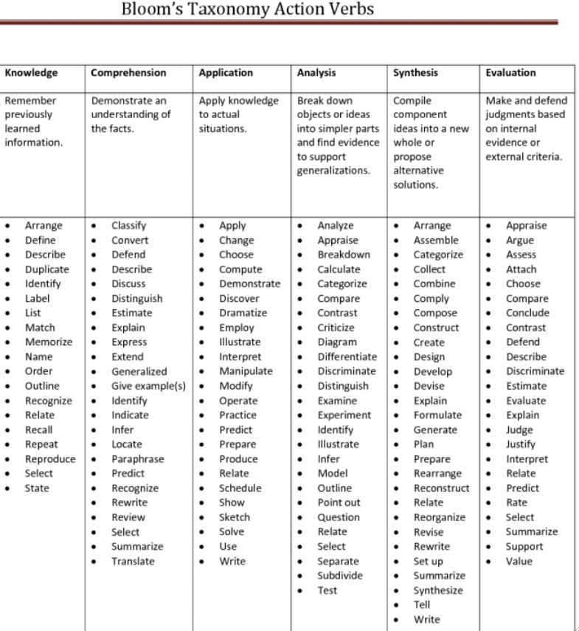 | 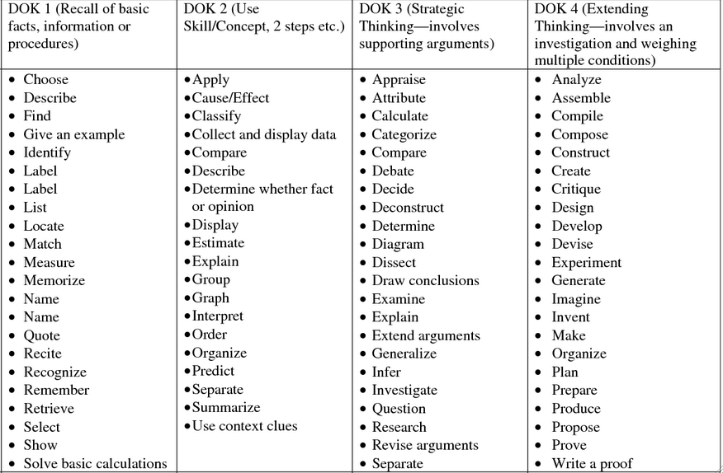

Note: Goals utilizing some of the verbs listed above, such as “identify”, will not be measureable if they don’t include a “ ‘by’ statement.” For example. if the goal is for Joshua to identify kitchen utensils you might want to write something like: “Joshua will identify kitchen utensils by pointing to 3 kitchen utensils in a set that includes 6 non-kitchen utensils.
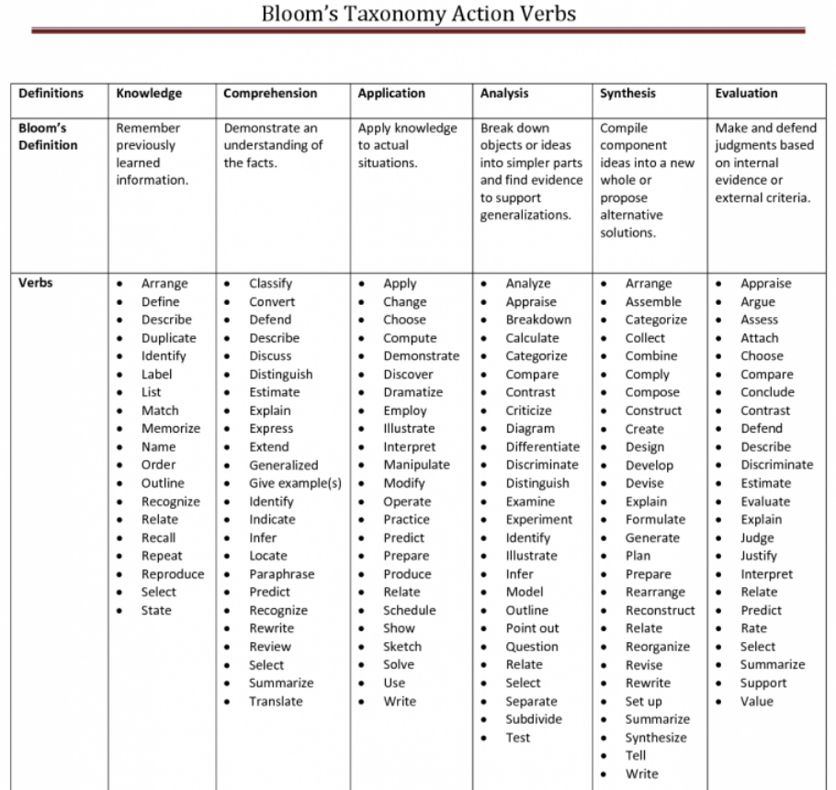

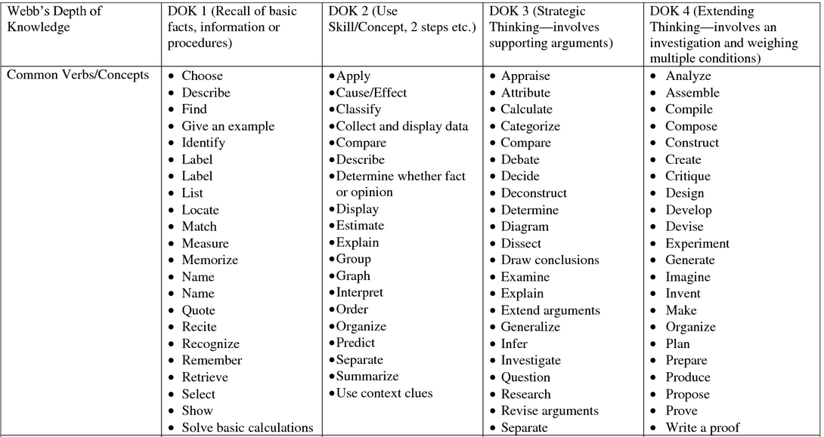

***Annual Goals related to learning new vocabulary must list the words to be learned.***

19) Recommended Special Education Programs/Services (7th Section of IEP):
REMINDER: All Staff developing an IEP are required to review the students previous IEP before working on the new Annual Review. Be sure to double check the Recommended Special Education Programs/Services in that previous IEP before entering information here. Remember, in the Evaluation section of the Present Levels you are stating that you have done this!

In the past many services have been accidentally dropped because
the Recommended Special Ed Program & Service
on the previous IEP was not referenced!!!

19) Recommended Special Education Program/Services (cont.)
Teachers are to enter the Special Education Program. Counselors, Speech Teachers, Occupational (OT) and
Physical Therapists (PT) are to enter their own mandates. If the site does not have an OT or PT provider, remind the IEP Coordinator to enter the mandate.

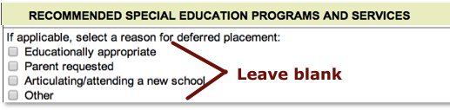

19a) Service Delivery Recommendations, Location and Projected Beginning Date(s)

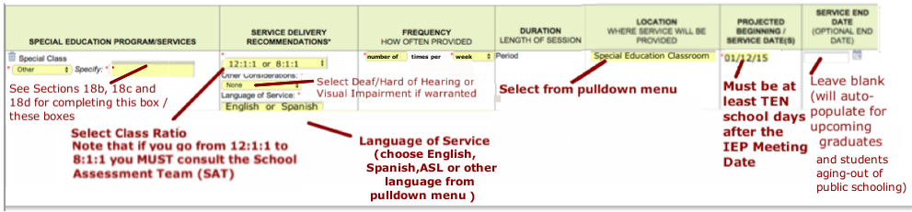
19b) Procedures for Completing the Recommended Special Education Program Page
The ONLY Classes to Be Listed in the Recommended Program Are:
- English Language Arts (ELA) (Note: Language of Service for ELA must always be English. )
- Mathematics (Math)
- Science
- Social Studies
- Career Development – 29 periods a week for Out-of-Building Worksite students
– 24 periods a week for In-House Worksite students
– 1 period a week for all other Alternate Students
- Home Language Arts – for students in 582 & 583.

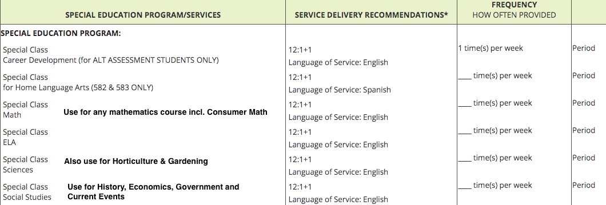

19c-d) Special Education Program for Worksites

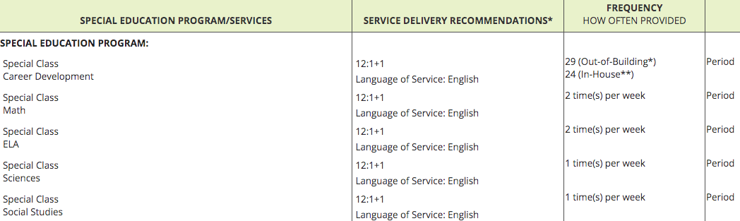

Work-Based Learning (WBL) is no longer an option in SESIS:
* Worksite Students placed out in the community are recommended to have 29 periods of
Career Development.
** Worksite Students whose vocational experience takes place at the Main Site or the Bronxwood
campus are recommended to have 24 periods of Career Development.

Reminder: Be sure to add Social Studies 1 period a week for all Worksite students!

***A SPECIAL NOTE ON BEHAVIOR SUPPORT PARAPROFESSIONALS***
A 1:1 Behavior Support Paraprofessional is an exceptionally restrictive mandate. It is a last resort measure of intervention and we may not consider or suggest one outside of the following process*:
1. FBA consideration form
2. If warranted by the form, an FBA
3. If warranted by the FBA, BIP with no para
4. If BIP fails to work, new BIP, with 1:1 only if no other options exist
*the process should never be initiated with the end goal of a 1:1 in mind.

19) Recommended Special Education Programs/Services (cont.)
*Reminder* An “internal” and “external” FBA & BIP are both required for students with Behavior Management Paras.

19e) Adding /Continuing a 1:1 Behavior Support Paraprofessional (If Para being added for first time it must be done as a Re-Eval) If a student requires a 1:1 Behavior Support Paraprofessional, the Counselor will enter the following information
19f.1) 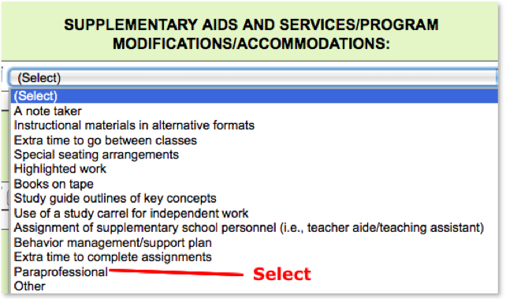 19f.2) 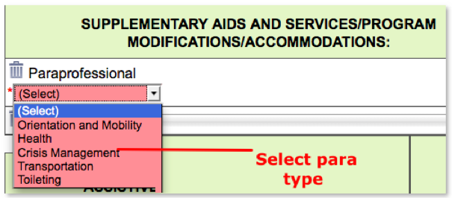

19f.3) 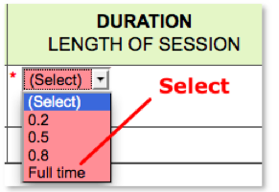 19f.4) 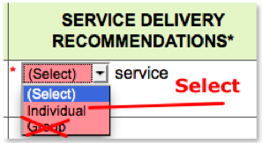 19f.5) 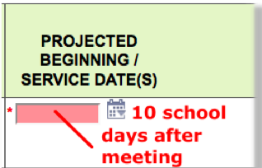
19f.6) At the top of the page:
19) Recommended Special Education Programs/Services (cont.)

19g) Adding / Continuing a 1:1 Health Paraprofessional (If Para being added for first time it must be done as a Re-Eval)
If a student requires a 1:1 Health Paraprofessional the Teacher will enter the following information:

19g.1) 19g.2) 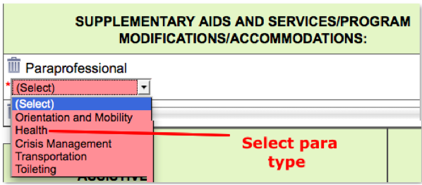

19g.3)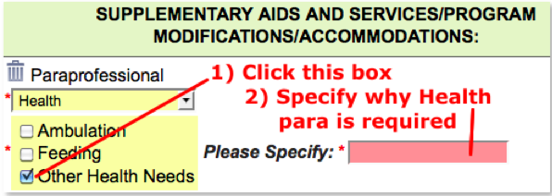 19g.4) 19g.5) 19g.6)

19g.7) At the top of the page:

*Note* A doctor’s note verifying that the student still requires a 1:1 Health Para
should be uploaded into SESIS each year.

***Going forward all 1:1 paraprofessionals will be entered as .8 in the Recommended Services.***
19) Recommended Special Education Programs/Services (cont.)
….. 19h) Transportation Paraprofessionals are no longer added on the Recommended Program page.
If the student requires a Transportation Paraprofessional as per their last finalized IEP, let the IEP
Coordinator know when you complete the Request to Open Draft IEP form and he will attend to
making sure it is on the new IEP.

…….. Reminder: All students with a Behavior Support Para (and/or Bus Para for behavior support) must have
an FBA/BIP. All students with a Health Para (and/or Bus Para for health reasons) must have a current
doctor’s prescription. Submit all prescriptions to the IEP Coordinator for scanning. (Do not drop a Bus
Para from the IEP without discussing it with the IEP Coordinator). Note that there is a new HIPAA form.
Please inform the parents that they must provide a signed copy to their doctor and to the school.

Suggestion: If you know that the student is slated to receive a service that requires a doctor’s prescription
(e.g. health paraprofessional, special transportation accommodations, barrier-free school, etc.), remind the
parent / guardian of this when you set up the Annual Review conference so that they arrange for a doctor’s
visit prior to the meeting.

For questions regarding adding Supplementary Aids and Services/Programs Modifications/Accommodations or Assistive Technology Devices, please contact the IEP Coordinator.

At 754X, in addition to Classroom Paraprofessionals, we offer the following types of 1:1Paraprofessionals when needed:
- Crisis Intervention - Health
- Transportation - Alternate Placement (Language)*

Note that the NYCDOE does not offer 1:1 Paraprofessionals for Academic Support! If you are having difficulty differentiating instruction for a specific student, consult with your Assistant Principal.
* If the language of service (instruction) is Spanish, a Spanish speaking classroom paraprofessional
can act in this capacity. For other languages, speak with your AP, IEP Coordinator, Unit Coordinator or SAT.
19) Recommended Special Education Programs/Services (cont.)
19 i) Parent Training and Counseling:

This service is a bit of a misnomer as there is no Counseling component.
It is strictly a training opportunity for parents.

Parent Training and Counseling is available to all parents but is specifically available for parents of students with Autism AND students in classes with an 8:1+1 ratio. This training opportunity must appear on those students’
IEPs.

20) Measurable PostSecondary Goals (4th Section of the IEP):
Definition: Postsecondary Goals are “generally understood to refer to those goals that a child hopes to achieve after leaving secondary
school (i.e. high school)" rather than "the process* of pursuing or moving toward a desired outcome."
~ The National Secondary Transition Technical Assistance Center ~

* The “process” referred to here is addressed in the Coordinated Set of Transition Activities and Annual Goals.
20a) The Counselor is responsible for reviewing the Student, Parent (if available*) and Teacher Level 1 Voc Assessments before completing this section. As so much of what the other IEP Team members need to do is dependent upon what is entered here, the PostSec Goals must be completed no later than 1 week after being notified that the IEP draft has been opened. Please use the exact introductory phrases shown below.
*Parent Lev. 1 may not be available this early in the process. Be sure to incorporate parent input here at the Annual Review.

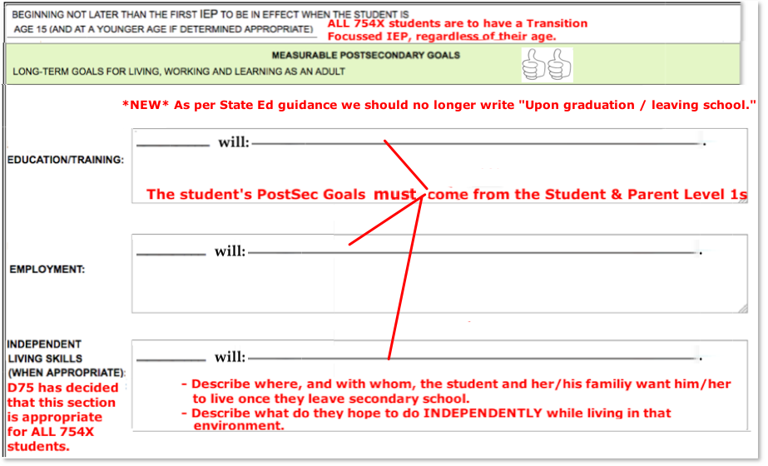
As a rule of thumb, the younger the student, the broader the PostSec Goals can be. With each new Annual Review / Tri, the expectation is that the goals become more specific. For example at age 15, Isabel’s goal is: “to attend a 2 year college”; at age 17: “to attend a 2 year college out-of-state”; at age 19: “to attain an Associate’s Degree in Culinary Arts at an out-of-state school.”
PLEASE BE ADVISED: If an IEP you helped develop is selected for SPP-13 Review, the Reviewers/Auditors will be looking at the Level Vocational Assessments (especially the one completed by the student) and the IEP Meeting Notes you are expected to keep. (see pages 101-102) to verify that the PostSec Goals etc. match the student’s desires!

20) Measurable PostSecondary Goals (cont.): Transition Needs
***The PostSec Goals & Transition Needs are at the heart of any Transition Focused IEP.***
20b) Once the Counselor has entered the PostSecondary Goals, the Teacher should develop a list of
Transition Needs that identify the gaps between what the student is currently able to do (outlined in the
Present Levels) and what s/he would like to be doing once they leave secondary school (i.e. the PostSec
Goals).

Even if a student’s dreams, hopes and aspirations (as stated PostSec goals and Level 1 Vocational) are
seemingly unrealistic, our obligation is to come up with a list of Transition Needs, that if met, would bring
that student as close as possible to the actualization of those goals.

The Transition Needs section of the IEP is a major part of the IEP that informs both the Annual Goals and the Coordinated Set of Transition Activities.

If the IEP Team cannot identify a substantial list of Transition Needs then the team must give extra consideration to the idea of the student moving to a Less Restrictive Environment (LRE) and the team must document those considerations in the Present Levels and on the Summary Page

If a LRE is rejected, the reasons why should be converted into
Transition Needs. That is, what are the students current “needs”
that prevent “transitioning” to a LRE?

19) Measurable PostSecondary Goals (cont.): Transition Needs
The Teacher is responsible for completing this section. For Standardized students, the Counselor adds
information related to credits earned and credits needed. The Counselor and other Related Service Providers
are encouraged to provide insights into the students Transition Needs list.

19c) 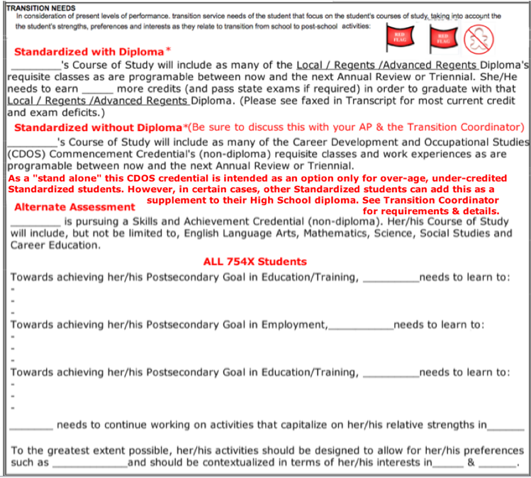
The Related Service of ___________will support the student in the Transition to PostSec Ed/Training, Employment and Indep Liv by:_______________________________________________________________________________________________________.
***Linkage of Transition Needs with the Rest of IEP***
1) Go back to Present Levels. Confirm that EACH Transition Need has been raised as a “Concern of” the student, the parent, or staff.
2) The Transition Needs listed here should be directly linked to the Coordinated Set of Transition Activities (Pages 86-90)
3) One of these Transition Needs must also be addressed as a Transition Annual Goal for Alternate Students (optional for Standardized)
REMINDER: If you promise an Annual Goal or Transition Activity you must deliver on the promise in the Annual Goals or Coordinated Set!

POSTSEC GOALS SAMPLE FOR A STANDARDIZED STUDENT
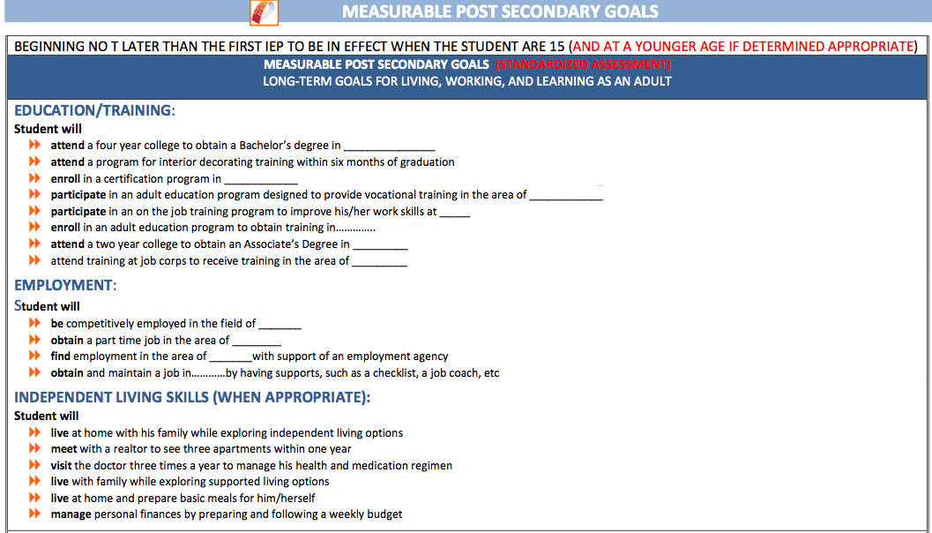“Beginning not later than the first IEP to be in effect when the student is 15” MEANS that this is required if the student has already turned 14 at the time of the meeting.”
School policy is that ALL students at 754X require Transition Focused IEPs.

TRANSITION NEEDS SAMPLE FOR A STANDARDIZED STUDENT
(Below the PostSecondary Goals)

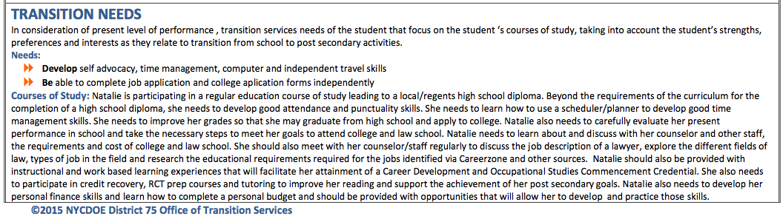

POSTSEC GOALS & TRANSITION NEEDS SAMPLE FOR AN ALTERNATE STUDENT
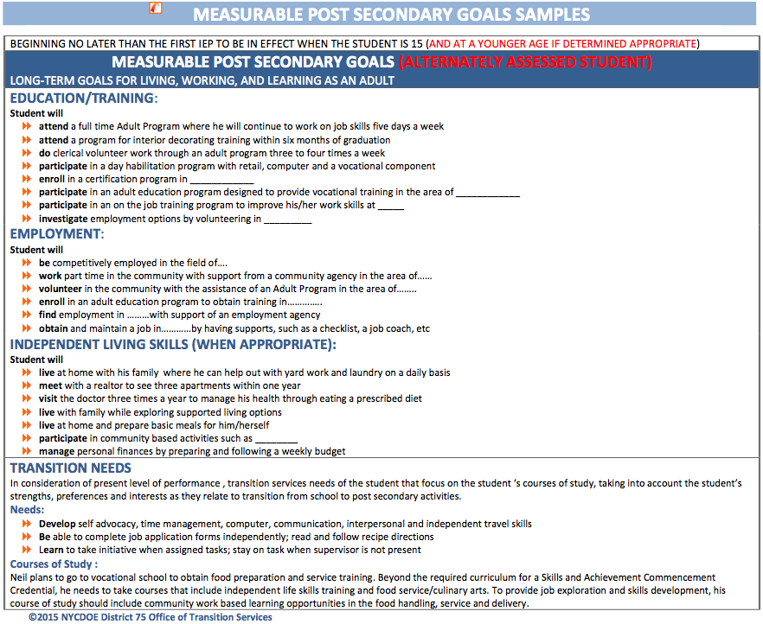
“Beginning not later than the first IEP to be in effect when the student is 15” MEANS that this is required if the student has already turned 14 at the time of the meeting.”
School policy is that ALL students at 754X require Transition Focused IEPs.

20) Coordinated Set of Transition Activities (10th Section of the IEP):

The Coordinated Set of Transition Activities for Instruction may supplement Annual Goals
but should not be identical to Annual Goals.

Teachers are responsible for entering one or more Transition Activities for each of the following: Instruction,
Community Experiences, Development of Employment and Acquisition of Daily Living Skills.
Counselors & Related Service Providers are responsible for entering one or more Transition Activities for: Related
Services must enter at least one Transition Activity for: Related Services
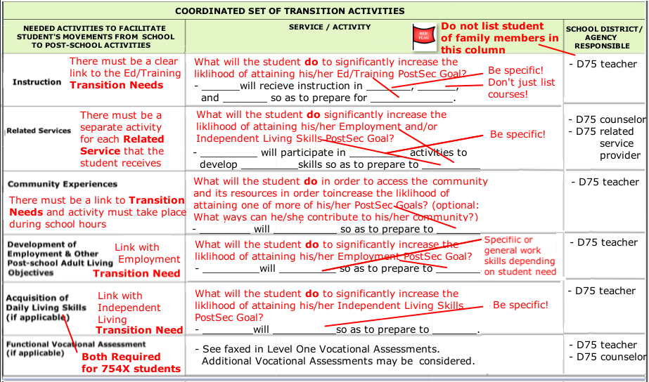
*Self-Check*
- Is every Transition Activity on this page directly linked to a Transition Need identified on the PostSec Goals page?
- Is each Student Need on the Present Levels, not addressed by an Annual Goal, addressed by a Transition Activity?
(Remember: On the Present Levels you likely flagged many “Needs” stating they would be addressed by Trans Activities.)

COORDINATED SET OF TRANSITION ACTIVITIES SAMPLE FOR A STANDARDIZED STUDENT
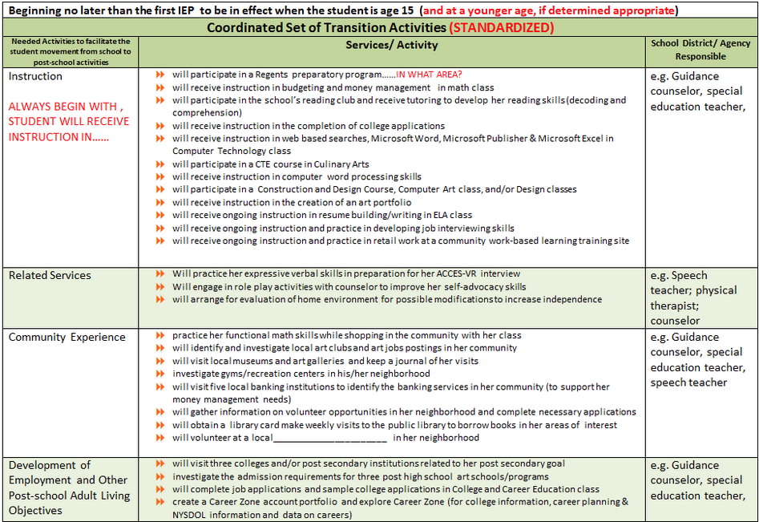

COORDINATED SET OF TRANSITION ACTIVITIES SAMPLE FOR A STANDARDIZED STUDENT (CONT.)
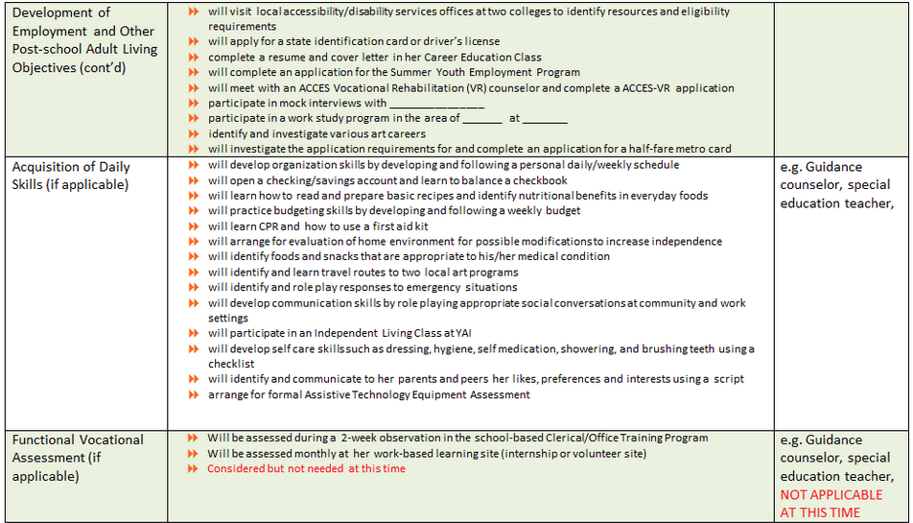
Keep In Mind : The transition to postsecondary school life begins the day our students enroll in our school! Some students will transition to college, some to a training program and others directly to a career. Each and every student on our roster is considered a “Transition Student” and her or his IEP must reflect this!

COORDINATED SET OF TRANSITION ACTIVITIES SAMPLE FOR AN ALTERNATE STUDENT
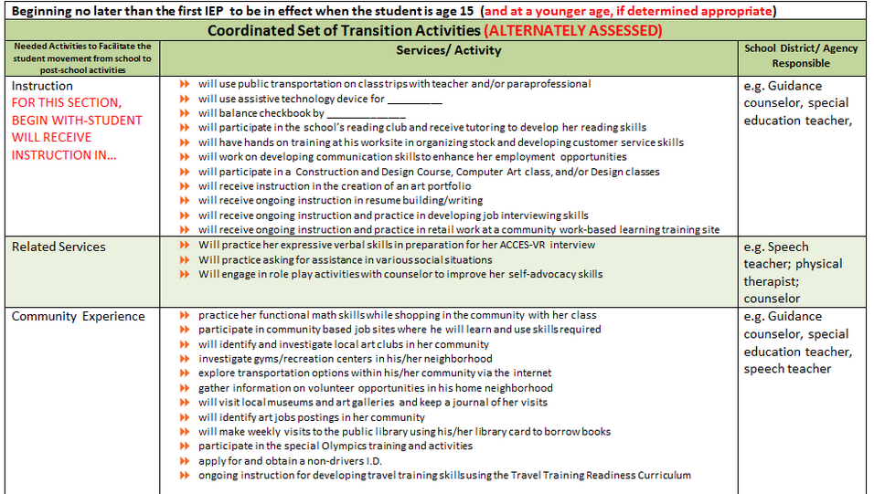

COORDINATED SET OF TRANSITION ACTIVITIES SAMPLE FOR AN ALTERNATE STUDENT (CONT.)

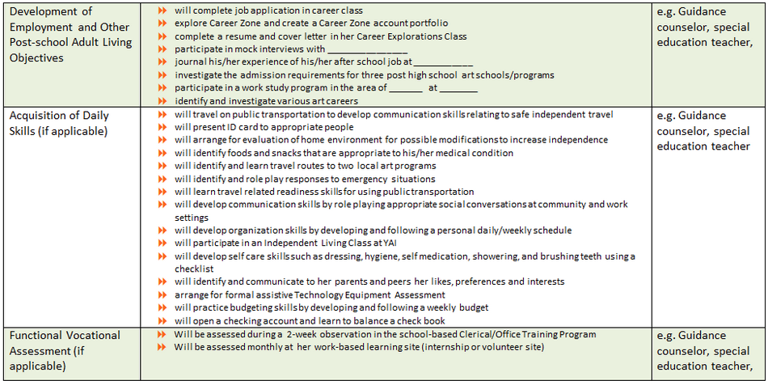
Keep In Mind : The transition to postsecondary school life begins the day our students enroll in our school! Some students will transition to college, some to a training program and others directly to a career. Each and every student on our roster is considered a “Transition Student” and her or his IEP must reflect this!

21) Participate in State and District-wide Assessments (11th Section of the IEP):
21a) The IEP Coordinator will complete this section. It needs to be reviewed by the entire IEP Team prior
…. to and during the Annual Review meeting. The IEP Team must inform the parents / guardians of
Alternate Assessment Students that their young adults are on track to receive a NYS Skills and
Achievement Commencement Credential and NOT a regular high school diploma (see bottom of page
for more information). The same conversation must be had with the parents / guardians of Standardized
Assessment students who are “over-age and under-credited” and who are pursuing the “stand alone”
… NYS Career Development and Occupational Studies (CDOS) Credential.
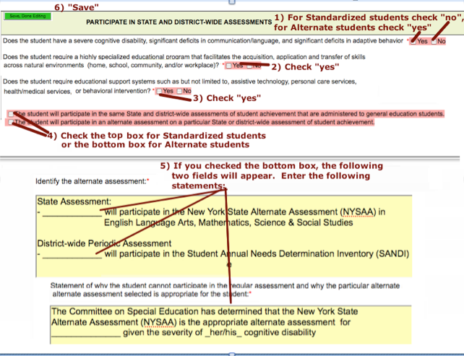
NOTE: Periodic Assessments (i.e. SANDI for Alternate Students and MAP Growth for Standardized Students) MUST be administered a minimum of TWO TIMES per school year. MAP Growth can be used to supplement SANDI scores for Alternate students. MAP may not be used in lieu of SANDI for Alternate student. SANDI should never be administered to Standardized Students.
21b) ***RETURN OF FORMER POLICY*** The following documents must again be used to facilitate the conversation that must be had with the parents of Alternately Assessed students to the effect that the Skills and Achievement Commencement Credential is NOT a high school diploma nor it’s equivalent.
- New York State Alternate Assessment (NYSAA) Participation Decision-Making Checklist
- Parent Notification of Participation in the New York State Alternate Assessment / Notice of Eligibility for Skills and Achievement Commencement Credential
The parents must sign each document. The Parents keep a copy & a copy gets uploaded into SESIS

21c) For students pursuing a Skills and Achievement Commencement Credential (Alternate Assessment
Students) the IEP Coordinator will add the following statement: The Committee on Special Education
has determined that the severity of the student’s disability precludes participation in regular assessment
and that NYSAA is the most appropriate alternate assessment for this student at this time. The student is
pursuing a Skills and Achievement Commencement Credential (non-diploma). This must be clearly
……….. re-articulated to the parent at the Annual Review every year. Standardized students pursuing a . ..
stand-alone Career Development and Occupational Studies (CDOS) Certificate and their parents must
also understand that a CDOS Certificate is not a diploma.
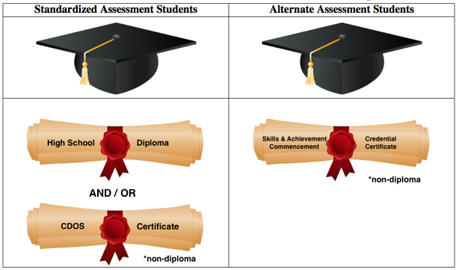
*NOTE* Speak with your AP and the IEP Coordinator before adding any new Testing Accommodations.

22) Testing Accommodations (9th Section of IEP) :

The Teacher completes this section after reviewing the Testing Accommodations on the previous IEP, consulting with All Teachers currently working with the student and reviewing the Academic Management Needs section of the Present Levels in this Draft IEP.

EACH TESTING ACCOMMONDATIONS MUST BE LINKED TO AN ACADMEIC MANAGEMENT NEED LISTED IN THE PRESENT LEVELS!!!

… It is highly recommended that all students, both Standardized and Alternate, have at least some Testing
Accommodations. If none of the suggested accommodations apply, reconsider recommending that the student
move to a Less Restrictive Environment (LRE).

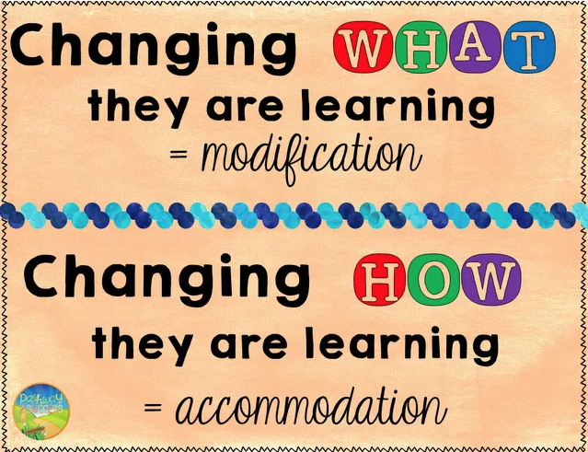
Reminder: If an Alternate Assessment student requires an accommodation of Test Read Aloud – Human, it needs to be documented in the Testing Accommodations and Academic Management Needs.

IMPORTANT REMINDER: Testing accommodations should not be provided for the first time during a State assessment. Students should have experience in using the recommended testing accommodations during instruction and classroom. (SOPM, pp. 68-69)
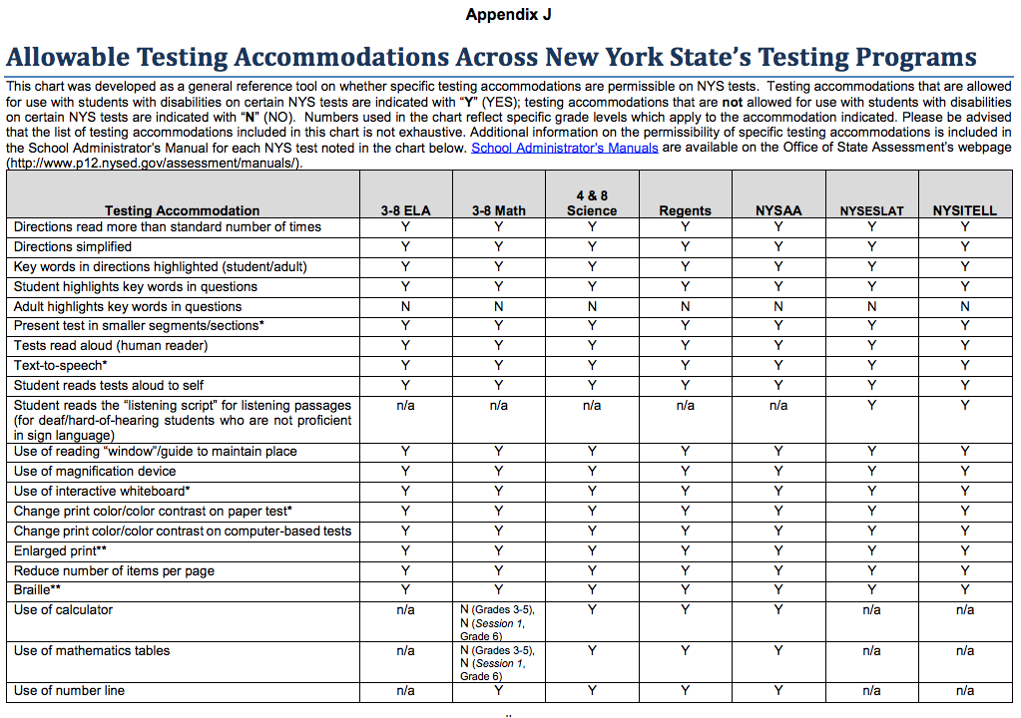
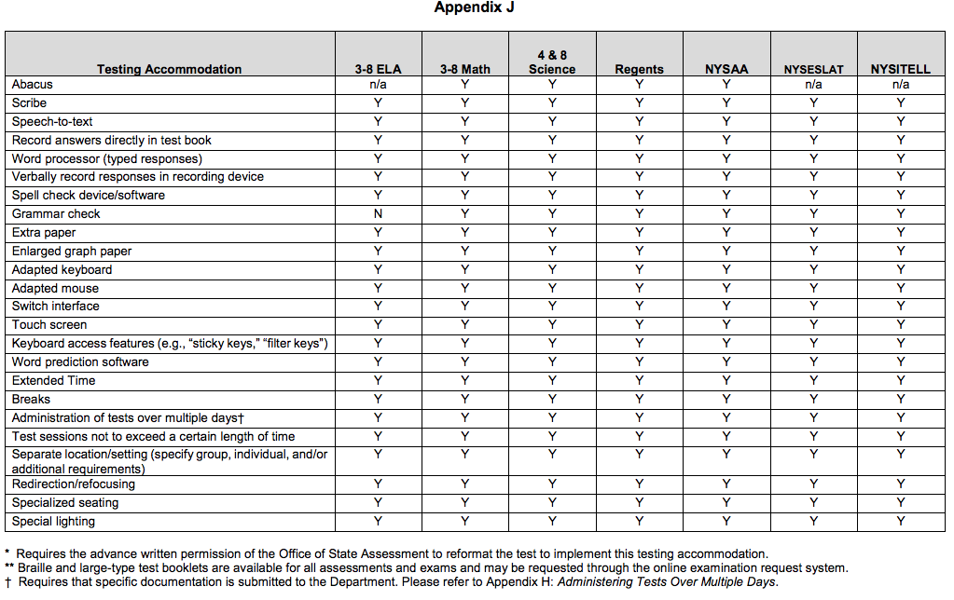

Please be reminded that the scribing accommodation is not merely dictation! Before adding a scribe, you must consult with your AP and make yourself familiar with the detailed regulations that guide this accommodation.

23) Reporting Progress to Parents (6th Section of IEP) :
The IEP Coordinator is responsible for entering this information in the IEP.
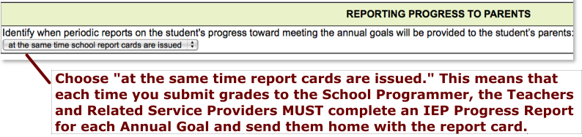

Reminder: Every time a Report Card is sent home, Teachers & Related Service Providers must generate a Progress Report for each Annual Goal for which progress was measured. Submit Progress Reports to the Assistant Principal’s designee by the same date that Report Card grades are due. See pp. 112-115 for details on generating Progress Reports.

.. … *IMPORTANT NOTE*: “Closing Out the Annual Goals”

DO NOT proceed with the development of an IEP until you have ensured that the Literacy, Numeracy, and Transition Teachers and RSPs in your cluster have indicated “Goal Met” OR “Do not anticipate meeting goal” on the IEP Progress Report for EVERY GOAL on the current (i.e. last finalized) IEP! (“Anticipate meeting goal” is NOT sufficient.”)

Some staff have suggested that we call this process “Closing Out the Annual Goals.” Please make sure that you “close out the Annual Goals” before you start developing the new IEP.

24) Participation with Students without Disabilities (12th section of IEP):
The IEP Coordinator is responsible for initially entering this information in the IEP.
***The Teachers and Related Service Providers should elaborate***
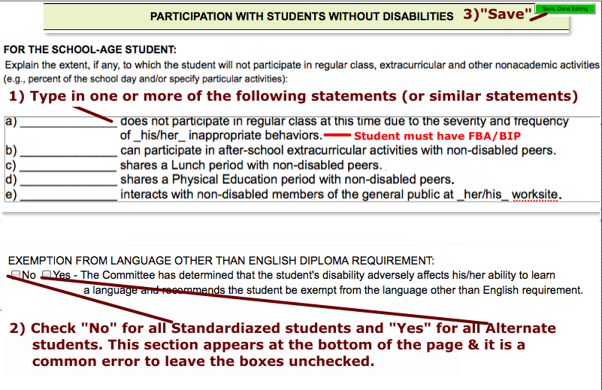

25) Special Transportation/Placement Recommendation (13th section of IEP )
The Teacher and the IEP Coordinator have shared responsibility for entering this information in the IEP.
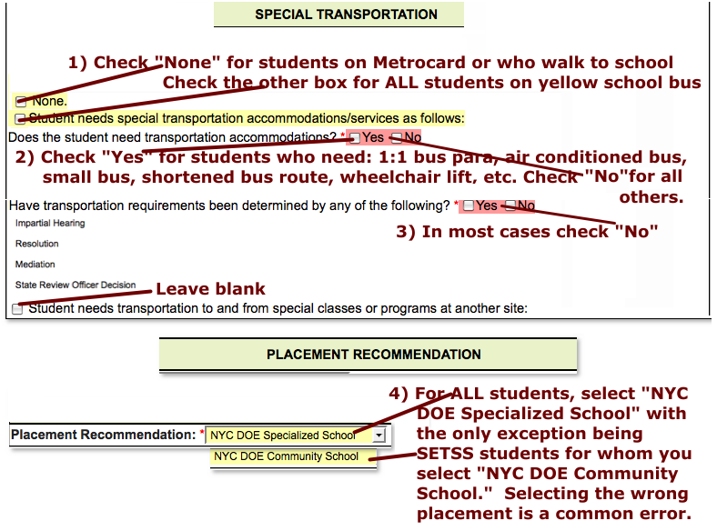

26) Twelve Month Service and/or Program (8th section of IEP):
The IEP Coordinator is responsible for entering this information in the IEP when a student requires 12 month
schooling.
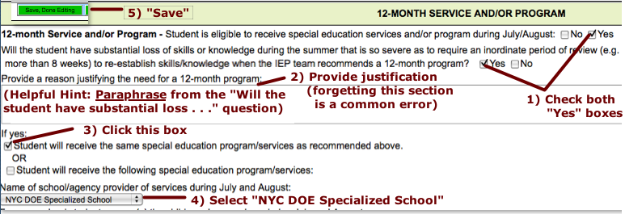

27) Summary Page (14th section of IEP):
27a) Instructional / Functional Levels
The Teacher is responsible for entering the Instructional/Functional Levels and ensuring that this
information matches what is written in the Present Levels. When SESIS was revamped in late August,
the feature that allowed us to leave this section blank was disabled. Grade Levels must be entered. See
page 41and page 43 for instructions on how to determine these Grade Levels.

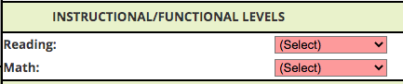
…
Make sure that the Grade Levels that you enter on the Summary Page match what is reported in the Evaluation Results section of the Present Levels!

27) Summary Page (14th section of IEP) (cont.):

27a) Promotion Criteria

The IEP Coordinator is responsible for this section.

Standardized Student .. . Alternate Student (leave blank!!!)

27b) Summary of Recommendations

The IEP Coordinator is responsible for this section.

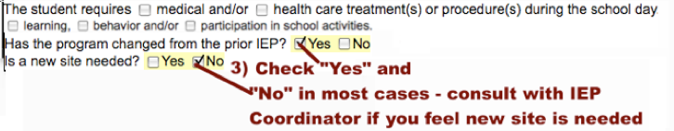

27) Summary Page (cont.)
27c) Other Options Considered
The Teacher / District Rep completes this section with input from the rest of the IEP Team.
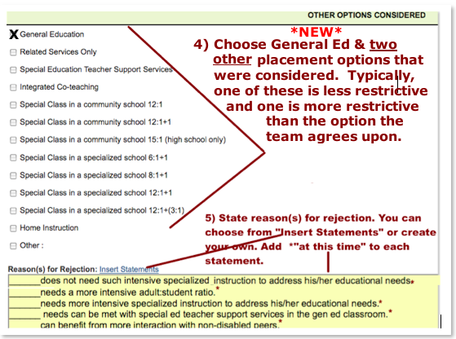

28) DRAFT Copies of IEP
The Teacher will print a copy of the Draft IEP (in landscape orientation) and have copies made for each IEP Team member (especially the parent!) with the word “DRAFT” stamped on every page.

Part IV: The Annual Review Meeting

*Important Notice*

A) If a Draft of the IEP is not complete (with the exception of adding parent / guardian / student concerns), do not hold an Annual Review Meeting. In the rare cases when the parents come in and extenuating circumstances have prevented completion of the Draft, write “Pre-Conference Meeting” on the top of the Conference Attendance Page, but do not fax it in at this time. Inform the parent that an actual IEP Conference will still have to be held at a later date. The actual IEP meeting can be done by telephone.

B) The IEP Team members must inform their Assistant Principal of the reasons that the Draft of the IEP was not ready in time for the scheduled IEP meeting and the date for which the IEP meeting has been re-scheduled.

C) After the re-scheduled IEP Meeting is held the Teacher will submit both the Pre-Conference Attendance Page and the new Conference Attendance Page under one fax coversheet.
IEP Conference Notes State Ed SPP-13 Feedback to D75:
“It appears from the timeline that information was added into the IEP that was not discussed at the meeting.”
“ALWAYS keep conference notes.”
- State Ed requires IEP Meeting Notes be taken and maintained for at least 2 school years. They are to be furnished to SPP-13 reviewers / auditors upon request. It is, therefore, recommended that you upload the Conference Notes into SESIS so that you will have easy access to them if you are called upon to provide them.
- This new requirement has the benefit of documenting things discussed at IEP Meetings that have to be added to the IEP after the meeting. State Ed is very suspicious of anything added after the meeting as they feel it may not have been discussed with parents (see previous page).
- While State Ed expects you to keep meeting notes, the format is entirely up to you. Consider using the form developed by the IEP Compliance Team (see next page), or at least basing your version upon it.
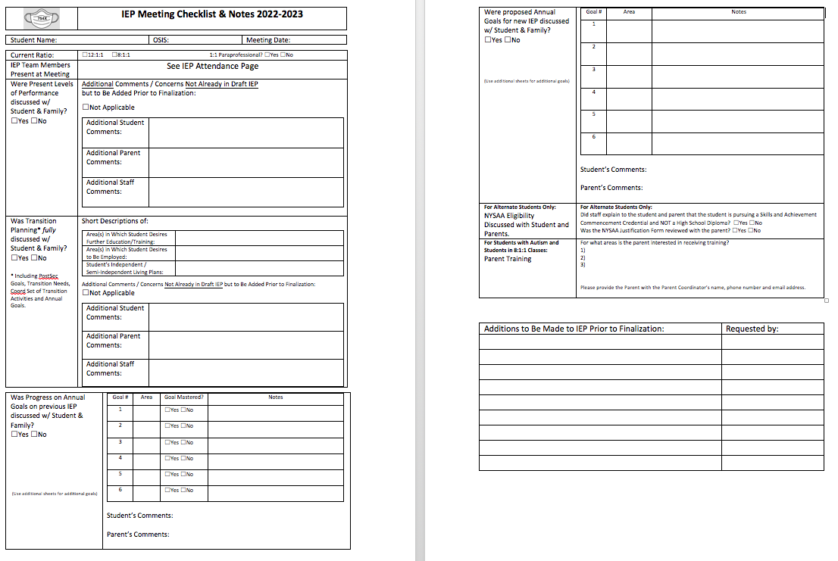
STRONG SUGGESTION! |  | Because of the frequency with which SESIS goes off-line (or worse yet, when the internet isn’t available at all via the DOE connections), the Teacher should print the IEP 2 days prior to the meeting and print or stamp the word “DRAFT” clearly on each page.
29) The Annual Review Meeting
29a) Welcome and Sign In: After welcoming everyone, the District Representative / Teacher chairs the
meeting and is responsible for asking all present members to sign the Conference Attendance Page. Remind
everyone that signing ones name does not imply that one agrees with what is in the IEP. It merely indicated
being present at the meeting. The only signatures that should appear on the Conference Attendance Page are
those who attended the meeting in person or by phone. DO NOT SIGN IF YOU DID NOT ATTEND!
Note: The District Representative can be anyone “qualified to provide or supervise the provision of special education, knowledgeable about the general education curriculum and knowledgeable about the availability of district resources” (e.g. Assistant Principal, IEP Coordinator, Job Developer, Site Coordinator, etc.). In most cases, as per school policy, the Official Class Teacher is to serve as the District Rep.

29b) Procedural Safeguards Notice  The Procedural Safeguards Notice describes “the rights of a parent of a child with a disability and the procedures that safeguard those rights under state and federal special education law.” The Procedural Safeguards document must be provided to the parent annually. Whenever possible, the link to the Procedural Safeguards in the family’s Home Language will be sent by email. In other cases, a hard copy will be provided to the parent(s) at the IEP Meeting or mailed home with the IEP. The IEP Compliance Team will log an Event in SESIS noting that the Procedural Safeguards were provided to the parent.  Hardcopies are available in: the IEP Coordinators office, the Transition Coordinator’s office and the Bronxwood Coordinator’s office. | 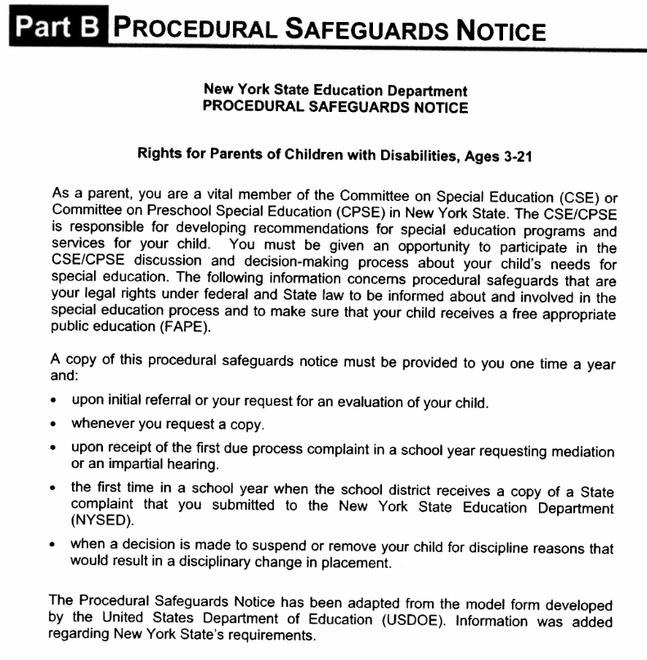
CAUTION: Never sign the Attendance Page if you did not attend the meeting!
Case Managers must remove the names of anyone who did not attend!
29) The Annual Review Meeting (cont.)
29c) Reviewing the Proposed IEP (Draft*)  It is important that you remind the parents that “nothing in the proposed draft is set in stone.” Even after the parents receive the Finalized Version of the IEP and the Prior Written Notice (PWN), they have the right to request mediation or an impartial hearing if they disagrees with the IEPs recommendations. (See Procedural Safeguards Notice for further information.)  Review the proposed IEP (i.e. the Draft) with the student and her/his parents. The IEP Team has the option of reviewing the sections in the order they appear in the printed draft document or skipping around to highlight obvious connections between sections. For example, after discussing the Postsecondary Goals, the team might want to jump ahead to the Coordinated Set of Transition Activities.  29d) Additional Input from Student and Parent: As you review each section, be sure to ask the student and his/her parents what changes that they would like to see made to the IEP draft at this time. Remember that “student voice” and “parent / family voice” must be clearly evident in the Pres. Levels.  29e) The Teacher must write a brief statement summarizing / highlighting the major needs/concerns raised at the meeting and outlining broadly how they will be addressed. For example: “The following needs/concerns were raised at the meeting. They will be addressed by (annual goals? activities? programs? services? a reevaluation?”)  This statement must be typed and emailed (*NEW*) to the IEP Coordinator who is likewise required to include it in the Prior Written Notice (PWN) that he sends home to the parents. There is a space for this statement on the Request for Review/Finalization form.  Be mindful of your phrasing!  The statement will be seen by the student’s parent(s)! | * The Teacher should not set the Draft to “Review” until after the Annual Review meeting is held and all changes to the Draft have been made.

29) The Annual Review Meeting (cont.)

29f) Parent/Guardian Copy of the Finalized IEP

If the parents/guardians wish to take a copy home the same day double check that every page is stamped “DRAFT.”

The Teacher /District Representative should ask the parents/guardians if the finalized IEP home should be sent home with the student, posted in the mail or emailed (consent to send Special Ed Documents via email required)

Regardless of the parents/guardians’ decision, the Teacher/District Rep. must let the IEP Coordinator know what choice was selected. This is because the IEP Coordinator also has to send home a mandatory form called Prior Written Notice (PWN) and he needs to know whether or not to include the IEP (and the Procedural Safeguards Notice).

29g) The Teacher/District Rep thanks everyone for taking the time to attend and contribute to this important meeting.

PROCEDURAL SAFEGUARDS
The Procedural Safeguards document must be provided to the parent annually. Whenever possible, the link to the Procedural Safeguards in the family’s Home Language will be sent by email. In other cases, a hard copy will be provided to the parent(s) at the IEP Meeting or mailed home with the IEP. The IEP Compliance Team will log an Event in SESIS noting that the Procedural Safeguards were provided to the parent.

Annual Review IEPs at 754X

Part V: Post-Meeting Paperwork – Uploading by Fax and Uploading Scans
30) Incorporating Changes to IEP
30c) IEP Team Members open the student’s draft IEP and make all the respective changes agreed upon during
the meeting. Do not request that the IEP be Reviewed/Finalized unless all the changes have been made.
And most importantly: DO NOT MAKE ANY CHANGES THAT HAVE NOT BEEN DISCUSSED
WITH THE STUDENT AND PARENT!*
*IF post-meeting changes not discussed at the meeting do need to be made to the IEP, beyond minor typographical errors, a follow up meeting must be held.

30d) If the meeting date was changed it is imperative that the Teacher / District Rep change the date on the Cover Page to reflect the date the meeting was actually held. Teacher / District Rep must also go to the Recommended Programs/Services Page and make sure the Projected Beginning / Service Date is 10 school days after the IEP meeting date.

31) Printing & Faxing in the Conference Attendance Sheet
31a) Until further notice, the Teacher /District Rep is responsible for generating a fax cover sheet for the Conference Attendance Page internally from the IEP and NOT as a Document Related to IEP. Note that the IEP cannot be finalized until the fax has shown up in SESIS. Currently, the Conference Attendance Page can be faxed or scanned in by a SESIS
scanner (see the Pupil Accounting Secretary, Ms. R. Vargas).

31a.1)

31a.2)

31) Faxing in the Conference Attendance Sheet (cont.):

31b) Print the fax Cover Sheet.
Helpful Tip: Write the words “Conference Attendance Page” lightly in pencil on the top right
hand of the page to prevent it getting mixed up with your other fax coversheets for other
documents for this student. Though, at this point, you really should be scanning and uploading all
other docs.

It is strongly advised that you keep a copy of the Conference Attendance Page for your own records!

32) Scanning and Uploading “Documents Related to IEP”

Be careful not to upload one student’s documents into another student’s SESIS account! Before you finalize an uploaded document, double check the student’s name on the document!

32a.1) Until further notice, the Teacher/District Rep is responsible for scanning and uploading
the “Documents Related to IEP” (i.e. the Invitations, Teacher and Parent Level 1s, and LRE checklist).

Create a separate “Documents Related to IEP” file in SESIS for each of the following:
- Level 1 Vocational Assessments (upload the Parent and Teacher versions together making sure the label lists both) (Check that each Level 1 is fully dated!)
- Invitations to Attend IEP Meeting (upload the Student Invitation, Parent Consent to Invite
Outside Agency, and a copy of the Invitation to Outside Agency together under one cover sheet).

32a.2) Until further notice, the Counselor is responsible for generating a “Documents Related to IEP” file in
SESIS for the Student Level 1 Vocational Assessment and for scanning and uploading that document.

32) Scanning and Uploading “Documents Related to IEP” (cont)
32b) Creating “Documents Related to IEP”
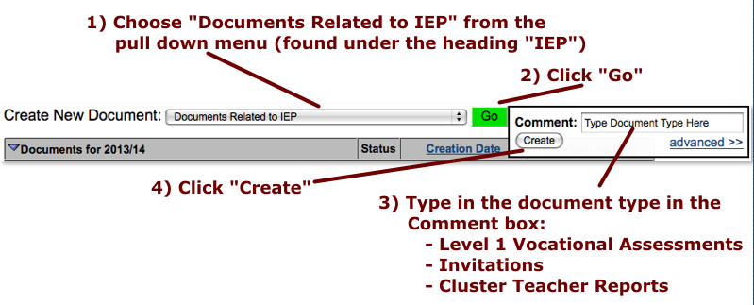
32c) - All Documents (except the Conference Attendance Page) are to be scanned and saved as PDF files. A
scanner is available in Rm 137 at the Main Site and Rm. 114 at Bronxwood.
- Save your scanned document(s) (PDF file(s)) on a USB flash drive and transfer them to your computer. To
protect student confidentiality, be sure to delete the documents from the office computer!
- If you will be uploading more than one document to a “Documents Related to IEP” be sure that each one is
named with a clearly identifiable tag (e.g. “Student Level 1 Voc” rather than just “Level 1”).
- Go into SESIS and open the specific “Documents Related to IEP” that you wish to attach the scanned
document to. (Note: the status should be “Draft”… if the status is “Final”, you probably won’t be able to
attach the document and will need to create a new draft “Document Related to IEP.”)
- Click on “Navigate to” and select “File Attachments.”
- Click on the “Attach Files” icon found below the student’s name and above the words “File Attachments.”
- Click on the Select button.
- Chose your document(s) and click on the “Open” button.
- Click on the “Upload Documents” button.
- Change the Document Status from Draft to Final.

NOTE *NOTE* Follow the above instructions when uploading the PERMISSION FOR STUDENT TO TRAVEL ON

PUBLIC TRANSPORTATION / PERMISSION FOR SCHOOL TO ISSUE METROCARD form.

32) Scanning and Uploading “Documents Related to IEP” (cont)
32d) Once the Parent and Teacher Level 1 Voc Assessments and Invitations have uploaded, the Teacher is responsible for finalizing those “Documents Related to IEP”. However, do not finalize the IEP!
The Counselor is responsible for finalizing the Student Level 1.

33) Scanning and Uploading “Documents Related to IEP”: External FBAs and BIPs

33a) When an FBA and/or BIP are required, the Counselor is responsible for scanning and
uploading the “Documents Related to IEP: FBA” and/or “Documents Related to IEP: BIP”

Create a separate “Documents Related to IEP” for the FBA and for the BIP.

33b) Creating “Documents Related to IEP”
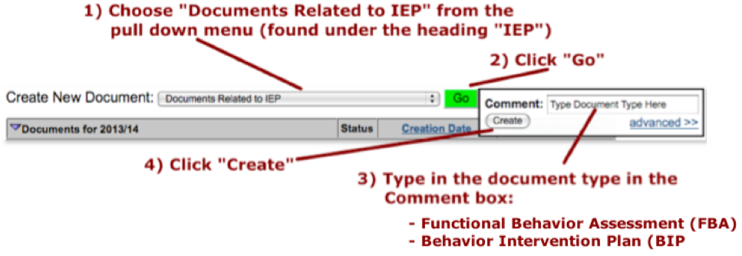
33c) Follow the steps outlined in 33c.

33g) Once the FBA & BIP have uploaded, the Counselor is responsible for finalizing those “Documents
Related to IEP”. However, do not finalize the IEP!

Section 200.2 of the Regulations of the Commissioner (amended) requires that: “any copy of a student’s IEP remains confidential and not disclosed to any other person consistent with the school district’s policy for ensuring the confidentiality of student records.” This confidentiality requirement extends to all other documents printed from or faxed into SESIS. With this in mind:
- If you print from any printer not in your immediate vicinity (e.g. the 151 staff room at the Main Site),
be sure to retrieve everything you printed immediately.
- Do not take an uncollated stack of student documents to the fax machine, especially if they are the
documents belonging to different students. It is better to separate the documents out and organize them with paper clips. It is strongly suggested that you highlight the student’s name on the fax cover sheet and, in the bottom left corner, next to “Documents Related to IEP”, note what type of document it is (e.g. Parent Level 1 Vocational Assessment, Student Invitation, etc.)
- Last school year there were several instances where documents were faxed in
under the wrong heading. What is worse, there were cases where documents
were faxed in under the wrong student’s name! Accidental or not, this could
lead to a breach of confidentiality!
- All IEPs and Documents Related to IEPs MUST be shredded before being disposed of.

For more information see Protecting the Privacy of Student Records https://nces.ed.gov/pubs97/97527.pdf

34) Requesting Review/Finalization

34a) Proofreading:
All Teachers, Counselors and other Related Service Providers are responsible for proofreading the sections of the IEP that they have developed BEFORE the Teacher submits a Request for Review and Finalization!

***If there are numerous and/or egregious errors made by staff (still)
working at 754X, Administration has the discretion to assign them the task of amending the IEP.***

34) Requesting Review/Finalization
34b) The Teacher /District Rep confirms that all scanned and uploaded documents (except FBAs and BIPs*) now appear in SESIS:
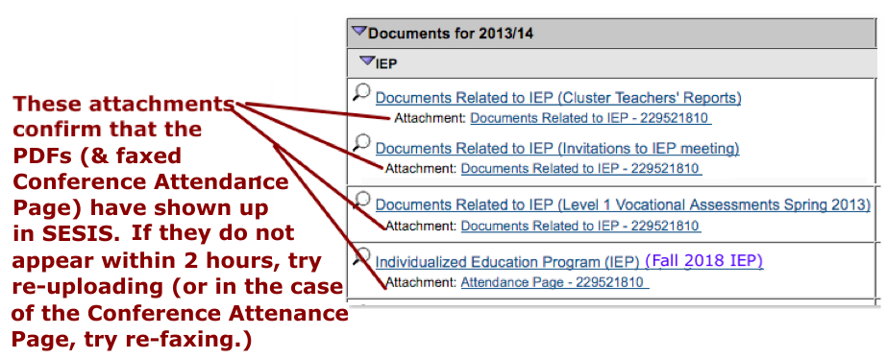
*The Counselor confirms that the FBA and/or BIP showed now appear in SESIS.

34c) The Teacher /District Rep changes the IEP from “Draft “ to “Review”
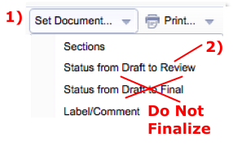
34) Requesting Review/Finalization (cont.)
34d) The Teacher must submit a “Request for IEP Review/Finalization Form” to the IEP Coordinator by emailing the form as an attachment, embedding the information below (cut & paste) in an email (preferred method!).

*This Form NOT Required for PRELIMINARY Review of IEP Due 2 Weeks Before IEP Meeting*

2023-2024 Form

Request for FINAL REVIEW/ FINALIZATION OF IEP
1) Student Name & OSIS (*Response Required)*:

2) Official Class Teacher / Case Manager:

3) Which of the following Assessments are listed in the Evaluation Results? (*Response Required*):
(Be sure to indicate the EXACT DATE. Month and Year is NOT SUFFICIENT!)
Periodic Assessments (REQUIRED twice per year):
___ MAP Growth Reading (FULL date: ______ ) ___ SANDI Reading (FULL date: ______ )
___ MAP Growth Math (FULL date: ______ ) ___ SANDI Math (FULL date: ______ )
Level 1 Vocational Assessments (All Three Required)
___ Student Level 1 (date: ___ ) ___ Parent Level 1 Voc (date: ___ ) ___ Teacher Level 1 Voc (date: ___ )
Miscellaneous:
___ The VARK (date: ____ ) ___ Other (specify): ___________ (date: ____ ) ___ Other (specify): ___________ (date: ____ )

4) Anticipated Diploma/Certificate Type (*response required*):
Standardized:
(check all that apply) ____ Student is currently pursuing a Regents HS Diploma.
____ Student is currently pursuing a Local HS Diploma.
____ Student is currently pursuing a CDOS Credential.

Alternate: ____ Student is currently pursuing a Skills & Achievement Commencement (SAC) Credential (non-diploma).

5) Brief, INDIVIDUALIZED, sentences (that will be entered on the PWN/PNP and sent to the parents):
5a) Briefly describe parental, student, teacher and/or related service provider concerns or student needs raised at meeting and how they will be addressed (e.g. via programs/services/goals/activities/request for reeval): (*Response Required – Do Not Leave Blank!)*):

5b) Briefly describe how the Periodic Assessments (MAP Growth for Standardized students and SANDI for Alternate students) “relate to and/or support the recommendation(s) made at the IEP Meeting.” (e.g. Describe how the needs identified in the Periodic Assessment are addressed by Annual Goals and/or Transition Activities)
(*Response Required – Do Not Leave Blank!)*):

5c) Briefly describe how the Level 1 Vocational Assessments (Student/Parent/Teacher) “relate to and/or support the recommendation(s) made at the IEP Meeting.” (e.g. Describe how the student’s postsecondary interests identified in the Level 1 Assessments are reflected in the Transition Activities and Annual Goal for Transition)
(*Response Required – Do Not Leave Blank!)*):

6) Other Options Considered:
6a) Briefly describe the “Reasons for Rejection.” “Explain why the options considered are not appropriate for the student. This must be more than just indicating that a more or less restrictive setting is appropriate for the student.”
(*Currently Optional – May Be Required Later in School Year*)

6b) Briefly describe “any other options that were discussed and considered at the IEP meeting but not recommended should be explained here, along with the reasons they were not recommended. If a parent is seeking a particular testing accommodation or related service recommendation but the IEP team does not recommend that, the consideration of that accommodation or service and the reasons the IEP team did not recommend it must be specified here.”
(*Currently Optional – May Be Required Later in School Year*)

7) Briefly describe “Other factors that are relevant to the proposed or refused action.” You could describe anything of note not covered in items 5a-c or 6a-b. If nothing else you can reiterate the student’s Definition of Future Success and how it is addressed in the PostSec Goals, Transition Needs, Transition Activities and Annual Goals.
(*Response Required – Do Not Leave Blank!)*):

Language Translation (Must be offered to any family whose Home Language is listed here):
___Arabic ___Bengali ___Chinese ___French ___Haitian Creole ___Korean, ___Russian ___Spanish ___Urdu ___N/A

8) How will the parents receive a copy of the IEP?
___ to be emailed by teacher ___ to be emailed by IEP Office ___ to be mailed by IEP Office ___ to be sent home by teacher
(signed/e-signed permission needed!) (signed/e-signed permission needed!)

9) Confirmation on how the student gets to school? (*response required*) ___ metro/walk ___ yellow bus

10) Has the Attendance Page been completed (Incl. Participation by Phone) AND uploaded / faxed in? ___ yes ___ no

11) Have the following been faxed in and finalized?
- LRE Checklist (754X requirement)  - Student Lev 1 (SPP-13 State Ed requirement!)  - Parent Lev 1 (SPP-13 State Ed requirement!)  - Teacher Level 1 (SPP-13 State Ed requirement!)  - Student Invite (SPP-13 State Ed requirement!)  - Consent to Invite Agency (SPP-13 State Ed requirement!)  - Direct Invitation to Agency (SPP-13 State Ed requirement!)  - FBA/BIP (State Ed requirement when student needs this intervention!) | ___ yes ___ no  ___ yes ___ no  ___ yes ___ no ___ not returned  ___ yes ___ no  ___ yes ___ no  ___ yes ___ no __ not returned  ___ yes ___ no __ consent not given  ___ yes ___ no __ not required

REQUIRED CONTACT INFORMATION for Chapter 408 Distribution:
Provide First & Last Names of ALL Related Service Providers working with this student:
Counseling:
Speech:
OT:
PT:
Other Related Service Provider:
Provide First & Last Names of ALL Paraprofessionals working with this student:
Class Para:
1:1 Para:
1:1 Para:
Transportation Para:
Alternate Placement (Language) Para:
Do Not Submit Unless ALL Annual Goals on the Last Finalized IEP Have Been “Closed Out” for Mastery/Non-Mastery!!!

Annual Review IEPs at 754X

Part VI: Implementing the IEP

The Implementation Date is the next school day following the IEP Meeting.
35) Chapter 408 Review

35a) All pedagogical staff (i.e. Teachers, Related Service Providers & Paraprofessionals) who work
with the given student must review the IEP. When completed, the 408 Form is given to the IEP
Coordinator (or Bronxwood Coordinator) who will ask the Family Worker to put it in the student’s
IEP/408 file. Tentatively, those files will be kept in Room 116 at the Main Site and the Coordinator’s
office at Bronxwood.

35b) Worksite IEP/408 files will also be maintained in Room 116 at the Main Site.
Worksite teachers should keep a print copy of each student’s IEP in a secure location.
Reminder : The IEP Compliance Team has developed an electronic version of the Chapter 408
Review Form that you must now complete to document that you conducted the Review.
Here is the link for Teachers and RSPs: INSERT TEACHER/RSP 408 LINK HERE
Here is the link for Paraprofessionals: INSERT PARAPROFESSIONAL 408 LINK HERE
Each time a new IEP is finalized I will send a reminder to use the above link to document your mandated Chapter 408 Review. You must also use the above link anytime a student comes into your class for the first time. However, you do not have to conduct a 408 Review of the IEP if you already reviewed it while they
were in another class.
36) Implementing Programs, Services, Annual Goals and Activities
36a) All Teachers, Paraprofessionals and Related Service Providers should implement the
Recommended Special Education Programs and Services the day after the IEP Meeting date.
They should also being collecting data on the Annual Goals and initiating the Coordinated Set of
Transition Activities.
36b) Teachers and Related Service Providers should begin collecting data on Annual Goals. Progress
on these goals needs to be reported to parents/guardians each time report cards are sent home

Annual Review IEPs at 754X

Part VII: Reporting Progress to Parents

37) Reporting Progress to Parents
Teachers and Related Service Providers must go to the Annual Goals section of the finalized IEP and complete the following steps each and every time Report Card grades are submitted.

37a)
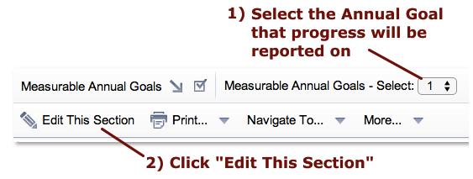

37b)
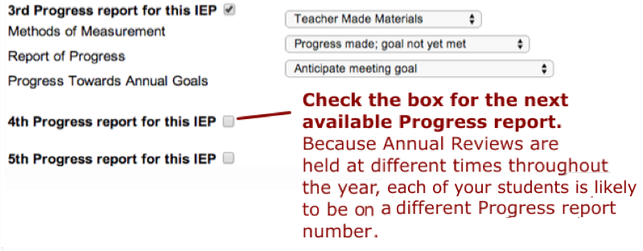

Annual Review IEPs at 754X

37) Reporting Progress to Parents (cont.)

37c)
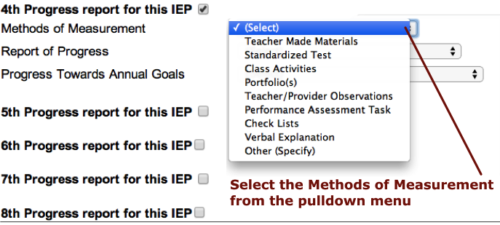
*The Methods of Measurement must match those listed in the Annual Goal.

37d)
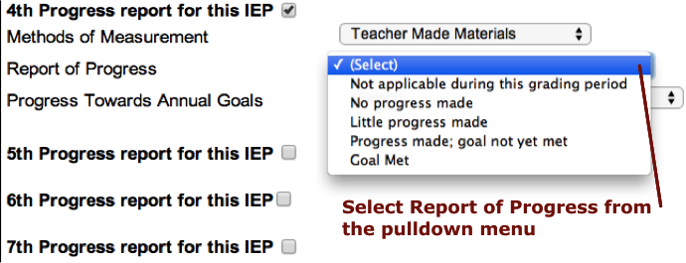

37) Reporting Progress to Parents (cont.)
37e)
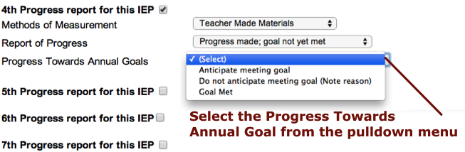
37f)
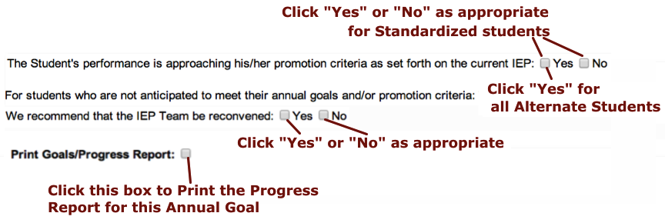

37g) Click “Save Done Editing” and Print “This Section” from the pulldown menu
for that goal. Repeat for each goal that you measured during the marking period.

37h) Submit the updated Progress Report to the person designated by your Assistant Principal
no later than the date Report Card grades are due.

37) Reporting Progress to Parents (cont.)

37i)
*IMPORTANT REMINDER*: “Closing Out the Annual Goals”

DO NOT proceed with the development of an IEP until you have ensured that the Literacy, Numeracy, and Transition Teachers and RSPs in your cluster have indicated “Goal Met” OR “Do not anticipate meeting goal” on the IEP Progress Report for EVERY GOAL on the current (i.e. last finalized) IEP! (“Anticipate meeting goal” is NOT sufficient.”)

Some staff have suggested that we call this process “Closing Out the Annual Goals.” Please make sure that you “close out the Annual Goals” before you start developing the new IEP.

Annual Review IEPs at 754X

Part VIII: Triennials & Reevaluations*
* Procedures may vary slightly at different sites within the 754x organization. As with all sections of this Manual, items in this section are subject to updates and policy changes. Please see page 11 for an important notice regarding Mandated Triennials.
PLEASE NOTE: If an LTA/595 Mandated Triennial is developed for a Long Term Absent/595 student, a new Triennial must be developed and completed within 60 days of that student’s return to school.

Important Reminder:
Anytime a student’s program needs to become more restrictive in any way (e.g. reducing class size, adding a crisis paraprofessional, etc.) you must consult with the School Psychologist on the Student Assessment Team (SAT).

38) Triennials (Mandated Three Year Reevaluations) & Other Evaluations

38a) The Family Worker (for School Assessment Team) should distribute the following documents to the
official class Teacher via Main Office mailbox:
- Notice of IEP Meeting
- Level 1 Vocational Assessment - Teacher Version
- Cluster Teacher Present Levels Report
- Any Documents Related to Assessment, such as behavioral or adaptive checklists or questionnaires
38b) Distribute the following documents to ALL applicable Cluster Teachers via Main Office mailbox:
- Notice of IEP Meeting
- Cluster Teacher Present Levels Report (see Appendix C)
38c) For Teachers off-site, the Family Worker (SAT) should fax the above listed documents to the
work/academic site.
38d) Distribute the following documents to Related Service Providers via Main Office mailbox:
- Notice of IEP Meeting
- Related Service Present Levels Report (see Appendix C)
- Any Documents Related to Assessment, such as behavioral or adaptive checklists or questionnaire
38e) For Related Service Providers off-site, the Family Worker (SAT) should fax the above listed
documents.
38) Triennials (cont.)
38f) The Family Worker (SAT) will mail or fax upon receipt of Consent to Invite Outside Agency:
- Notice of IEP Meeting
- Other Documents Related to Assessment, such as Release of Records or Request of Documents

***Note to All Teachers and Related Service Providers***

ALL DOCUMENTS requested by the Student Assessment Team MUST be returned within TEN school days of the distribution date via Main Office mailbox or fax, including:
- Teachers Level 1 Vocational Assessment - Teacher Version
- Cluster Teacher Present Levels Report
- Related Service Present Levels Report
- Any Documents Related to Assessment, such as behavioral or adaptive checklists or questionnaires

Important Reminder: Anytime it is recommended that a student is in need of a more restrictive setting (e.g. reducing class size, adding a crisis paraprofessional, etc…) you must consult with the School Psychologist of the School Assessment Team and a Request for Reevaluation may need to be submitted to process the request.

The School Psychologist will respond to all ‘Finalized’ Requests for Reevaluation within ten school days.

If the request for a more restrictive setting is processed through the Student Assessment Team, additional documents such as SESIS Progress Reports, SWIS forms and anecdotal reports may be requested as part of the Reevaluation.

39) Requests for Reevaluation
39a) REMINDER: The Parent/Guardian has the right to Request a Reevaluation at any time if they feel that
their student is not being appropriately served in his/her current academic setting. If a Parent/Guardian
provides a staff member with a letter requesting a Reevaluation, please submit it to the Mr. Hoehn (for
students the Main Site or Worksites) or Ms. Rivera (for students at Bronxwood) . Please email the IEP
Coordinator any time you submit a Reevaluation request to the 754X Administration. Mr. Hoehn and
Ms. Rivera will pass the request on to the Student Assessment Team (SAT).

39b) If staff recommend a more restrictive setting for the student, such as adding a 1:1 paraprofessional, an
FBA/BIP or reducing class size, an appointed staff member(s) will use SESIS to complete and
‘Finalize’ a Request for Reevaluation. The appointed staff member may include the Teacher, Related
Service Provider, Counselor or Administrator, but may NOT include the SAT School Psychologist or
Family Worker. Please see the IEP Coordinator if assistance is needed.

39c) To create a Request for Reevaluation, the staff member should go to the student’s SESIS Page and select
‘Documents.’ To the right of ‘Create New Document,’ drop down to ‘Request for Reevaluation.’ Click
‘Go’and type a comment (e.g. add 1:1 Crisis Paraprofessional,) select ‘Create.’

39d) Date and complete the four sections of the Request for Reevaluation document on SESIS. Use the
guideline below to complete each section.
39d.1) Academics:
- Report Student’s current class ratio
- Report Student’s patterns of attendance, performance on test exams, work completion rate of
progress, participation in class and Activities of Daily (ADL) skills (which can include money
management.)
- Report the interventions and modifications previously attempted to accommodate Student needs.
- Report student’s academic strengths, learning style and preferred academic interests.

39) Requests for Reevaluation (cont.)

39d.2) Social/Behavioral Development:
- Report Student’s current Related Service mandates
- Report Student’s patterns of attendance, current
counseling or other Related Service goals, rate of
progress on meeting goals, participation in service and
ADL skills if applicable.
- Report the interventions and modifications previously
attempted to accommodate Student needs.
- Report student’s social/behavioral strengths, patterns of
peer interaction and preferred leisure interests.

39d.3) Please provide an explanation regarding why the student’s needs warrant a Reevaluation:
- State what intervention is being requested (e.g. FBA, 1:1)
- Include a summary statement of the presenting academic,
social and/or behavioral problem(s.)
- Report anecdotal evidence and interventions previously
attempted.
- State why the Student’s needs cannot be accommodated in
the current setting.

39d.4) Click ‘Yes’ or ‘No’ for a Recommended Program change. If ‘Yes,’ drop down to the
recommended change.

39d.5) Select ‘More Actions’ and ‘Finalize’ the document.

Addendum: Compensatory Services

During the IEP Meeting we are required to discuss Compensatory Services with the parent(s). In order to offer Compensatory Services, the IEP Team must have data showing remaining skill regression or gaps in expected progress towards IEP goals due to the learning disruption caused by the pandemic.

Prior to the meeting the Teachers and Related Service Providers must ask: “Does the data we have collected regarding a particular student indicate a loss of skills, compared to other students, that can be attributed to the student not receiving in-person learning? If so, what specific skill has regressed?

If the answer is “No”, select one of the following reasons on the Compensatory Services
page of the IEP:
___ The student made expected progress toward IEP goals and did not experience a loss in skills during
blended and remote learning.
___ The student benefitted from Special Education Recovery Services received during the 2021-22 school
year and additional services are not required.
___ The student benefitted from compensatory services received during the 2022-23 school year and
additional services are not required
___ Other:

If data shows that the student still has gaps, check “Yes” and select one of the following reasons:
___ The student experienced a loss of skills during blended and remote learning that has not been
remedied since the return to in-person learning.
___ The student received Special Education Recovery Services during the 2021-22 school year, but
additional services are required to close gaps in expected progress toward IEP goals and to address
skill loss experienced during blended and remote learning
___ The student received compensatory services during the 2022-23 school year, but additional services are
required to close gaps in expected progress toward IEP goals and to address skill loss experienced
during blended and remote learning.
___ Other

AND complete the Compensatory Service Recommendation.

***You must discuss any Compensatory Service Recommendation
with Mr. Hoehn and your Assistant Principal prior to discussing it with the parent.***

For more information, see the Compensatory Services and Compensatory Services FAQ sections under Special Education Family Resources:
https://www.schools.nyc.gov/learning/special-education/family-resources
Contact Information

P754X IEP Coordinator:
Main Site Room 114 – (718) 993-5581(x1140)
Dr. John “Fitz” Fitzgerald, Ed.D. JFitzgerald3@schools.nyc.gov

P754X Main Site & Worksite School Assessment Team (SAT):
Main Site Room 210 – (718) 993-5581 (x2100)
School Psychologist: Ms. Leslie Francis LFrancis4@schools.nyc.gov
Family Worker: Ms. Ilsa Portalatin IPortalatin@schools.nyc.gov

Bronxwood School Assessment Team (SAT):
Bronxwood Campus – (718) 696 -3840 (x1391) and (718) 696 -3891
School Psychologist: Ms. Jacqueline Mauro JMauro7@schools.nyc.gov
Family Worker: Ms. Karima Gonzalez KGonzalez58@schools.nyc.gov

754X Transition:
Main Site Room 134 – (718) 993-5581(x1340)
754X Job Developer / Transition Coordinator: Ms. Lisa Tong LTong3@schools.nyc.gov

Remember . . .
The greater the collaboration among ALL the members of the IEP team the greater the quality of the IEP that the team produces!!!

Annual Review Responsibilities @ 754X (subject to updates / policy changes): Mr. Hoehn has stressed the importance of following the division of responsibilities according to this chart. If, on the rare occasion you feel the need to switch roles with another team member, you must discuss it with your AP.
 | Official Class Teachers | Cluster Teachers | PE/Dance Teachers | Related Service Providers | IEP Compliance Team | Student Assessment Team
Open Notice of IEP |  |  |  |  | ✓
Finalize & Mail Notice of IEP | ✓
Open IEP Draft & Notify Team |  |  |  |  | ✓
Progress Report (from “Create New Document” pull-down menu in SESIS) |  |  | ✓  (opened by IEP Coordinator) | ✓ (if service is to be terminated)
LRE Checklist (must fax in to SESIS) | ✓
Student Invitation (must be faxed in to SESIS) | ✓
Agency Invite & Consent (must be faxed in to SESIS) | ✓ |  |  | ✓(if Official Teacher  requests assistance)
Level 1 Vocs (must be faxed in to SESIS) | ✓  (Teacher & Parent) | ✓(Teacher version when student moving to SETSS) |  | ✓(Student(Counselor))
Cover Page | ✓ (IEP date) |  |  |  | ✓
Present Levels | ✓ | ✓(if requested by Official Teacher) |  | ✓ | ✓
Student Needs (Special Factors) |  |  |  | ✓ (if BIP or Adaptive Tech needed) | ✓
PostSec Goals (& Trans Needs) | ✓  (Transition Needs) |  |  | ✓ ( PostSec Goals &, for Stand. Students, credits needed - Counselor)
Annual Goals | ✓ | ✓(if requested by Official Teacher) |  | ✓
Progress Reporting Recommendation |  |  |  |  | ✓
Recom. Special Ed. Programs & Services | ✓ |  |  | ✓
12 Month Program |  |  |  |  | ✓
Testing Accommodations | ✓
Coord. Transition Activities | ✓ |  |  | ✓
Participation in Assessment |  |  |  |  | ✓
Participation w/ Students w/o Disabilities |  |  |  |  | ✓
Transport & Special Ed Plcmnt | ✓   (Transportation) |  |  |  | ✓  (Placement)
Summary Page | ✓ |  |  | ✓(if Official Teacher  requests assistance) | ✓ (Promotional Criteria)
Conference Attendance Page | ✓
FBA/BIP (if needed) | ✓  (assist in data collection) |  |  | ✓  (Counselor)
Finalize IEP |  |  |  |  | ✓
Prior Written Notice |  |  |  |  | ✓
Report Progress on Annual Goals (4X per year) | ✓ | ✓ | ✓ | ✓ (PE Teacher if student has APE)
Reevaluations / Evaluations (including Triennials, Initials, Comparative Service Plans, but excluding “Collapsed” IEPs) (subject to updates / policy changes) Mr. Hoehn has stressed the importance of following the division of responsibilities according to this chart. If, on the rare occasion you feel the need to switch roles with another team member, you must discuss it with your AP.
 | Official Class Teachers | Cluster Teachers | PE/Dance Teachers | Related Service Providers | IEP Compliance Team | Student Assessment Team
Open Notice of IEP |  |  |  |  |  | ✓
Finalize & Mail Notice of IEP |  |  |  |  |  | ✓
Open IEP Draft & Notify Team |  |  |  |  |  | ✓
Progress Report (from “Create New Document” pull-down menu in SESIS) | ✓ | ✓ | ✓  (ask IEP Coord. to open) | ✓
LRE Checklist (must fax in to SESIS) |  |  |  |  |  | ✓
Student Invitation (must be faxed in to SESIS) |  |  |  |  |  | ✓
Agency Invite & Consent (must be faxed in to SESIS) |  |  |  | ✓(if SAT requests assistance) |  | ✓
Level 1 Vocational (must be faxed in to SESIS) | ✓  (Teacher) | ✓(Teacher version when student moving to SETSS) |  | ✓(Student(Counselor)) |  | ✓  (Parent)
Cover Page |  |  |  |  |  | ✓
Present Levels | (See SESIS Progress Report) | (See SESIS Progress Report) |  | See SESIS Progress Report) |  | ✓
Student Needs (Special Factors) |  |  |  | ✓ (if BIP or Adaptive Tech needed) |  | ✓
PostSec Goals (& Transition Needs) | ✓  (Transition Needs) |  |  | ✓ ( PostSec Goals &, for Stand. Students, credits needed - Counselor)
Annual Goals | (See SESIS Progress Report) | (See SESIS Progress Report) |  | (See SESIS Progress Report)
Progress Reporting Recommendation |  |  |  |  |  | ✓
Recom. Special Ed. Programs & Services | ✓(if SAT requests assistance) |  |  | ✓(if SAT requests assistance) |  | ✓
12 Month Program |  |  |  |  |  | ✓
Testing Accommodations | ✓(if SAT requests assistance) |  |  |  |  | ✓
Coord. Transition Activities | ✓ |  |  | ✓
Participation in Assessment |  |  |  |  |  | ✓
Participation w/ Students w/o Disabilities |  |  |  |  |  | ✓
Transport & Special Ed Plcmnt |  |  |  |  |  | ✓
Summary Page (Including Grd Levels) |  |  |  |  |  | ✓
Conference Attendance Page |  |  |  |  |  | ✓
FBA/BIP (if needed) | ✓ (assist in data collection) | ✓ (assist in data collection) | ✓ (assist in data collection) | ✓  (Counselor)
Finalize IEP |  |  |  |  |  | ✓
Prior Written Notice |  |  |  |  |  | ✓
Report Progress on Annual Goals (4x per year) | ✓ | ✓ | ✓ | ✓ (PE Teacher if student has APE)

“Collapsed” Reevaluations / Annual Reviews (subject to updates / policy changes) Mr. Hoehn has stressed the importance of following the division of responsibilities according to this chart. If, on the rare occasion you feel the need to switch roles with another team member, you must discuss it with your AP.
 | Official Class Teachers | Cluster Teachers | PE/Dance Teachers | Related Service Providers | IEP Compliance Team | Student Assessment Team
Open Notice of IEP |  |  |  |  |  | ✓
Finalize & Mail Notice of IEP |  |  |  |  |  | ✓
Open IEP Draft & Notify Team & IEP Coord. |  |  |  |  |  | ✓
Progress Report (from “Create New Document” pull-down menu in SESIS) |  |  | ✓ (ask IEP Coord. to open)
LRE Checklist (must be faxed in to SESIS) | ✓ 
Student Invitation (must be faxed in to SESIS) |  |  |  |  |  | ✓
Agency Invite & Consent (must be faxed in to SESIS) |  |  |  | ✓(if SAT requests assistance) |  | ✓
Level 1 Vocational (must be faxed in to SESIS) | ✓  (Teacher) | ✓(Teacher version when student moving to SETSS) |  | ✓(Student(Counselor)) |  | ✓ (Parent)
Cover Page |  |  |  |  |  | ✓
Present Levels | ✓  | ✓(if requested by SAT) |  | ✓ 
Student Needs (Special Factors) |  |  |  | ✓ (if BIP or Adaptive Tech needed) |  | ✓
PostSec Goals (& Trans Needs) | ✓  (Transition Needs) |  |  | ✓ ( PostSec Goals &, for Stand. Students, credits needed - Counselor)
Annual Goals | ✓  |  |  | ✓ 
Progress Reporting Recommendation |  |  |  |  |  | ✓
Recom. Special Ed. Programs & Services | ✓  |  |  | ✓ 
12 Month Program |  |  |  |  |  | ✓
Testing Accommodations | ✓(if SAT requests assistance) |  |  |  |  | ✓
Coord. Transition Activities | ✓ |  |  | ✓
Participation in Assessment |  |  |  |  |  | ✓
Participation w/ Students w/o Disabilities |  |  |  |  |  | ✓
Transport & Special Ed Placement |  |  |  |  |  | ✓
Summary Page (Including GrdLevs) | ✓
Conference Attendance Page (must be faxed in to SESIS) |  |  |  |  |  | ✓
FBA/BIP (if needed) | ✓  (assist in data collection) | ✓ (assist in data collection) | ✓ (assist in data collection) | ✓  (Counselor)
Finalize IEP |  |  |  |  |  | ✓
Prior Written Notice |  |  |  |  |  | ✓
Report Progress on Annual Goals  (4x per year) | ✓ | ✓ | ✓ | ✓ (PE Teacher if student has APE)
THIS PAGE INTENTIONALLY LEFT BLANK

