Hoch Topic - Because, But, So

The purpose of these activities is to:
- Helps students write complex sentences
- Enhances their comprehension
- Assists students in analytical thinking
- Helps students write extended responses
- Because: tells us why
- But: indicates a change of direction
- So: shows a cause and effect

Tips:
- Start with just because. Introduce “but” and “so” later.

Scaffolding:
- Easier: Give a sentence stem and have students add “because” “but” and “so”
- More difficult: Give a topic with no sentence stem and “because” but and “so”
Check out these examples of activities you can use to help your students learn about sentence types!

Example Resource: “because”

Name: _________________ Date: ______
Lunch Food
Directions:
-Complete the following sentences about lunch foods using the word because.
- Chicken fingers are good because...

_______________________________________________________

2. Chocolate milk is sweet because...

______________________________________________________

3. Salads are healthy because...

_______________________________________________________

4. It is important to drink water because...

_______________________________________________________

Name: _________________ Date: ______
………………………
Directions:
-Complete the following sentences about...______________________
1. ………………………………………………………………..

_______________________________________________________

2. …………………………………………………………………...

_______________________________________________________

3. ………………………………………………………………….

_______________________________________________________

4. …………………………………………………………………...

_______________________________________________________

Fill in the word: because, but, so
-Tips: make sure to include a comma before but and so.

Name: _________________ Date: ______
Thanksgiving
Directions:
-Fill in the blank with because, but, or so.

- Thanksgiving is the best holiday ____________ you can drink beer at 10AM, go to the parade, watch a dog show, and cheer on your favorite football team.
- Thanksgiving is the best holiday, ____________ make sure you eat a lot of stuffing!
- Thanksgiving is the best holiday, ____________ you have to be careful or you will eat too much.

Name: _________________ Date: ______
Thanksgiving
Directions:
-Fill in the blank with because, but, or so.

- ………………………….. ____________ ………………………
- ………………………….. , ____________ ……………………
- ………………………….. , ____________ ……………………

Name: _________________ Date: ______
Structure of the Earth
Directions: - Complete the following sentences about the structure of the Earth using because, but and so.

- The inner core of the Earth is the hottest part because_________
_______________________________________________________
2. The inner core and the outer core are made of the same materials
but_____________________________________________________
________________________________________________________
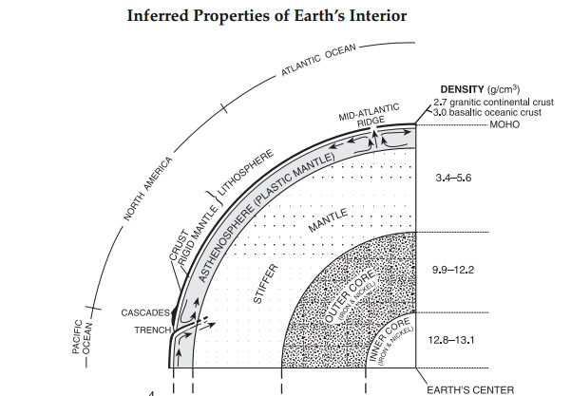

3. The inner core of the Earth is liquid so ____________________

_______________________________________________________
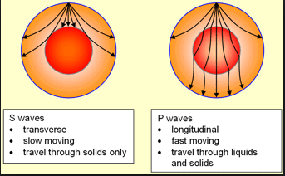

Name:____________________________ Date:_________________

Wednesdays are Great!
Directions: Answer the following sentence stems. You must use complete sentences.
Key Info:

Because= Why/Explains.
But= Change of Direction/Opposite.
So= Cause and Effect.

We have early dismissal on Wednesday because ______________________________ ________________________________________________________________________________ ________________________________________________________________________________

We have early dismissal on Wednesday, but ___________________________________ ________________________________________________________________________________ ________________________________________________________________________________

We have early dismissal on Wednesday, so ____________________________________ ________________________________________________________________________________ ________________________________________________________________________________

Name:____________________________ Date:_________________

Topic:________________
Directions: Answer the following sentence stems. You must use complete sentences.
Key Info:

Because= Why/Explains.
But= Change of Direction/Opposite.
So= Cause and Effect.

------------------------------------------------------------ because ______________________________ ________________________________________________________________________________ ________________________________________________________________________________

------------------------------------------------------------, but ___________________________________ ________________________________________________________________________________ ________________________________________________________________________________

------------------------------------------------------------, so ____________________________________ ________________________________________________________________________________ ________________________________________________________________________________

Industrial Revolution
Directions: Use the word bank to find the correct ending for each clause.

there was child labor
there were advancements in technology
the economy grew

- The Industrial Revolution was a prosperous time in history because ______________________________
_____________________________________

- The Industrial Revolution was a prosperous time in history, but ____________________________
_____________________________________

- The Industrial Revolution was a prosperous time in history, so _____________________________
______________________________________

Pizza
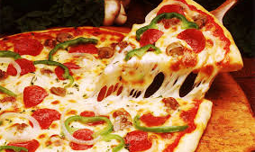

Directions: Use the given words and conjunctions in sentences.

- pizza/because
_____________________________________
_____________________________________

2. pizza/but
_____________________________________
_____________________________________

3. pizza/so
_____________________________________
_____________________________________

Gamma Rays

Directions: Use the given words and conjunctions in sentences.

- gamma rays/because
_____________________________________
_____________________________________

2. gamma rays/but
_____________________________________
_____________________________________

3. gamma rays/so
_____________________________________
_____________________________________

Conversation Starters

Directions: Use kernel sentence and conjunctions to write complete sentences.

- It is important to know how to start a conversation because ______________________________
_____________________________________

2. It is important to know how to start a conversation/but
_____________________________________
_____________________________________

3. It is important to know how to start a conversation/so
_____________________________________
_____________________________________

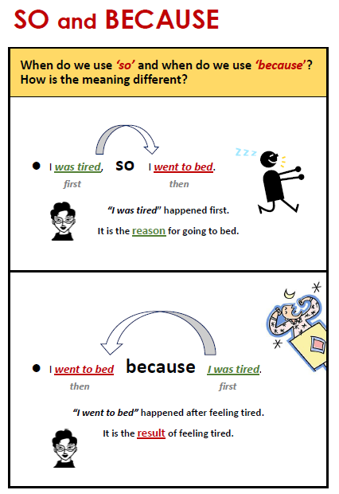
http://www.allthingsgrammar.com/and-but-so-because.html

Classroom Materials
Print this out as a poster to put in your room, or make it smaller and give it as a notecard to students who are having trouble remembering the purpose of each word.
because - tells why

but - change of direction

so - cause and effect

