Hoch Topic - Key words, symbols, and phrases
The purpose of these activities is to:
- Teach students a quick way of notetaking.
- Provide a universal language of symbols for notes across subject areas
- Aid students in picking out important details.
- Helps students to identify the general idea of writing.
- Helps students identify the purpose of their writing
- Ability to summarize
Tips:
- Focus on introducing one symbol a day. Start with +. You can teach the new symbols based on the table below.

Week | Monday | Tuesday | Wednesday | Thursday | Friday
1 | + | = | p. (page) | e.g. (example) | b/c
2 | → | w/ | w/o | vs. | Review
3 | ↑ | ↓ | max. | min. | Review

- Teach students both converting from text to symbols and symbols to texts.
Scaffolding:
- Have print-outs of the symbol key on the next page to tape on student’s desk. Make sure to put up the Hochman poster in your room, too!
Check out these examples of activities you can use to help your students learn about topic sentences!

Symbol Key

= …………………… means, that, equals, is, worth
+ .............................. and, with, also
→ …………………… led to, results in, causes
↑……………………increase/more
↓……………………decrease/less
/ ……………………. Comma or period, new idea

Classroom Activity: Science

Example:
- Biology is the study of all living things.

- biology = study/living things

B. Life processes are carried out by all living things.

2. Life processes = carried out/living things

C. The sum of all life process is metabolism.

3. Metabolism=all life processes.

Symbols Matching
Directions: Match each complete sentence with the matching notes.

- Thanksgiving is a favorite holiday. A. Trick or Treating = candy

- Christmas and Halloween are holidays. B. Thanksgiving = favorite holiday

- Trick or Treating leads to candy. C. Fourth of July/Memorial
Day/Presidents day = patriotic holidays

- Fourth of July, Memorial Day, D. Christmas + Halloween = holidays
and Presidents’ Day are all patriotic holidays

Classroom Activity: Social Studies

Directions: Convert sentences into key words, abbreviations and symbols.

1. Artifacts are man-made objects.

Artifacts = man-made objects_________________________________________________________________________________________

2. Artifacts are weapons, pottery, bowls and tools.

________________________________________________________________________

3. Using artifacts leads to the discovery of clues about ancient civilizations.

_________________________________________________________________________

Classroom Activity: Romeo and Juliet

Directions: Convert sentences into key words, abbreviations and symbols.

1. Capulets are enemies of the Montagues.

Capulets = enemy/Montague___________________________________________________________________

2. Romeo and Juliet die because their families rancor.

Families rancor → Romeo+ Juliet /death________________________________________________________

3. Tybalt killing Mercutio causing Romeo to kill Tybalt.

Tybalt killing Mercutio → Romeo killing Tybalt ____________________________________________

4. More people die as the plot progresses

Plot ↑ = Death ↑_________________________________________________________________________________

5. The deaths of Romeo and Juliet cause great sadness in their parents

Romeo/Juliet death = happiness ↓_____________________________________________________________

Directions:
- Look at the graph below.
- Read the accompanying description.
- Translate each sentence into corresponding keywords and symbols.
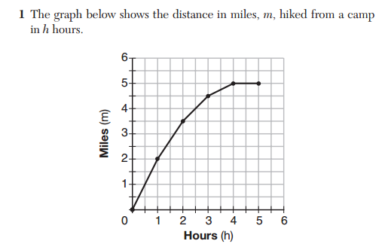
Juan hiked for five hours and graphed his distance as shown above. For the first hour he increased his distance at a rate of 2 mph. Then, he continued to hike but decreased his speed to 1.5 mph. He continued but slowed down more to 1 mph. After three hours of hiking he slowed down to 0.5 mph. He reached his maximum distance after 4 hours. His maximum distance was 5 miles.

- For the first hour he increased his distance at a rate of 2 mph.
Distance↑@ 2 mph

2. Then, he continued to hike but decreased his speed to 1.5 mph

_____________________________________________________________

3. He continued but slowed down more to 1 mph.

_____________________________________________________________

4. After three hours of hiking he slowed down to 0.5 mph.

_______________________________________________________________
5. He reached his maximum distance after 4 hours.
_______________________________________________________________

6. His maximum distance was 5 miles.

______________________________________________________________

Directions: Convert the notes into a complete sentence.

1. Mr. Hoehn = Principal of 754x

__________________________________________________________________________

2. Doing work → shout outs

__________________________________________________________________________

3. My favorite subjects = Math + ELA

__________________________________________________________________________

4. Absences = ↓ grades

__________________________________________________________________________

Directions: Use the correct manipulative to complete the sentence.

1. 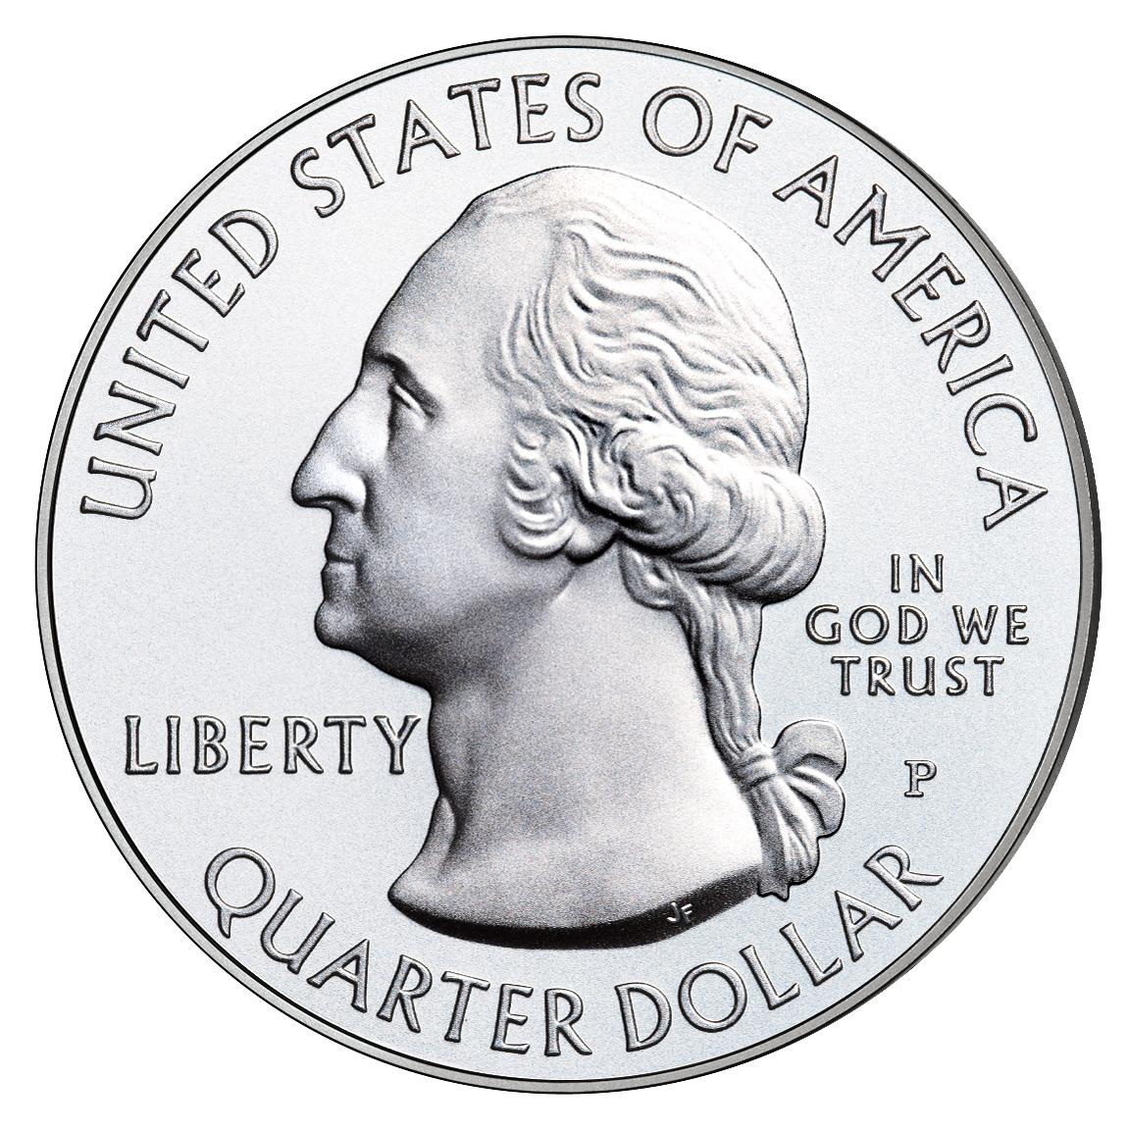 = 25 cents
equals

=

A quarter 25 cents.

2. 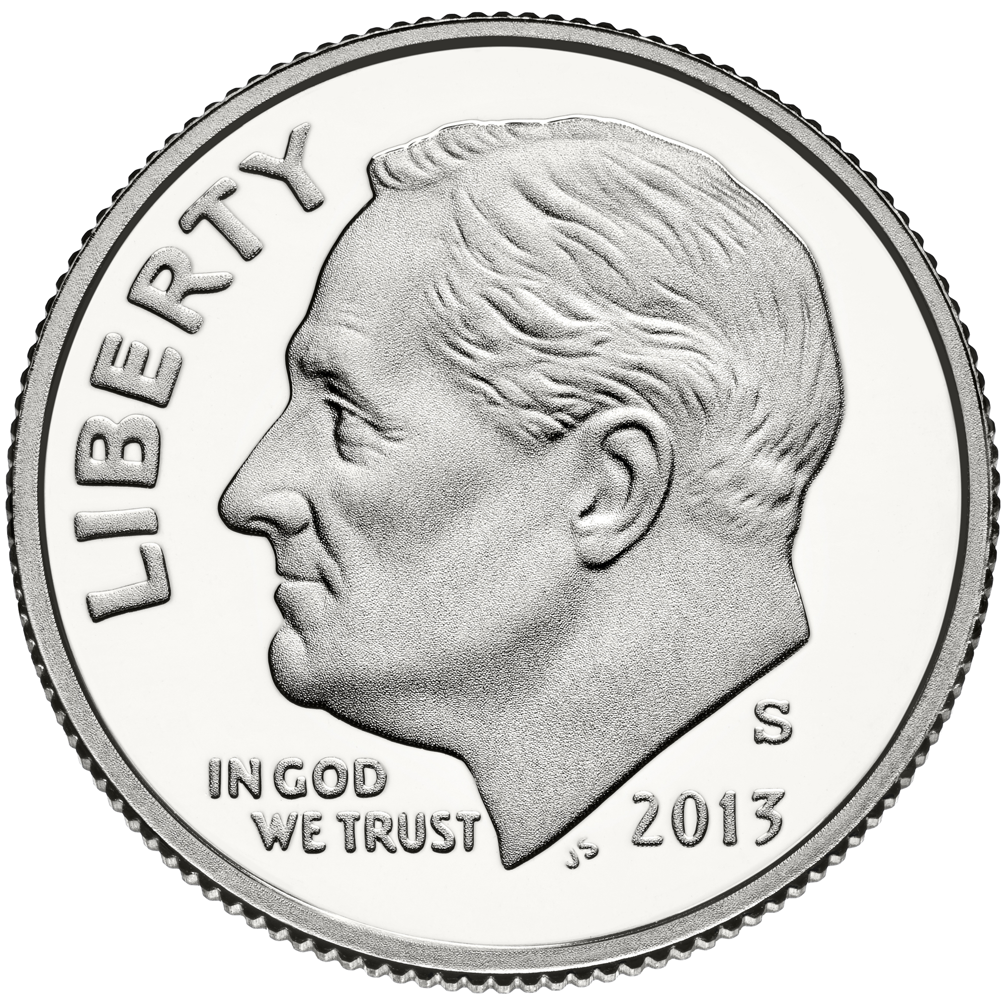 = 10 cents
equals

=

A dime 10 cents.

3. + 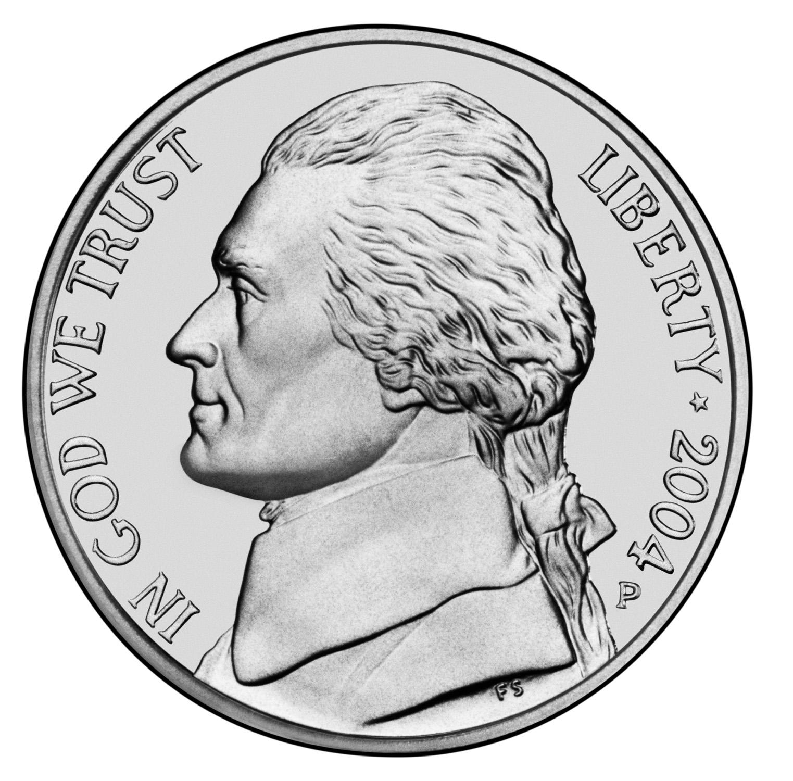 = 15 cents

and

+

equal

=

A dime a nickel 15 cents.

Name: ___________________________ Date: __________

Algebra Regents Prep
Directions:.
- Translate each sentence into corresponding keywords and symbols.
- = can be used more than once.
Symbol bank: w/ w/o = + ↑ ↓ max.
- The Algebra Regents is a test with 24 multiple choice questions.
_________________________________________________________________
- To increase your score on the Regents, you must study and complete the classwork everyday.
_________________________________________________________________
- Your score will decrease without answering the extended response.
_________________________________________________________________
- Ten is the minimum number of multiple choice questions you must get right to pass.
_________________________________________________________________

Math Symbols
Operations
1. The - symbol represents subtraction (fewer, decreased, difference, less than…)
2. The + symbol represents addition (and, increased, sum, more than…)
3. The = symbol represents equal (is, equivalent, results in…)
4. The ( ) symbol represents grouping and multiplication (times, product, multiplied by…)
5. The / symbol represents division (per, quotient, divided by…)

More Advanced Operations
6. A letter (x, y, z, h…) represents a variable (a number, unknown value…)
7. The $\sqrt{}x$symbol represents the square root (finding the number that multiplied by itself makes x)
8. The | x | represents absolute value (how far a number is from zero, make x positive)
9. f(x) represents a function

Sequence
10. $a_{1}$means the first number in a sequence
11. $a_{n}$means the number you are looking for in a sequence
12. $a_{n-1}$means the number before the one you are looking for in a sequence

Inequalities
13. > means greater than (more than, larger than, over, exceeding)
14. < means less than (fewer than, smaller than, below, under)
15. > means greater than or equal to (at least, price ceiling, no less than, not below)
16. < means less than or equal to (at most, price floor, no more than, not above)

