Sample Hochman Resources

Example 1: Sentence or Fragment?
Why should I do this?
- This is a starter activity that helps students tell the difference between sentences and fragments
- By making the fragments and sentences about key vocab words, students get to learn math and grammar!
Tips:
- To drive home some important words, have the students circle the vocab word.
- If you want your Group A students to focus on sentences vs. fragments, have the vocab word bolded for them!
- Don’t capitalize the sentences or add periods to have students focus on sentence mechanics

Algebra:
Name: ____________________________ Date: __________________

The Parts of a Graph

Directions:
- If the words make a sentence, write ‘S’ on the line.
- If the words only make a fragment, write ‘F’ on the line.

1. _________ the scale is

2. _________ the origin is the starting point of the graph

3. _________ the y-axis is the line that goes up and

4. _________ title is located

5. _________ the slope of the line is found by using the formula m =y2 -y1
_________
x2-x1

Example 2: Changing Fragments to Sentences?

Why should I do this?
- This is a starter activity that helps students identify the components of a complete sentence.
Tips:
- Make the sentences include vocab words relevant to class, so students have to come up with definitions.
- Don’t capitalize the first word of the sentence or use punctuation.

Social Studies:

Name __________________________________ Date ___________________

Directions:

1. Change the fragments into complete sentences and rewrite on the line below.

1. system of writing

________________________________________________________________________

2. mohenjo-daro
________________________________________________________________________
3. social class in ancient Egypt
_________________________________________________________________________
4. the Code of Hammurabi
_________________________________________________________________________

5. used oracle bones to communicate with ancestors and god
__________________________________________________________________________

Example 3: Identifying and Correcting Fragments

Why should I do this?
- This helps students to learn what the components of a complete sentence are.
- This provides students part of the information to make the material more accessible for our students.
- This combines skills of differentiating fragments from sentences as well as correcting and rewriting sentences.

Tips:
- Always start with an example, and ask guiding questions about the example to have students explain the process.
Science:
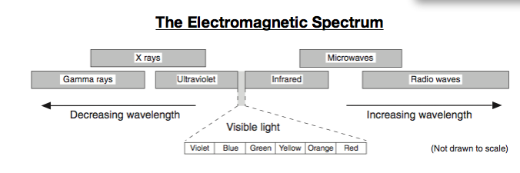

Directions: Using the chart above, do the following:

- Put an F next to each fragment. Put an S next to each complete sentence.
- Capitalize and punctuate the sentences and rewrite on the line below.
- Change the fragments into sentences and rewrite on the line below.

Ex. ____F____ gamma rays
Gamma rays have the shortest wavelength.

- ________ energy travels as a wave
________________________________________________________________________________________

- ________ longest wavelength
_______________________________________________________________________________________

3. ________ the wavelength gets smaller as you move towards the left side of the
spectrum.
___________________________________________________________________________________________

4. ______ radio waves are the
_________________________________________________________________________________________

Example 4: Finding Fragments in Paragraphs

Why should I do this?
- This is a more advanced activity to help students work towards editing completed paragraphs.
- This helps students progress in both writing and reading.
- Gives students a purpose for reading, kind of like a treasure hunt!
Tips:
- Paragraphs should be content specific, so students learn grammar and the topic.
- For students who need more support, try chunking the paragraph into shorter bits like in the example below.

Alternate Assessment:

Name:___________________________________ Date:_______________________

Directions: 1. Underline the sentence fragment in the given paragraph.

2. Use the lines below the paragraph to change the
fragment to a complete sentence.

Public schools across the country. are going on a health kick. Students are saying good- bye to junk food and hello to better eating habits. Kids are also exercising more during the school day.
____________________________________________________________________________________

The goals of the new law are to promote good health. and to fight obesity. Obesity is the condition of being very overweight. Experts say the percentage of young people who are overweight has tripled since 1980. Being obese can lead to serious health problems.

___________________________________________________________________

Example 5: Subject and Predicate Matching

Why should I do this?
- This helps students break down the parts of a sentence.
- This is great for introducing content specific vocabulary in any subject.
- This helps students develop the skills to use context clues when reading.
Tips:
- Before doing the exercise, explicitly teach what a predicate is and provide several examples.
- Make sure to put an example for students.
- Directions: Draw a line connecting the subject to the proper predicate.
Example: The Hochman Program teaches students how to write.
The Hochman Program --------------------------------------------------------------------------- teaches students how to write
The soccer player barked at the cat.

The boat needed glasses.

The squinting boy flapped its wings.

The bird scored a goal.

The dog sank into the water.

