Hoch Topic - Sentence Combinations
The purpose of these activities is to:
- Help students write complex sentences
- Enhances their comprehension
- Teach students grammar
- Helps students write extended responses
- Gives students a variety sentence construction options
- Teaches students sentence structure

Tips:
- Start off using very simple sentences and a conjunction.
- Always provide complete sentences for students to combine - don’t use fragments!
- Do the activity as a student to make sure the sentences can be combined.
- Teach the difference between ‘is’ and ‘are’.

Scaffolding:
- Easier: Use two short, simple sentences and combine into one sentence.
- Give students a word bank of conjunction and transition words.
- Medium: Identify run-on sentences.
- Harder: Use longer sentences.
- Use more than two sentences.
- Give a run-on sentence and have students create two sentences from the run-on.
- Give two sentences: One is the subject doing something (action) and the other is a descriptor (can be changed into an appositive)
Check out these examples of activities you can use to help your students learn about sentence types!

Sentence Combination

Directions: Combine the following sentences using because, but or so.

- 1. I like taking my dog for a walk. He sometimes pulls on the leash. __________________________________________________________________
__________________________________________________________________

- We did not go skating on the lake. It was not frozen. ________________________________________________________________________________________________________________________________________

3) My mother was angry. We did not go to the movies.
____________________________________________________________________
____________________________________________________________________

Sentence Combination-History

Directions: Combine the following sentences using because, but or so.

- England imperialized Africa. Africa had many desirable resources. __________________________________________________________________
__________________________________________________________________

2) The thirteenth amendment abolished slavery. The Jim Crow laws enforced segregation.

____________________________________________________________________
____________________________________________________________________

3) Buddha believed that anyone in society could achieve enlightenment. He rejected the caste system.
____________________________________________________________________
____________________________________________________________________

Group A Students (Low)

Name ___________________________________ Date _______________________
Dogs and Cats

Directions: Circle the best way to combine the two sentences. Try not to repeat the same words in the sentence.

- The dog is hungry. The cat is hungry.
  - The dog is hungry and the cat.
  - The dog and cat are hungry.
  - The dog is hungry and the cat is hungry.
- Lexi likes to eat pizza. I like to eat pizza.
  - Lexi and I like to eat pizza.
  - Lexi likes to eat pizza and I like to eat pizza.
  - Lexi likes to eat pizza and I like.
- Peyton is going to the store. Jimmy is going to the store.
  - Peyton is going to the store and Jimmy is going.
  - Peyton and Jimmy are going to the store.
  - Peyton is going to the store and Jimmy.

Students combine sentences using conjunctions.

Name: _______________________ Date: _____________

Mean, Median, and Mode.

Directions: Combine the sentences using the conjunctions in parentheses.

These numbers show how much money Kim Kardashian spent on shoes in thousands of dollars.
1, 5, 5, 7, 10, 15, 21

Kanye was angry, and wanted to prove to Kim that she was spending too much money using the mean, median, and mode. He said the mode was 5. He said the median was 7. He said the mean was 4.

- Kanye found the right median. Kanye needs to show his work by crossing out. (but)
______________________________________________________________________________________________________________________________
- Kanye did not find the right mean. Kanye should add up all the costs and divide by how many shoes Kim bought. (so) ______________________________________________________________________________________________________________________________
- Kanye calculated the mode correctly. The mode is the number that occurs the most (because)
______________________________________________________________________________________________________________________________

Name:________________________________ Date:________________

Directions: Combine the following sentences using the conjunctions below.

and but so because or

- I went to the store last night. I needed milk.
______________________________________________________________________________
______________________________________________________________________________

- Andy loves to watch football. He is not very good at it.
______________________________________________________________________________
______________________________________________________________________________

- We did not have school yesterday. It was Sunday.
______________________________________________________________________________
______________________________________________________________________________

- I could not get my copies. Tito was absent.
______________________________________________________________________________
______________________________________________________________________________

- Benjamin Franklin was a Founding Father. Benjamin Franklin helped write the Constitution.
______________________________________________________________________________
______________________________________________________________________________

- Guercio made pizza. The student ate pizza today.
______________________________________________________________________________
______________________________________________________________________________

Name _______________________________ Date ______________________

Solar System Sentence Combination

Directions: Use the chart below to combine each sentence using the words in parenthesis.
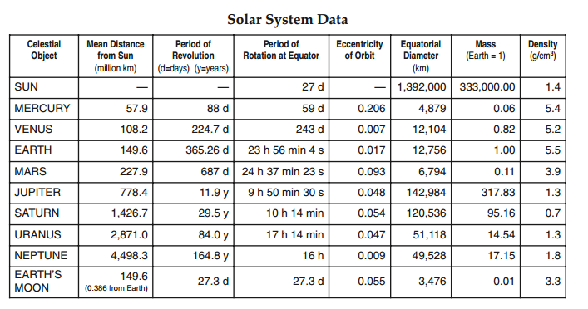

1) Jupiter is the largest planet. Jupiter has the most moons. (and)
____________________________________________________________________________________________________________________________________________________

2) Saturn is the second largest largest planet. Saturn has the lowest density. (and)
__________________________________________________________________________
__________________________________________________________________________

3) The moon is not a planet. The moon is larger than Pluto. (but)
__________________________________________________________________________
__________________________________________________________________________

4) Neptune is very far from the Sun. Neptune has an extremely long period of revolution. (so)
________________________________________________________________________
________________________________________________________________________

Name:_________________________ Date:__________________

Directions: Combine the following sentences into one sentence.

(use an appositive, delete words)

Mohenjo-Daro and Harappa were twin cities.
Mohenjo-Daro and Harappa had urban planning.
The cities had a system of plumbing.

______________________________________________________________________________________________________________________________________________________________________________________________________________________________

Juliet was a Capulet.
Juliet fell in love with Romeo.
Romeo was a Montague.

______________________________________________________________________________________________________________________________________________________________________________________________________________________________

Othello was a general.
Othello was betrayed by Iago.
Iago felt offended by him.
______________________________________________________________________________________________________________________________________________________________________________________________________________________________

Robb Stark was the King of the North.
Robb Stark was murdered.
He broke his promise to House Frey
____________________________________________________________________________________________________________________________________________________________________________________________________________________________________

Roland Deschain was a gunslinger.
Roland Deschain followed the man in black.
They were in the desert.

____________________________________________________________________________________________________________________________________________________________________________________________________________________________________

George shot Lennie.
Lenny killed Curley’s wife.
George was Lennie’s friend.

____________________________________________________________________________________________________________________________________________________________________________________________________________________________________

Name _______________________________ Date ______________________

Run-on Sentence Breakup

Directions: Break each run-on sentence into two separate sentences. Delete any unnecessary words.

- I like hummus it is really garlicky.
______________________________________________________________________
______________________________________________________________________

2) You can’t always get what you want if you try sometimes you just might find you get what need.
______________________________________________________________________
______________________________________________________________________

3) Beer is really good chips are really good too.
______________________________________________________________________
______________________________________________________________________

