Hoch Topic - Sentence Types

The purpose of these activities is to:
- Teach students what makes up the four types of sentences - command, question, exclamation, and statement.
- WIll help students to write topic and concluding sentences.
- Adds variety to students’ writing.

Tips:
- Start with focusing on one sentence type at a time to build student confidence.
- Mission: encourage students to engage in higher order thinking for writing their own questions.
- Focus more on the statement, question, and exclamation than the command.

Scaffolding:
- Prompt students by including the punctuation.
- Reference question word poster, or print out individual notecards with students.
- Have students underline the word in the sentence that let them know it was a question.
Check out these examples of activities you can use to help your students learn about sentence types!

Name: _________________ Date: ______
Wednesdays are Great
Directions:
-Identify whether the sentence is a statement, question, command or exclamation.

- This Wednesday, we are wearing pink.

_______________________________________________________

2. What day is early dismissal?

_______________________________________________________

3. Wednesdays are lit!

_______________________________________________________

4. Leave early on Wednesday.

_______________________________________________________

Name: _________________ Date: ______
Title: _ _ _ _ _ _ _ _ _ _ _
Directions:
-Identify whether the sentence is a statement, question, command or exclamation.

1. _ _ _ _ _ _ _ _ _ _ _ _ _ _ _ _ _ _ _ _ _ _ _ _ _ _ _ _ _ _.

_________________________________________________

2. _ _ _ _ _ _ _ _ _ _ _ _ _ _ _ _ _ _ _ _ _ _ _ _ _ _ _ _ _ _ ?
_________________________________________________

3. _ _ _ _ _ _ _ _ _ _ _ _ _ _ _ _ _ _ _ _ _ _ _ _ _ _ _ _ _ _ !

_________________________________________________

4. _ _ _ _ _ _ _ _ _ _ _ _ _ _ _ _ _ _ _ _ _ _ _ _ _ _ _ _ _ .
_________________________________________________

Add the correct punctuation: In this activity students have to read the sentence and add the correct punctuation mark. This helps them identify the components of each sentence type and helps them work towards creating different sentence types.
Scaffold:
-Have a poster in your room with the three punctuation marks if students have trouble with this.
-Let students know how many question marks, exclamation points, and periods there are.

Name: _________________ Date: ______
Wednesdays are Great
Directions:
-Add the correct punctuation mark.

- This Wednesday, we are wearing pink ______
- What day is early dismissal _____
- Wednesdays are lit ____
- Leave early on Wednesday ____

Name: _________________ Date: ______
Wednesdays are Great
Directions:
-Add the correct punctuation mark.

- _ _ _ _ _ _ _ _ _ _ _ _ _ _ _ _ _ _ _ _ _ _ _ _ _ _ _ _ _ _ _ _ _ _____
- _ _ _ _ _ _ _ _ _ _ _ _ _ _ _ _ _ _ _ _ _ _ _ _ _ _ _ _ _ _ _ _ _ _____
- _ _ _ _ _ _ _ _ _ _ _ _ _ _ _ _ _ _ _ _ _ _ _ _ _ _ _ _ _ _ _ _ _ _____
- _ _ _ _ _ _ _ _ _ _ _ _ _ _ _ _ _ _ _ _ _ _ _ _ _ _ _ _ _ _ _ _ _ _____

Name:____________________________ Date:______________
Directions: Generate 1 question, 1 sentence, 1 command, 1 exclamation about this picture and what is happening in it. It is of the Pilgrims landing in the New World.
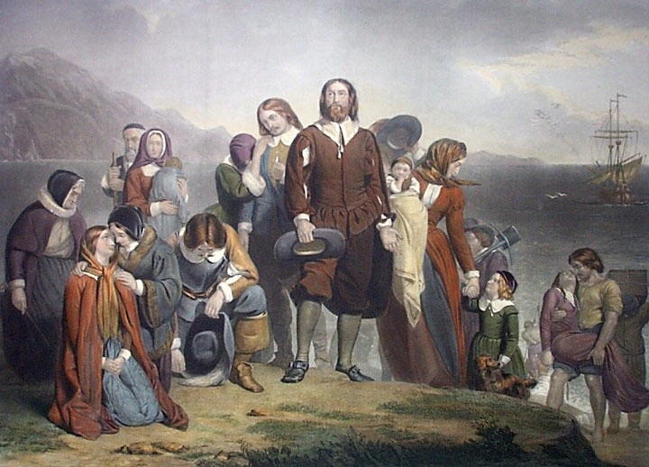
1.)_______________________________________________________________________________________________________________________________________________________________________________________________________________
_________________________________________________________________________________________________________
2.)________________________________________________________________________________________________________________________________________________________________________________________________________________________________________________________________________________________________________________________
3.)_______________________________________________________________________________________________________________________________________________________________________________________________________________
4.)_______________________________________________________________________________________________________________________________________________________________________________________________________________

Name: _________________ Date: ______
To Kill a Mockingbird
Directions:
-Write a question for each answer.

- Q: What is Atticus Finch’s occupation?____________________________
A: a lawyer
- Q: Who helps Atticus raise Scout and Jem? ________________________
A: Calpurnia

Name: _________________ Date: ______
To Kill a Mockingbird
Directions:
-Write a question for each answer.

- Q: _________________________________________________________
A: _ _ _ _ _ _ _ _ _ _ _
- Q: _________________________________________________________
A: _ _ _ _ _ _ _ _ _ _

Given a kernel sentence and/or picture, write the 4 sentence types.

Name: _________________ Date: ______
Immigration
Directions:
-Write a different sentence type for each kernel (statement, question, exclamation, command).

- immigrants ( question)
What countries did many immigrants come from in the early 1900s?___________________________________________
- Ellis Island (statement)
Many immigrants were documented at Ellis Island._______
________________________________________________
- citizen (command)
As a citizen, exercise your right to vote.________________
________________________________________________
- Freedom (exclamation)
We are so fortunate to have freedom in this country!______
________________________________________________

Name: _________________ Date: ______
Title:_________________
Directions:
-Write a different sentence type for each kernel (statement, question, exclamation, command).
- _ _ _ _ _ _ _ _ _ _ (_ _ _ _ _ _ _ )
____________________________________________________________
___________________________________________________________
- _ _ _ _ _ _ _ _ _ _ (_ _ _ _ _ _ _ )
____________________________________________________________
___________________________________________________________
- _ _ _ _ _ _ _ _ _ _ (_ _ _ _ _ _ _ )
____________________________________________________________
___________________________________________________________

Given a topic, write four sentences types.

Name: _________________ Date: ______
International Space Station
Directions:
-Write a different sentence type given the topic provided

- ( question)
How many crew members live and work at the international Space Station?___________________________________________
- (statement)
The international Space Station is the largest and most complex international scientific undertaking in history.
- (command)
Continue the space program

- (exclamation)
Almost an acre of solar panels provide electrical power to state-of -the-art laboratories!

Sentence Types Anchor Chart

Use the following definitions and examples to create an anchor chart in your room. You may use the example on the next page as an example of how to make the anchor chart. Be sure to use the words Statement, Question, Exclamation, and Command on your chart.

Statement: A sentence that tells a fact or opinion. Ends in a period.

Ex. I like dogs. Halloween is the last day in October.

Question: Asks us a question. Ends in a (?)

Ex. Where is the bus stop? How old are you?

Exclamation: Sentences that show emotion. Ends in an (!)

Ex. Cool, that’s awesome! Pizza is the best!

Command: Tells you to do something. Ends in (!) or (.)

Ex. Do your homework. Pass the ball!

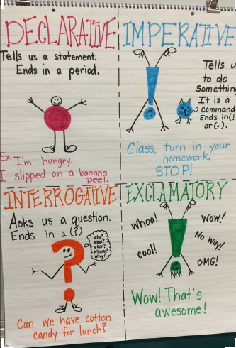
Use this in your classroom as a graphic organiser or materials in your classroom.
4 Sentence Types
Statement  (Declarative)  Gives the reader facts or an opinion. They are the most common sentence.  They end in periods ( . ).  Examples:  I like sports.  The sky is blue.  Mr. Hoehn is the principal.  We need more food at lunch. | Question  (Interrogative)  Asks the reader for information.  Often times start with question words.  They end in a question mark (?).  Examples:  When do we go home?  What day is tomorrow?  How did she make this?  Did you do this?
Exclamation  (Exclamatory)  Sentences that are full of emotion and have excitement and energy.  They to tell people how we feel.  They end in exclamation points ( ! ).  Examples:  I love you!  I hate school!  Orange soda is the best! | Command  (Imperative)  Sentences that tell the reader to do something.  The reader is the subject.  They end in periods ( . ) or exclamation marks ( ! ).  Examples:  Stop!  Do your homework.  Get me the milk.  Catch the ball!

